William Penn Plans the City

Penn's conceptions of Philadelphia may be characterized as one of the earliest attempts at utopian city planning, and they certainly represented the most extensively 'pre-planned' American city at that time. Penn's early plans grew from his love of the country estate, as opposed to the metropolis.. Thus his original vision of a "greene Country Towne" seeks to replicate this model of life in the New World. The first plan called for individual houses to be separated from their neighbors by sizable areas of green, thus replicating the gentleman's farm that he so loved.

Though Penn envisioned country estates, he could scarcely ignore the occupation of most of his colony's investors. They were tradesmen, and trade would be the economic engine of the new city. So, in addition having to fertile farm lands, the 'towne' would still have to be accessible to trading ships. It would be situated "in the most Convenient place upon the river for health & Navigation." The chosen site, where the Delaware and Schuykill rivers meet, was already farmed by a groups of Swedes, Finns, Dutch and English. It was not an ideal port however. Its high banks made unloading difficult, and the river froze more readily than did port of New York. However, the site also provided a safe, deep harbor and the Schuykill river gave the best access to the interior of the state. And extremely fertile farm land that surrounded the site of the city could not be ignored.

The 1200 acre site of Philadelphia formed a rectangle joining the Schuylkill and Delaware rivers. Penn provided a generous amount of room for expansion, far more than in any other contemporary American city. Each house will have its own space for a garden. His plans certainly varied from the cramped cities of Europe, and have received much praise and speculation ever since he first published them.

Penn first advertised the layout of his town in Thomas Holme's Portraiture of the City of Philadelphia, published in 1683. As one can see, Penn designed the city as a rectangular gridiron. Broad and High streets cross each other at 'centre square' and divide the city into four quadrants. These 100 foot wide avenues were at broader than the other street, and broader than any street in London. In any case, his wide, open, rectilinear design was somewhat revolutionary, though today seems 'normal' for most American cities.

Penn planned for the city's principal public buildings, the meeting house, school, state house, to border center square. As the map indicates, lots were evenly spread across the width of the city, with the prime real estate facing first the Delaware, and second the Schuylkill river. Penn originally planned to situate his own house near the Schuylkill. The lots marked off on the map were either one acre or half an acre in size, plenty large enough for all to plant their own gardens.. Additionally, each quadrant contained additional green-space in the form of a small park.

Penn was so interested in parks and gardens in part because he realized some of the dangers inherent in the 17th century city. He had lived through London's bubonic plague of 1665 and great fire of 1666. And so it is not surprising that he envisioned his 'greene towne' as one "which will never be burnt, and always be wholesome."

As lord of the manor, William Penn proved a relatively easygoing, and an almost always absent, land lord. His contributions in planning the city were far reaching, both locally and nationally.
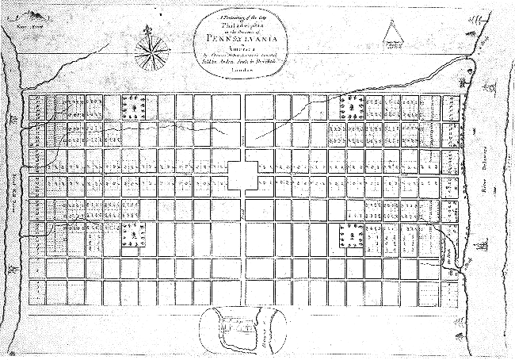
These 100 foot wide avenues were at broader than the other street, and broader than any street in London. Penn may have been influenced by Richard Newcourts plans for rebuilding burnt out parts of London, or perhaps by new garrison towns like Londonberry Ireland. In any case, his wide, open, rectilinear design was somewhat revolutionary, though today seems 'normal' for most American cities.

Penn planned for the city's principal public buildings, the meeting house, school, state house, to border centre square. As the map indicates, lots were evenly spread across the width of the city, with the prime real estate facing first the Delaware, and second the Schuylkill river. Penn originally planned to situate his own house near the Schuylkill, at Fairmount, close to the place where the city's famed Water Works, and then Museum of Art would stand. The lots marked off on the map were either one acre or half an acre in size, plenty large enough for all to plant their own gardens. Even the city dweller could live in a country-esque manner. Additionally, each quadrant contained additional green-space in the form of a small park.

Penn was so interested in parks and gardens in part because he realized some of the dangers inherent in the 17th century city. He had lived through London's bubonic plague of 1665 and great fire of 1666. And so it is not surprising that he envisioned his 'greene towne' as one "which will never be burnt, and always be wholesome." (Weigley, 2) Sadly, a little over one hundred years after Penn established his city, Philadelphia would be devastated by a series of yellow fever epidemics. The dream of a 'wholesome' city was seriously compromised by the 'stinking miasmas' of disease. Though like Penn, city leaders once again found salvation in both 'greening' and 'cleaning' the towne (by then the country's largest city, and national capitol) with the establishment of the Fairmount Water Works, and its surrounding park. City leaders in the 19th century also had to contend with the competing interests of business and public welfare, though unlike Penn they were not 'proprietors' of the land. Though as lord of the manor, William Penn proved a relatively easygoing, and an almost always absent, land lord. His contributions in planning the city were far reaching, both locally and ationally. Though Philadelphia has grown outward far beyond Penn's original design, he still symbollically controlled its vertical growth. His likeness atop City Hall (at Centre Square) was deemed to be the limit for building height until the mid 1980s; until then Penn's statue always looked down on his city. As well, his rectilinear street layout, his interest in 'suburban' development, and his desire to plan the perfect city, all foreshadowed many future city planning 'innovations'.

