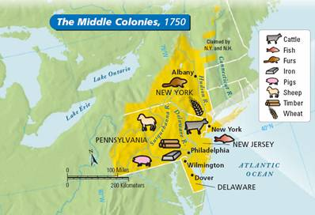

WHY WERE THE MIDDLE COLONIES REFERRED TO AS THE BREADBASKET COLONIES?

There was relatively good climate in the Middle colonies. Having this and good soil helped the farming greatly. They could produce more crops, causing the farmers to be able to sell their extras for money, but still not as much as the Southern colonies could. Even though the Middle colonies had decent climate and soil, farming was not the main way to make money and a living.

The "Breadbasket Colonies"

The Middle colonies were not known for their farming as well as they were known for their mills and bread. On average in the Middle colonies, people ate about 1 pound of bread per day. The mills used to produce the bread was powered by rivers to crush the grains. This was very helpful if you wanted to live in the Middle colonies. The main foods you got out of these grains were

Just about all the colonies needed farmers. They were a very important source for food for all the colonies, even if farmers couldn’t get very much crops. The main items for the farmers in this area was any type of grain, meats, and some corn. The Middle colonies had a mild climate, rich soil and a long growing season.

Picture Courtesy: http://rds.yahoo.com/S=96062883/K=conestoga+wagon/v=2/SID=e/l=IVR/SIG=1327b96l5/\*-