The Milgram Experiment
by Saul McLeod published 2007

One of the most famous studies of obedience in psychology was carried out by Stanley Milgram, a psychologist at Yale University,. He conducted an experiment focusing on the conflict between obedience to authority and personal conscience.

He examined justifications for acts of genocide offered by those accused at the World War II, Nuremberg War Criminal trials. Their defense often was based on "obedience" - that they were just following orders of their superiors.

The experiments began in July 1961. Milgram devised the experiment to answer the question "Could it be that the accomplices in the Holocaust were just following orders? " Milgram wanted to investigate whether Germans were particularly obedient to authority figures as this was a common explanation for the Nazi killings in World War II.

Milgram selected
participants for
his experiment by
advertising for male
participants to take
part in a study of
learning at Yale
University.

The procedure was that the participant was paired with another person and they drew lots to find out who would be the ‘learner’ and who would be the ‘teacher’. The draw was fixed so that the participant was always the teacher, and the learner was one of Milgram’s associates (pretending to be a real participant).

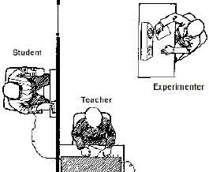

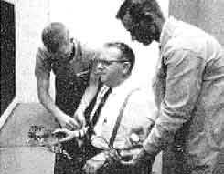

The learner (an associate
called Mr. Wallace) was taken into
a room and had electrodes
attached to his arms, and the
teacher and researcher went
into a room next door that
contained an electric shock
generator and a row of switches
marked from 15 volts (Slight Shock) to 375 volts (Danger: Severe Shock) to 450 volts (XXX).

Milgram's Experiment

Procedure:

The “learner” (Mr. Wallace) was strapped to a chair in another room with electrodes. After he has learned a list of word pairs given him to learn, the "teacher" tests him by naming a word and asking the learner to recall its partner/pair from a list of four possible choices.

The teacher is told to administer an electric shock every time the learner makes a mistake, increasing the level of shock each time. There were 30 switches on the shock generator marked from 15 volts (slight shock) to 450 (danger – severe shock).

The learner gave mainly wrong answers (on purpose) and for each of these the teacher gave him an electric shock. When the teacher refused to administer a shock and turned to the experimenter for guidance, he was given the standard instruction order (consisting of 4 prods):

Prod 1: please continue.
Prod 2: the experiment requires you to continue.
Prod 3: It is absolutely essential that you continue.
Prod 4: you have no other choice but to continue.

Results:

65% (two-thirds) of participants (i.e. teachers) continued to the highest level of 450 volts. All the participants continued to 300 volts.

Conclusion:

Ordinary people are likely to follow orders given by an authority figure, even to the extent of killing an innocent human being. Obedience to authority is ingrained in us all from the way we are brought up. Obey parents, teachers, anyone in authority etc

Please answer the following questions after you do the reading:
1. What prompted Stanley Milgram to research the concept of obedience to authority?
2. How did Milgram atrack subjects for his experiment?
3. In this experiment, what was the role of the learner?
4. In this experiment, what was the role of the "teacher?"
5. In what ways did the "experimenter" coax the teacher into continuing the experiment?
6. What percentage of the "teachers" went all the way to the highest level of voltage?
7. What conclusions can be made from the results of this experiment?

