THE LOUISIANA PURCHASE
With the Louisiana Purchase in 1803, the United States purchased a large area of land from the French. It was the single largest purchase of land ever by the United States and doubled the size of the country.
Why did the United States want more land?
The United States had been growing rapidly. In search of new land to plant crops and raise livestock, people had been expanding to the west past the Appalachian Mountains and into the Northwest Territory. As these lands became crowded, people needed more land and the obvious place to expand was to the west.
How much did it cost?
Thomas Jefferson wanted to buy the settlement of New Orleans from the French. It was a major seaport that was fed from the Mississippi River, making it important to many American businesses. He sent Robert Livingston, the U.S. Minister to France, to try and buy the land from the French Emperor Napoleon.
At first Napoleon refused to sell. He had hopes of creating a massive empire that included the Americas. However, soon Napoleon began to have troubles in Europe and he needed money desperately. James Monroe traveled to France to work with Robert Livingston. In 1803, Napoleon offered to sell the entire Louisiana Territory to the United States for $15 million.

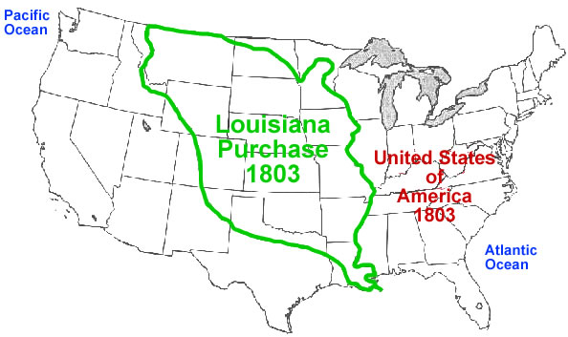

Interesting Facts About the Louisiana Purchase
On April 30, 1803, U.S. representatives in Paris agreed to pay $15 million for about 828,000 square miles of land that stretched from the Mississippi River to the Rocky Mountains and from the Gulf of Mexico to Canada. This deal, known as the Louisiana Purchase, nearly doubled the size of the United States.
1. France had just re-taken control of the Louisiana Territory.
French explorer LaSalle first claimed the Louisiana Territory, which he named for King Louis, during a 1682 canoe expedition down the Mississippi River. France gave the land to Spain 80 years later. In 1800, however, French leader Napoleon pressured Spain to sign a secret treaty under which he received the Louisiana Territory. When word of the secret agreement leaked out, President Jefferson became extremely worried.
2. The United States nearly went to war over Louisiana.
Under a treaty with Spain, U.S. farmers could send their goods down the Mississippi River and store them in New Orleans. For many Americans, this so-called “right of deposit” was important. There was talk that France was not going to stop this.
Alexander Hamilton , wrote that the United States should “seize at once New Orleans and then negotiate.” Meanwhile, the governor of the Mississippi Territory claimed that 600 militiamen would be enough to grab hold of New Orleans.
Napoleon’s powerful army had yet to arrive in Louisiana. Several thousand troops scheduled to arrive were instead being killed by a slave rebellion and yellow fever in Haiti, and additional troops were stuck in a Dutch port waiting for the winter ice to clear.
3. The United States never asked for all of Louisiana.
Jefferson offered to purchase land from Napoleon rather than threatening war over it. He instructed his negotiators to pay up to $9.375 million for New Orleans and Florida. If that failed, they were to try to get back the right of deposit.
Napoleon dangled the entire territory in front of them. A treaty, dated April 30 and signed May 2, gave all of Louisiana to the United States.
The price was more than the US could afford. The US was forced to borrow from two European banks at 6 percent interest. It did not finish repaying the loan until 1823.

THE LOUISIANA PURCHASE

1. What was a reason why the US was looking for more land?
2. What was the “right of deposit?
3. Why was the “right of deposit” important to American farmers?
4. Why did France taking the territory from Spain pose a threat to the US?
5. Why didn’t the French leader Napoleon send troops to America to protect this
6. Who was sent by the United States to buy the land?
7. What was the original offer?
8. How did the offer change?
9. Why did Napoleon offer the entire territory to the United States?
10. How much was the final price
11. How did the US get the money to pay for this territory?

Interesting thought:

How did the slave rebellion impact the deal that was made for this territory?

