The Folsom Cowboy

THE LUCKY FIND THAT WENT UNNOTICED
In September 1908, a cowboy named George McJunkin, foreman of a ranch in New Mexico, had a fencing problem.
A month before, a huge storm dropped thirteen inches of rain causing a flood which tore a ten-foot wash out of dirt, leaving a gap under a barbed-wire fence. The same flash flood had swept through the nearby town of Folsom, killing seventeen people.
While thinking about how to fix the fence, McJunkin noticed some freshly exposed bones at the bottom of the trench. He climbed down and using his pliers, dug out a couple of bones, which he brought back to the ranch house. He placed them in his room on a shelf next to rocks, minerals, arrowheads, and an ancient Indian skull.
McJunkin was not a typical cowboy. He loved reading scientific books. He learned enough to realize that the bones came from an extinct animal. Although they resembled those of a bison, they were much larger.
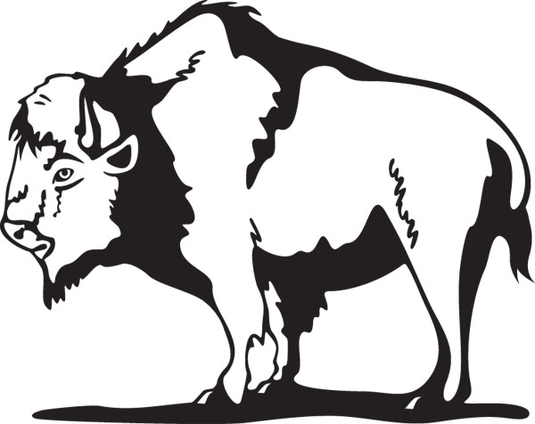
He figured the bones must be very old, because they were almost thirteen feet below the surface. He felt that the "bone pit," as he called it, was important and should be reported.

NO HELP FOR THE DISCOVERY
McJunkin wrote to a man in Las Vegas, who knew about bones, but could not convince him to visit the site. He gave detailed directions to the bone pit to a blacksmith in a nearby town who collected bones. The blacksmith was interested but never had time to make the two-day horseback ride to the site because it was too far away. McJunkin also described the bone pit to the local banker who had once dug up a woolly mammoth, but the banker too was also not interested in the idea of a long trip. The bone pit sat explored.
Nothing came of McJunkin's letters and conversations reporting the fossil bones. The years passed, McJunkin grew old, and the ranch was sold. He moved from the main ranch house to a small cabin which was later struck by lightning and burned to the ground, and McJunkin lost everything: the fossils, his telescope, scientific books, and Indian skulls.
He became ill and moved into a room at the Folsom Hotel. Eventually, he could not get out of bed. He died in 1922.

LATER INTEREST IN THE DISCOVERY

Four months after McJunkin's death, the blacksmith and the banker decided to visit the bone pit. The banker, had purchased one of the first motorcars and so the long horseback trip became an easy, afternoon's drive. Both men found the bones just where McJunkin said they would be and filled a bag with them. That evening, the two men went through several books trying to figure out what kind of animal the bones were from. They decided they were from an extinct elk or bison, but four years passed before they had an opportunity to show the bones to a scientist.

In January 1926, the two men carried the sack of bones to the Colorado Museum of Natural History. They were met by Jesse D. Figgins, the museum's director and what happened next was one of the most controversial scientific questions of the day: how long had human beings been in the New World.
In the 1800s, the common view was that Indians had arrived in the New World no earlier than 1,000 B.C.
Figgins was deeply interested in the fossils. He recognized them as being an older extinct bison now called “Bison antiques”.
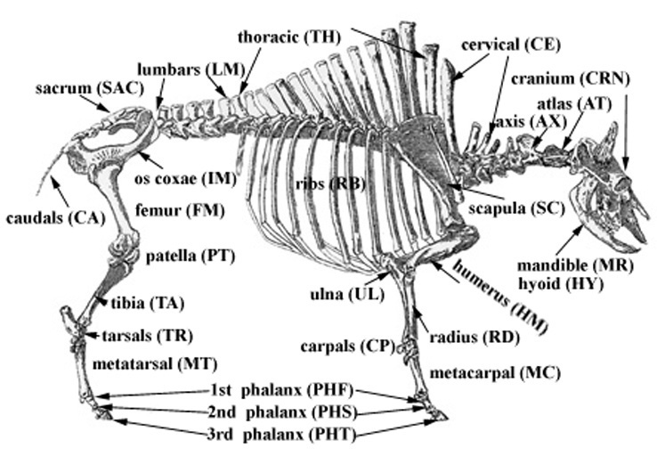
He suspected the bone pit might be a prehistoric kill site--and might offer just the proof that humans had been in the New World a lot earlier than 1000 BC.
Figgins organized an excavation of the pit.
They uncovered skeleton after skeleton--mostly intact, all from a species of giant bison that had been extinct for 10,000 years. They also unearthed beautifully spear points. Figgins suggested that these prehistoric bison had been killed by human hunters.
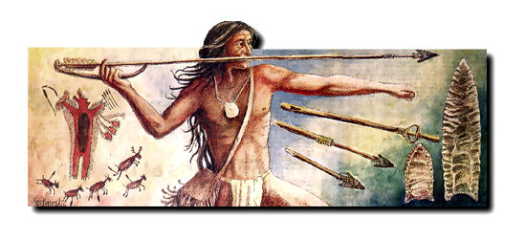

ARGUING THE MEANING OF THE BONES

Some argued the artifacts could have rolled into the dig from the surface or washed into the site at a later time.
On July 14, 1926, Figgins found a spear point embedded in a bone, and sent the block to the Colorado Museum for further analysis.
Further digs by an expedition at the bone pit finally convinced the world that this was actually a prehistoric kill site.
The Folsom hunters had driven a bison herd into a valley, where the animals milled about in confusion. The hunters then heaved a bunch of spears into the herd and backed off, waiting to see which animals died. There were more than twenty-seven skeletons--an unusually large Folsom kill--and most were still intact. The hunters left behind many of their spear points still embedded in the bisons' flesh.

A CHANGE IN THINKING
McJunkin's bone pit was one of the most important archeological discoveries made in America, and it caused a permanent shift in thinking. All of a sudden, archeologists had another 7,000 years of human history account for.
Once such a change in thinking occurs, a flood of new discoveries often follow. The spear points had been turning up for years--only nobody had recognized them for what they were.
The Folsom find led directly to the discovery of an even older culture, the Clovis mammoth hunters. Today, they are believed to be oldest cultural in the New World.

MCJUNKIN LEFT OUT

Not one scientific publication about the Folsom discovery mentioned McJunkin. By the 1960s many archeologists assumed that the story of George McJunkin was no more than a colorful myth.
Then, George Agogino, an Indian archeologist at New Mexico University, became curious about the tale. He went to Folsom and, through interviews with local ranchers, cowboys, and townspeople, pieced together the McJunkin story. Half a century after his death, McJunkin was still held in high regard by the citizens of Folsom, who, while knowing little about the scientific revolution he had caused, remembered with great affection the remarkable black cowboy with the telescope, bones, and scientific books

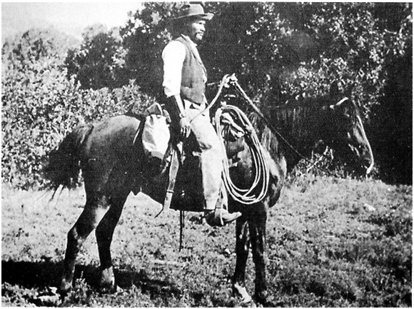
WANT TO KNOW MORE ABOUT GEORGE MCJUNKIN?

We know very little about George McJunkin. Although a skillful cowboy, he was not happy with the cattle business. His great interest was science.
His saddle was rigged with two pockets: in the left, he carried his rifle; in the right, his telescope, with which he kept track of cattle by day and studied the heavens by night. In his room at the ranch were a small but treasured library of encyclopedias, books about geology and surveying, and a tattered Bible. He was a man out of place in his world.
McJunkin had another reason to feel out of place: he was an African- American, born a slave on a ranch in Texas, in 1851. During the Civil War, Union soldiers arrived at the ranch to tell them the slaves were free.
George spent three more years on the ranch. At seventeen, he got a job working with cattle in Dodge City, Kansas. He worked cattle for various outfits, finally ending up in the valley in northeastern New Mexico. New Mexico had sided with the Union, and because of its racially mixed population of Hispanics, Anglos, and Indians, a black man was more readily accepted.
One of the ranchers he worked for asked McJunkin to train his two sons to ride and rope. In exchange, the boys taught McJunkin how to read from their schoolbooks, and he became a huge reader.
By the time McJunkin became foreman of the nearby Crowfoot Ranch, he was considered to be one of the top cowboys in the county, and in his new position he had a number of white and Hispanic cowboys working under him.
When McJunkin encountered prejudice, his cowboy friends backed him up. One time he and a white cowboy named Mallon decided to have a fancy lunch at the Eklund Hotel in Clayton, New Mexico. When they were told that the hotel did not serve Negroes, Mellon removed his long-barreled Colt .45 from its holster and pointed it at the manager's heart. "Your policy has just been changed," he said quietly.
QUESTIONS TO ANSWER FROM THE READING

1. What event caused the bones to be exposed?

2. Why couldn't McJunkin convince people to come and view the site where the found the bones?

3. How did scientists realize they had found a "prehistoric kill site?"

4. Why was McJunkin's bone pit a huge discovery for archeology?

