SHOW WHAT YOU KNOW
THIRD MARKING PERIOD #1
(CHAPTER 7)
REVIEW

Know these topics for the next assessment.
Be ready on the date the exam is given.
You may use your reading guides, power point worksheet and the textbook.

UNLIKE THE PREVIOUS EXAMS, THERE WILL BE NO REVISIONS HERE
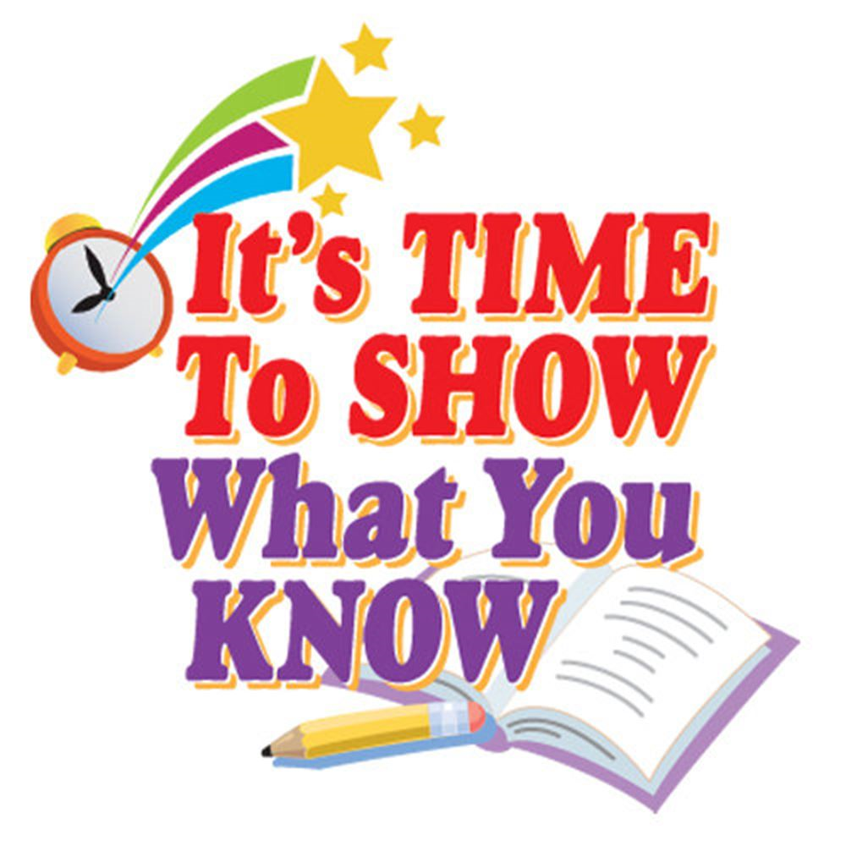
Vocabulary words and important terms to know
- First Continental Congress
- Olive Branch Petition
- Minutemen
- Patriots
- Loyalists (Tories)
- Hessians

Some important people to know
- Paul Revere
- General Gage
- George Washington
- Thomas Paine
- Thomas Jefferson
- General Howe
- Marquis de Lafayette
- Benedict Arnold
- Lord Cornwallis

Map
- How did the political map of North America changes after the Revolutionary war?

Major concepts and ideas:
- What happened at the First Continental Congress?
- Why did General Gage send troops to Concord?
- What plan did colonists have to warn people about Gage’s troops?
- What happened at Lexington Green?
- What happened at Bunker Hill?
- What was Thomas Paine trying to say in his pamphlet Common Sense?
- What rights can be found in the Declaration of Independence?
- What advantages did the British have at the start of the war?
- What advantages did the colonists have at the start of the war?
- Why did Southerners not allow slaves to fight in the war?
- Why did Washington’s men cross the Delaware river?
- Why was Saratoga “turning point” of the war?

