SHOW WHAT YOU KNOW
SECOND MARKING PERIOD #3
(CHAPTER 6)
REVIEW

Know these topics for the next assessment.
Be ready on the date the exam is given.
You may use your reading guides, power point worksheet and the textbook.

UNLIKE THE PREVIOUS EXAMS, THERE WILL BE NO REVISIONS HERE
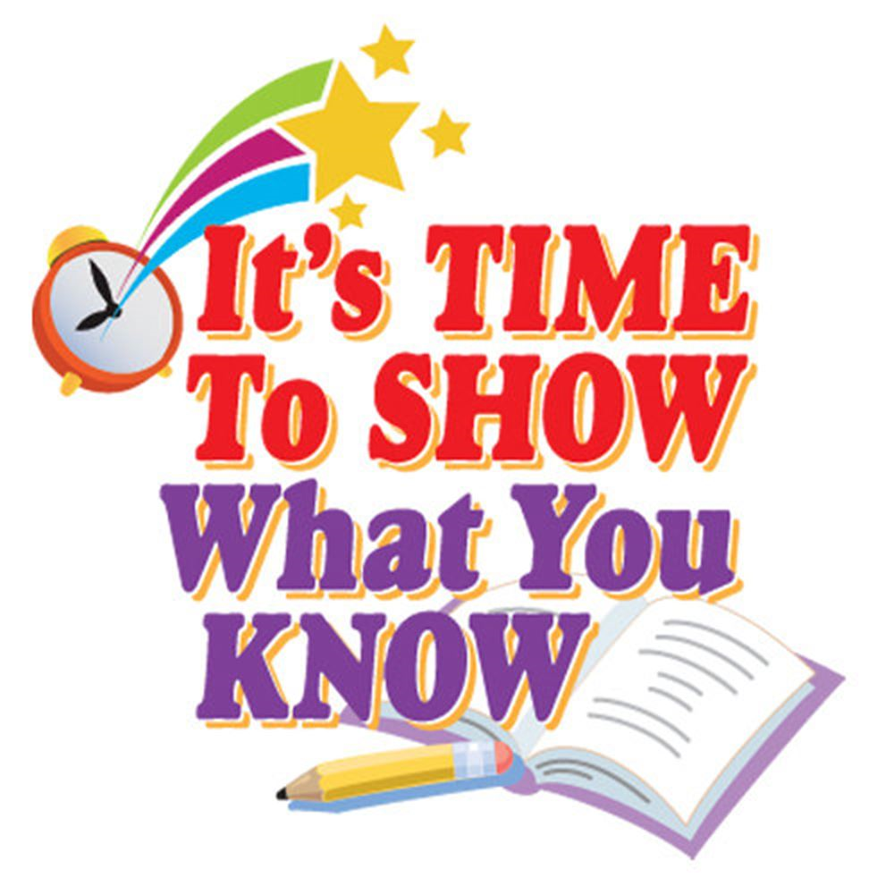
Vocabulary words and important terms to know
- The Ohio-Valley
- Back country
- Pioneers
- Royal Proclamation of 1763
- Taxation Without Representation
- Boycott
- Writs of Assistance
- Boston Tea Party

Some important people to know
- Metacomet
- George Washington
- General Edward Braddock
- Chief Pontiac
- Daniel Boone
- Sons of Liberty

Major concepts and ideas:
- What was the Albany Plan of Union and why didn’t it work?
- How did the Treaty of Paris change the land possessions in the New World?
- How did people make a living in the back country?
- How did Chief Pontiac’s rebellion change the plan the English had for the Ohio valley?
- What were the different view points about who should pay for the French and Indian war?
- What did the Sugar Act do?
- What did the Stamp Act do?
- How did colonists react to these taxes?
- Why was smuggling a problem?
- How did the British try to stop smugglers?
- What happened at the Boston Massacre?
- Why did colonists throw tea into the harbor of Boston?
- What did the British do in reaction to this event? Explain the Intolerable Acts

