SHOW WHAT YOU KNOW
FOURTH MARKING PERIOD #1
(CHAPTER 10)
REVIEW

Know these topics for the next assessment.
Be ready on the date the exam is given.
You may use your reading guides and the textbook.

THERE WILL BE NO REVISIONS HERE
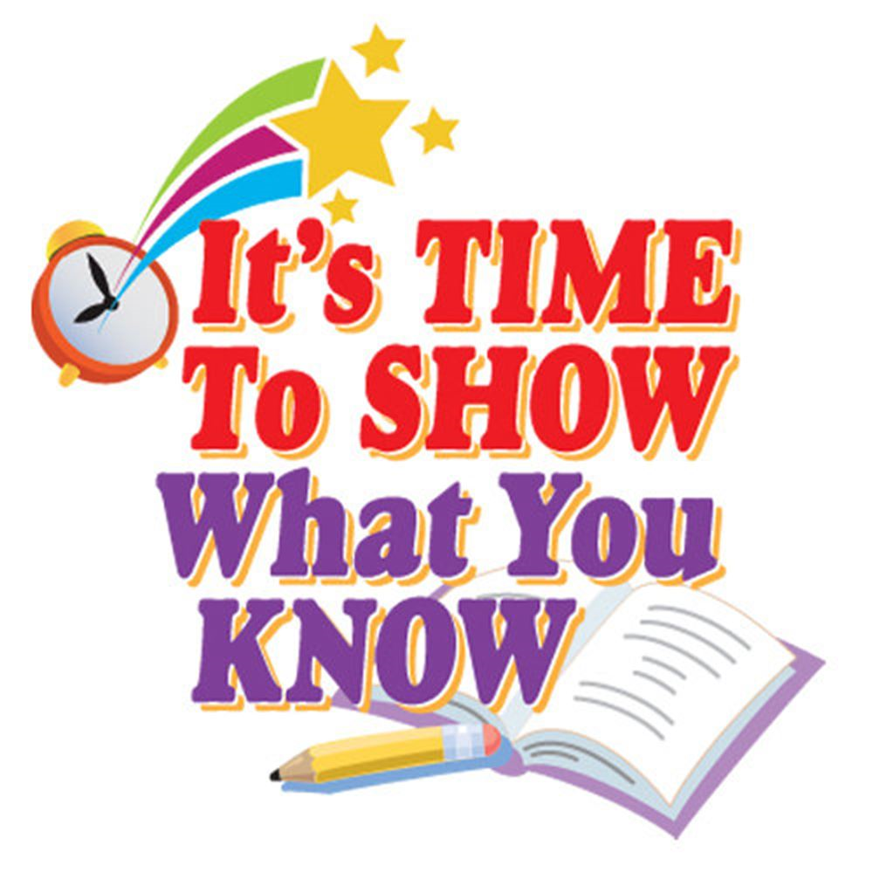
Vocabulary words and important terms to know
- Electors (what do they do?)
- Tariff (what is it)
- Cabinet (what do they do)
- National debt
- War Bonds
- Speculators
- Loose contructionist versus a strict constructionist
- Neutrality
- Privateers
- “Right of Deposit”
- Whiskey rebellion (explain what happened)
- XYZ affair (explain what happened)
- Democratic-Republican (what did the party stand for?)

Major concepts and ideas:
- What concerns did George Washington have about himself as being President?
- How does a tariff protect jobs in America?
- What deal did Hamilton make that led to the location of our new capitol?
- Why did Hamilton want a National Bank?
- How did Jefferson and Hamilton differ on their beliefs about the common man?
- What was President Washington’s position on getting involved in a war in Europe?
- What did Jay’s Treaty say?
- What caused Spain to close the port of New Orleans to US trade?
- How did President Washington solve the Whiskey Rebellion?
- Why did Washington feel he needed to step down after 8 years as President?
- When Washington retired, he gave us two important warning (advice). What were they?
- What did the Alien and Sedition Acts do?
- What did the Kentucky Resolutions do?
- What happened in the election of 1796 that had never happened before?
- Why was the election of 1800 a mess?
  - What happened that caused a problem?
  - How was the problem solved?
  - How do they prevent the problem from happening ever again?

