Scientists learn from 9,000-year-old man

KENNEWICK, Wash. - From the time we are children, we are told to listen to our elders. Well, scientists are listening to the story being told by a man born 9,000 years ago.

His skull was found in 1996, along the banks of the Columbia River near Kennewick, Washington.
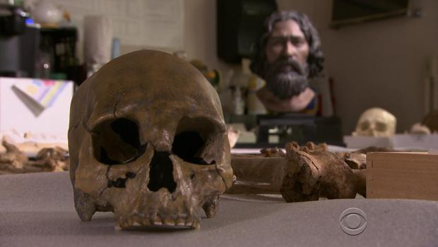

Doug Owsley is the
Smithsonian's top
anthropologist.

Eighteen years ago he and
a group of scientists sued
the federal government and
local Indian tribes for the right
to study a 9,000 year old
skeleton - known as
"Kennewick Man."

It is certainly America's most
important skeleton, it is an exceptionally rare discovery that doesn't happen but once in a lifetime," said Owsley.

The tribes believed the bones were ancestral and needed to be reburied.
The court ruled in favor of science.

"I truly consider him an ambassador from an ancient time period" said Owsley.

When asked about what "Kennewick Man" tells us about how humans first came to North America, Owsley replied, "You have people coming in thousands of years earlier than we had thought." "He is from these East Asian coastal populations," said Owsley.
He was five feet seven, and a muscular 163 pounds. His diet left a chemical signature in his bones.

"You find that this man is heavily dependent on seals," said Owsley. "From indications he's got lots of salmon in his diet. This man is a marine mammal hunter."

His enormous right arm bone suggests that he hunted with a spear, and that life was often brutal.

"His existence reflects a very strenuous physical existence," said Owsley. "He has half a dozen fractured ribs."
To add to that a severe shoulder injury, two skull fractures - and a spearhead lodged permanently in his hip.

"I think this is something that's intentionally lobbed at this man with the intention of killing him," said Owsley. "This is a very hardy soul and he was able to get away."
One of Owsley's biggest challenges was re-creating what "Kennewick Man" actually looked like.

Sculptors took months to build a likeness based on the shape of his skull and archival photos from Asian coastal people.

"Kennewick Man's" bones have been locked away by the federal government, but Owsley says there's still so much to learn - including what finally killed him.

"I feel like the skeleton is just beginning to talk to us and we need to carry on that conversation," said Owsley.

A conversation "Kennewick Man" has been waiting to have for a very long time.

