LAW CLASS
COURT CASES

Ross v. GTE California (2000)
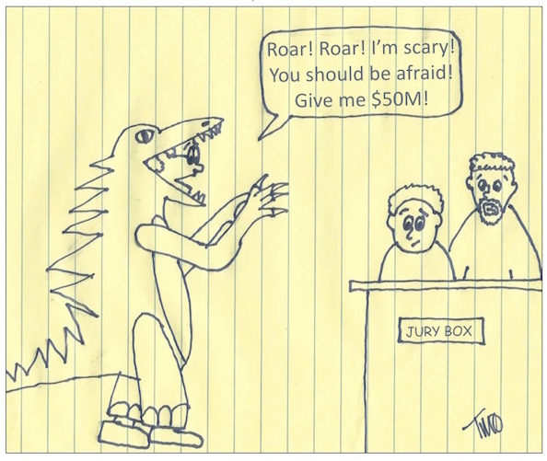
Background of the case

Linda K. Ross, A Southern California attorney filed a lawsuit against GTE California (now Verizon) for being listed in its GTE Yellow Pages directory under the heading of "Reptiles."

The lawsuit seeks damages in excess of $100,000.00 and alleges that the attorney became the target of jokes, rude telephone calls, people making hissing sounds in jest, and suffered other forms of ridicule and embarrassment.

It appears as though GTE inadvertantly listed the attorney under the heading of "Reptiles" in its December 1999 Yellow Pages due to the fact that the attorney's telephone number was previously issued to a recently defunct business named the "Reptile Show."

Somehow GTE forgot to update its records.

How would you rule on this?

