How the battle of Bosworth was lost
Archaeology Correspondent, David Keys
Wednesday 28 October 2009 18:09 GMT

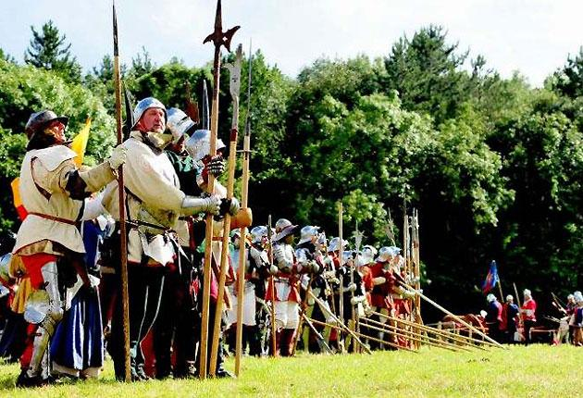

The history books on one of Britain’s most important battles will have to be re-written. The bad news for scholars is that the Battle of Bosworth Field, which marked the end of medieval England, didn’t take place where historians thought it did. But the good news is that the mistake has saved the battlefield from being looted and destroyed by metal detectorists.

Using documentary evidence (including previously unknown manuscripts), place names, soil and peat analysis (to determine where medieval marches existed), and an archaeological metal detecting survey, a team of experts from Britain’s main battlefield archaeology organization, The Battlefields Trust, has now succeeded in finding the real location of Bosworth Field.

Their research shows that the battle took place approximately two miles southwest of the site traditionally associated with it.

But they are not revealing the exact location, for fear of its being raided by unauthorized metal detectorists.

The archaeological metal detecting survey is continuing and the battlefield trust hopes to use the emerging evidence to help reconstruct exactly how the battle was conducted.
Advertisement (1 of 1): 0:02

Skip

The Battle of Bosworth Field was the final military encounter of the Wars of the Roses. Fought in 1485 between Richard III and Henry Tudor (who was crowned Henry VII after the battle), it ushered in the Tudor age and is usually seen as marking the end of the medieval period in England.

For more than 200 years, historians had thought that the battle was fought around Ambion Hill, west of the Leicestershire village of Shenton. Then in the 1980s and 1990s, various scholars proposed several other nearby sites.

So, in 2005, in order to clarify the situation, the Heritage Lottery Fund provided £154,000 to the Battlefield Trust for a 4 year investigation to investigate where the real battlefield was.

Earlier this year – at a location not previously proposed - the Trust’s archaeologists found what they believe to be the core of the battlefield. Work will now continue to define the edge of this late 15th century area of killing fields.

So far, the archaeologists have found dozen s of pieces of military material left over from the battle. They include 19 items of artillery shot, three items of handgun shot and fragments of swords, bridle fittings, spurs – and even three coins almost certainly lost by combatants during the battle.

Most of the artillery shot are between 23 millimetres and 65 millimetres in diameter – but there was one very large ball, 93 millimetres in diameter and weighing 7.2 kilos. Covered in a layer of lead, most of the shot was made of stone. They appear to have been fired form 6-12 artillery pieces located at two positions.

Experts in medieval gunnery suspect that the artillery played a role at the beginning of the battle – but may have become less useful tactically as the battle progressed. It was notoriously difficult to turn the artillery pieces round to face new directions – so adapting to the progress of the battle would have been difficult for these early gunners. Their artillery pieces and carriages would probably have weighed between 400 and 1000 kilos each.

The finds are important because they represent by far the largest collection of 15th-16th century artillery shot ever found in Europe. The continuing investigations should help reveal whether Henry had artillery as well as Richard. History only reveals Richard as having big guns. Archaeology may now demonstrate that they both did.

Now Leicestershire County Council is planning to change some aspects of its Bosworth battlefield visitor centre to take account of the new discoveries – and the change in battle field location.
However, although the new location is not covered by the visitor centre and associated country park, the newly discovered battlefield site is visible from the top of Ambion Hill some 300 metres from the visitor centre.

The County Council is also working with the police to protect the as yet undisclosed battle field location. Archaeologists say that the reason that medieval military material remained on the battlefield is that its location was not known up till now – and has therefore not attracted attention from metal detectorists.

The newly discovered location will be announced sometime next year – and negotiations with land owners may allow some public access through existing rights of way.

The real site of the battle was only found at the very end of the four year investigation. “For more than a year we had hints we were close to the action but it was only in the last week of planned field work, in the last possible area, that the critical evidence was found,” said archaeologist Glenn Foard of the Battlefields Trust

Is this the field where Richard III lost his kingdom for a horse? Real location of Battle of Bosworth finally revealed after 500 years
By Daily Mail Reporter 19 February 2010
Dug out of the ground after more than 500 years, this perfectly preserved tiny silver badge has finally pinpointed the exact site of the battle which decided the Wars of the Roses.
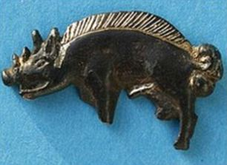
The 1.5in decoration proved to archaeologists where the Battle of Bosworth had actually taken place and it was in a field a mile from where historians have always believed it happened.
The most famous battle of the War of the Roses was fought on August 22, 1485, and famously saw the death of Richard III.

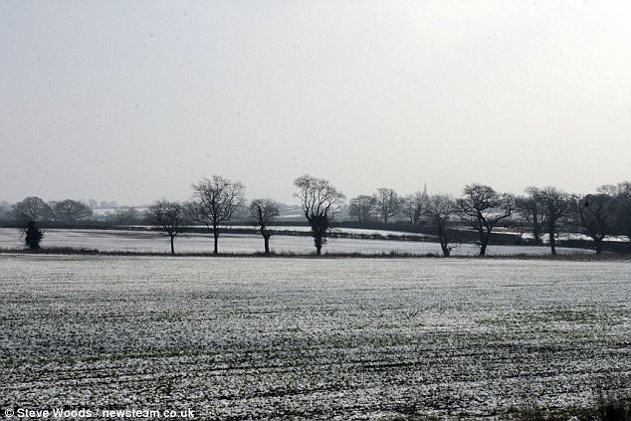

Pictured is the true site for the Battle of Bosworth which has been found.
It is in this field, where the treeline is, where Richard III is believed to have been killed in battle. The 1.5in boar badge was found there. The king's personal emblem is believed to have been given to one of his knights before their final stage
The marshy ground at Fen Hole where the badge (below) was found. In the 16th century Holinshed Chronicles (top of picture) it refers to 'Betweene both armies there was a great marish then...'
The battle ended decades of civil war and was won by the Lancastrians.
It paved the way for Henry Tudor to become the first English monarch of the Tudor dynasty.
The battle also inspired the scene from Shakespeare's play Richard III when the defeated hunchback king declares: 'A horse, a horse, my kingdom for a horse'.
The current site has a stone to mark the spot where Richard fell.
Historians originally thought the battle took place on Ambion Hill, near Sutton Cheney, Leics., and a stone memorial supposedly marks the spot Richard III died.
However, debate has raged for centuries over the exact location of the battlefield.
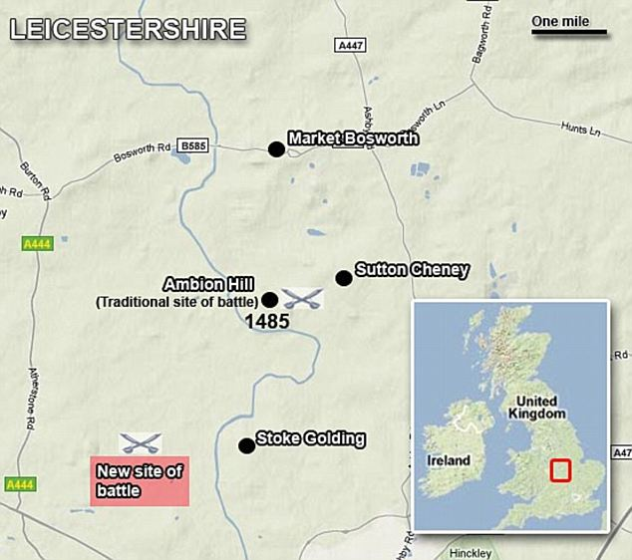
So four years ago the Battlefield's Trust spent £1million excavating dozens of nearby fields in a bid to end the argument once and for all.
Last October it was revealed the battlefield was not where it was originally thought - but the location was kept secret for fear of 'night hawkers' raiding the site for treasure.

But today experts revealed the exact location is a field behind Fenn Lane Farm which belongs to an arable farmer.

The new location was revealed after archaeologists discovered a hoard of medieval weapons in the field, including the silver white boar badge believed to have been carried by one of Richard's trusted knights.

Evidence such as cannon balls - now the largest collection of that date in Europe - and pieces of armour have been used to confirm the site.

A 16th-century historian recorded that Richard was 'killed fighting manfully in the thickest press of his enemies'.

Furthermore that he died fighting to the last, not calling out 'A horse, a horse, my kingdom for a horse', as Shakespeare claimed, but, in the words of a near-contemporary chronicler: 'Treachery, treachery, treachery.'

University lecturer Carl Dawson discovered the badge next to a medieval marsh which experts say was the exact location Richard was dragged from his horse and killed.
Researchers also found 22 lead shots fired by hand-held guns and from the largest cannon used during the battle.

But it was the silver white boar badge - an emblem of Richard III - which proved to be the key in pin-pointing the battlefield.

Measuring just 1.5in the badge would almost certainly have been worn by the king's knights during his last stand.

Archaeologist Dr Glenn Foard, who led the search for the battlefield, said: 'If we were looking for any artefact at all and if there's any location we might want to find that artefact, then it's the white boar badge of Richard III next to the marsh.
'This is almost certainly from a knight in Richard's retinue, who rode with him to his death on that last charge.'

The Battle of Bosworth Visitor Centre, which is a mile away from Fenn Lane Farm, will remain where it is but will lead vistors on a new trail to the battlefield.

Richard McKinder, operations manager for the site, said: 'A lot of American battlefields have had to move their interpretation centres because they are actually destroying what they are trying to interpret.

'We are within walking distance of the battlefield therefore they can use us as the main area for interpretation and then go and see the field itself.

