Monroe and the Florida Crisis

Spain's claim to Florida had long been a thorn in the side of James Monroe, especially after his fruitless months in Madrid trying to convince the Spanish government that France had included much of the land in the Louisiana Purchase.

Florida was a problem for the United States for three reasons:

1. While Spain owned the land, they did little to control it. As a result, Florida was a hotbed of British pirate activity.

2. Runaway slaves kept escaping from plantations in the South into Florida, where American authorities could not legally go after them.

3. Florida was a problem was that a Native-America tribes called Seminoles living in Georgia and Florida were being encouraged by the British privateers to committing raids in Georgia.

To deal with the Seminoles, Monroe sent General Andrew Jackson into Georgia. Jackson, true to his reputation, went beyond the President’s order and invaded Florida and captured the British responsible for encouraging the raids and hanged them. He seized two Spanish forts in direct violation of international law and his orders from Washington. This creating a diplomatic crisis as both Spain and Britain had reason to be upset. Secretary of State John Quincy Adams argued that Jackson did the right thing because Spain wasn’t doing enough to control its colony.

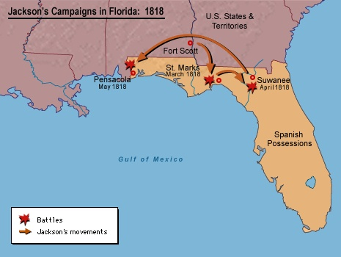

Monroe's cabinet split on whether to reprimand Jackson, Crawford and Calhoun wanted a reprimand but the expansionist-minded Adams pushed for a more ambitious move.

Eventually, Monroe quietly returned the captured posts to the Spanish, but in doing so, he put the European country on notice that his forces could readily storm the territory when needed. He then began treaty negotiations with Spain and a year later with the threat of war hanging over Spain, the Adams-Onis Treaty set the new boundaries for Spanish territory in America. The Spanish, realizing they risked losing the land anyway without compensation, agreed to settle for up to five million dollars in claims on the land. The treaty also definitively set the border with Mexico.

Adams-Onis Treaty

In the provisions, the United States ceded to Spain its claims to Texas west of the Sabine River. Spain retained possession not only of Texas, but also California and the vast region of New Mexico. At the time, these two territories included all of present-day California and New Mexico along with modern Nevada, Utah, Arizona and sections of Wyoming and Colorado.

The treaty -- which was not ratified by the United States and the new republic of Mexico until 1831 -- also mandated that Spain relinquish its claims to the country of Oregon north of the 42 degrees parallel (the northern border of California). Later, in 1824, Russia would also abandon its claim to Oregon south of 54’40,’ (the southern border of Alaska.)
