LEIF ERIKSSON

Norse explorer Leif Eriksson, the second son of Erik the Red, is regarded as the first European to reach North America. Eriksson never colonized the land he discovered, and he would never return to it once he headed back to Greenland after the winter was over.

Background

Leif Eriksson was born shortly before 1000 A.D. Exploration was apparently in his family blood, as he was the second of three sons of Erik the Red, who was the founder of the first European settlement on what is now Greenland. Eriksson's story has been told in several accounts, but which is true is not easily decided.

North America Awaits

By most accounts, Eriksson sailed from Greenland to Norway in 1000 and converted to Christianity under the guidance of the Norwegian king Olaf.

The following year, Olaf sent Eriksson to Greenland to spread Christianity to the settlers there. Eriksson made it to Greenland but his ships went off course on the return voyage home, finding dry ground at last on the North American continent.

What is now Nova Scotia is most likely where he landed, and he named this new land Vinland (perhaps because of the wild grapes his landing party saw there). Other accounts suggest that Eriksson had heard about "Vinland" from other seamen who had been there over a decade before, perhaps traders, and he headed there on purpose.

Whatever his reason, he is regarded as the first European to set foot on the shores of North America, nearly five centuries before Christopher Columbus would arrive in 1492. According to 13th and 14th century Icelandic accounts of his life, and others that would follow, Eriksson was certainly a member of an early Viking voyage to North America.

Return to Greenland and Legacy

Eriksson never colonized the region. He left at the end of the winter and never returned. Thorvald, one of Leif Eriksson's brothers, later revisited Vinland. Back home in Greenland, Eriksson spent his efforts spreading Christianity. His mother built Greenland's first Christian church.

The exact location of Vinland is not known, but in 1963, ruins of a Viking-type settlement were discovered at L'Anse-aux-Meadows, in northern Newfoundland. The site has been labeled the oldest European settlement in North America, and more than 2,000 Viking objects have been recovered from it.

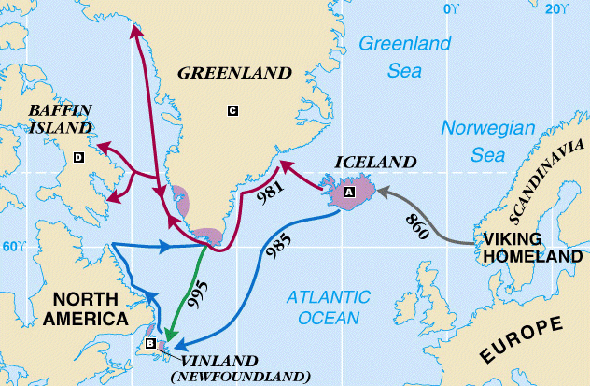

LEIF ERIKSSON

- Where do you think Leif got his desire to explore?

- Why did King Olaf send Leif Eriksson on a mission to Greenland?

- How did Leif end up in North America?

- How did the land he discovered get the name “Vinland?”

- Where did historians find evidence that Eriksson landed in North America

- Why do you think there is some doubt about Eriksson’s voyage to North America? (your opinion)

