LAW CLASS
COURT CASES
Kelly v City of Duluth (2001)
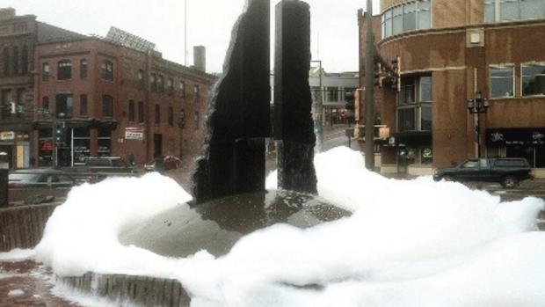
Background of the case
Sometime between 5 and 6 in the Saturday morning of July 7, 2001, a prankster put gallons of Joy dish soap into Duluth’s Fountain of Wind, turning it into an eight-foot-high mass of bubbles.
57-year-old Kathy Kelly walked through the bubbles, fell and cut her leg. As a diabetic, Kelly incurred $43,000 of medical expenses from the cut, which turned gangrenous.
Kelly sued the city because it had not cleaned up the suds or posted warning signs, despite the fact that municipal workers had received a call concerning the hazard some four hours earlier. She said the city didn’t clean up the fountain quickly enough or warn people not to walk into an eight-foot high mass of soap bubbles where they couldn’t see where they were walking.
“People shouldn’t have to be on their guard when they are taking a step,” explained her lawyer.”
"We got pranked," said Terry Groshong, architect for the city of Duluth. "We don't like it, but we can't control it much."
It took two plumbers about two hours to clean up the mess and make sure the fountain system was working properly.
The gag happens at Duluth water fountains four to six times a year -- and usually coincides with the start and end of the college school year, Groshong said. Of the seven city water fountains, Canal Park's Fountain of Wind and the Priley Fountain at the city's Civic Center are the most targeted.

How would you rule on this?

