JACQUES CARTIER biography
Jacques Cartier, the French navigator, established his country’s claim to present-day Canada.
Childhood and beyond
Cartier was born in a French seaport town. He studied navigation. His early activities remain somewhat unclear, but some historians believe he may have accompanied fishermen to Newfoundland in the 1520s. It is also possible that Cartier sailed with Verrazzano on one of his voyages.
France wants to explore
Cartier made his first documented voyage to the New World in 1534 under the rule of King Francis I.
Motivated by the fabulous wealth being discovered by the Spanish, France hoped to do the same elsewhere in the Americas. Cartier’s ships sailed around the northern tip of Newfoundland and along its western coast into the Gulf of St. Lawrence. Cartier landed and claimed the area for France.
The explorers became friends with native inhabitants and received reports from them about the existence of gold and jewels farther inland. On the return voyage to France, Cartier took two Indian boys and a supply of maize (corn), probably the first of that crop to reach Europe.
Cartier’s first voyage helped to change the French conception of North America. It had been widely believed that the area’s only value lay in its fisheries. Cartier’s report, however, described fertile lands and the possibility of mineral wealth.
Cartier Makes a Second Voyage
A second voyage began in 1535. After returning his young Indian guests to their homes, Cartier began to explore the St. Lawrence River. He pushed up river to a native village at the base of a large mountain, which he named Mont Real (later Montréal). With winter approaching, Cartier sailed down the river and established a camp at the eventual site of Québec. The party returned to France the following spring.

His third trip
In 1541, a new venture was formed. Cartier returned to the St. Lawrence. After leaving a small group at Québec to establish a settlement, Cartier led a useless search for gold. An already uncomfortable winter at camp was further marred by Indian attacks. In the spring, Cartier’s force began the return voyage to France..

Cartier’s contributions
Cartier, despite his contributions to a better understanding of North American geography, was regarded as a failure. No gold was discovered and no lasting settlements were created. The areas he explored would remain largely untouched by Europeans until over 60 years later

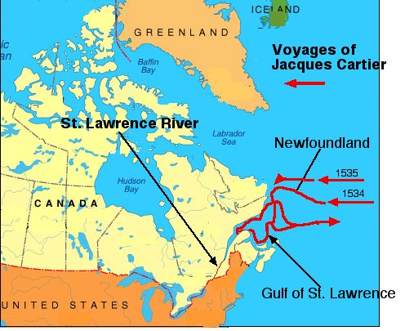

Jacques Cartier biography

- Who were the early influences on Jacques Cartier?
2. Which French King sponsored his trip?
3. Why was France interested in exploring?

4. How did Cartier’s first voyage change the way the French thought about North America?

5. How does Cartier’s relationship with the Indians differ from what we learned about the Spanish?

6. Which two settlements (towns) did Cartier help to establish?

7. Why was Cartier considered a “failure?”

