How the Search for Flavors Influenced Our World

Medicine and medieval tastes created a market for the world's first product to be traded around the world.

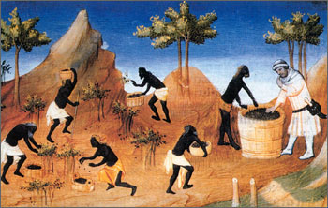
Harvesting pepper south India in the 14th Century

Introduction

The control over gold, silver, metals and oil has been a source of conflict. However, other products also inspired exploration, war, conquest which led to a world trading system. One such product comes in small bottles and packages on the shelves of supermarkets and corner markets: spices.

Spices once created a world-wide trade system, other items have followed a similar path, and many of these products have also faded in popularity.

Spices were prized goods in the Middle Ages

High prices and a very small supply brought forth a growing effort to discover spices and their source. The desire for spices helped create European colonial empires.

Historians know a fair amount about the supply of spices in Europe during the medieval period - the origins, methods of transportation, the prices

Why were spices popular?

Demand was great enough to inspire the voyages of Christopher Columbus and Vasco Da Gama. This was the first wave of European exploration.

Why were spices so highly prized in Europe in the centuries from about 1000 to 1500?

- They covered the taste of spoiled meat.

Spices were more expensive than meat. Butchers were not allowed to throw unwanted animal parts and blood in the streets. They could seel bad meat if they dipped them in spices! YUMMY!

- They could preserve meat.

People at meat much fresher than what the average city-dweller in the world of today has at hand. They had to eat it right away because refrigeration was not available. Spices allowed me to be eaten later without going bad.

- Spices could be used as a cure

Some hot spices have been shown to serve as an anti-bacterial agent. Most spices used in cooking began as medical ingredients, and throughout the Middle Ages spices were used as both medicines and condiments.

Above all, medieval recipes involve the desire to prevent disease. Most spices were hot and dry and so appropriate in sauces to counteract the moist and wet properties supposedly possessed by most meat and fish.

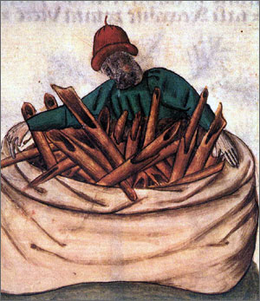
Cinnamon :
Valued for making food taste better but also for healing disease

How were spices used?

More than 100 medieval cookbooks survive today.

In one such book, written for the king of Naples, there are about 200 recipes, 154 of which call for sugar, 125 require cinnamon, 76 ginger, and 54 saffron.

Spices ordered for the wedding of the Duke of Bavaria in 1475 included 386 pounds of pepper, 286 pounds of ginger, 257 pounds of saffron, 205 pounds of cinnamon, pounds of cloves, and 85 pounds of nutmeg.

Clearly, recipes from the era called for not only large quantities of spices, but also a great variety.

- Spices such as cinnamon or nutmeg associated with desserts were used in meat and fish dishes.

- Sugar functioned as a spice during the era.

Where did spices come from?

Where spices came from was known centuries before the voyages of Columbus.

To the medieval European imagination, the East was a strange, unknown place.

People felt spices were very hard to obtain.

- An example is the conflicting information about how pepper is harvested. Europeans thought that pepper in India grew on trees "guarded" by serpents that would bite and poison anyone who attempted to gather the fruit. The only way to harvest pepper was to burn the trees, which would drive the snakes underground.

- Spices in Europe were affected by the weather

SPICE ROUTES

This is the land route for getting spices. Caravans of pack animals which traveled over land could take more than 2 years to complete a round trip

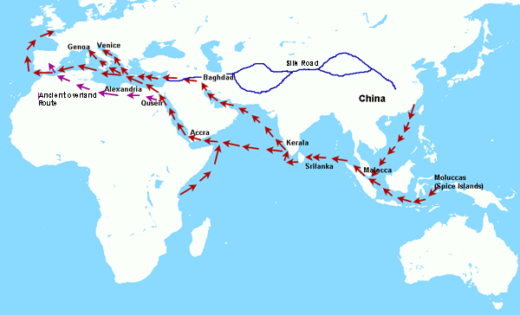

Why would this have been a dangerous trip?

SEARCHING FOR SEA ROUTES:

Why would anyone think they could sail around Africa?

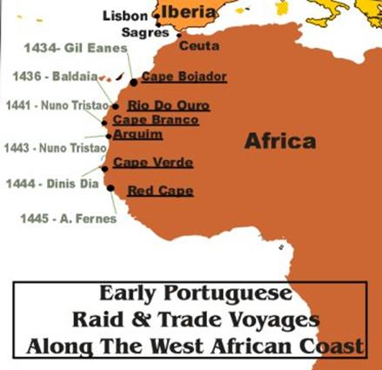
This is an early map of Africa drawn by Portuguese sailors who traded and fought with coastal settlements

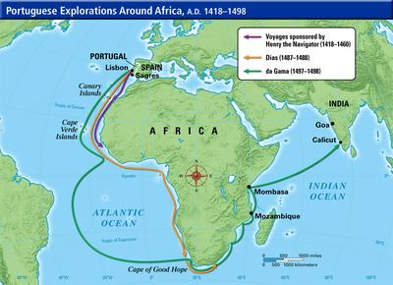

How did explorers eventually find their way to India?

HOW THE SEARCH FOR FLAVORS INFLUENCED OUR WORLD

- Why were spices so popular?
2. How were spices used on meat?
3. What did people use to keep meat fresh without refrigeration?
4. What value did "HOT" spices have?

5. Did people eat more meat back then or today?
6. In what way was spice considered to be medicinal (having medical uses)?

7. Name a few spices found during this time.

8. What scary stories existed about the way pepper was harvested?
TURN OVER TO THE BACK

9. Look at the map of the LAND spice routes and tell why these routes were dangerous.

10. Look at the SEA routes the Portuguese eventually used and tell why they were dangerous.

