HENRY HUDSON biography

Henry Hudson made two unsuccessful sailing voyages in search of an ice-free passage to Asia. In 1609, he went on a third voyage funded by the Dutch East India Company that took him to the New World and the river that would be given his name. On his fourth voyage, Hudson came upon the body of water that would later be called the Hudson Bay.

Early Life

Considered one of the world's most famous explorers, Henry Hudson actually never found what he was looking for. He spent his career searching for different routes to Asia, but he ended up opening the door to further exploration and settlement of North America.

There is little information about the famous explorer's life prior to his first journey in 1607. It is believed that he learned about sailing from fishermen. Prior to 1607, Hudson probably worked aboard other ships before being given on his own.

First Three Voyages

Hudson made four journeys in his career—a time when countries competed with each other to find the best ways to reach Asia and India.

In 1607, the Muscovy Company, an English firm, hired Hudson to find a northern route to Asia. Hudson brought his son John with him on this trip, as well as Robert Juet. Juet went on several of Hudson's voyages and recorded these trips in his journals.

Despite leaving in Spring, Hudson and his crew battling icy conditions. They had a chance to explore some of the islands near Greenland before turning back. But the trip was not a total loss, as Hudson reported numerous whales, which revealed a new hunting area.

The following year, Hudson set sail in search of the Northeast Passage. Hudson sailed into the Arctic Ocean to the north of Russia. But he could not travel further, blocked by thick ice. Hudson returned to England without achieving his goal.

In 1609, Hudson joined the Dutch East India Company. He took charge of the ship Half Moon sailing a route north of Russia. Again ice put an end to his travels, but this time he did not head for home. Hudson decided to sail west to seek western passage.

Crossing the Atlantic Ocean, Hudson reached land coming ashore at what is now Nova Scotia. They met local Native Americans and were able to make some trades with them

Traveling down the North American coast, Hudson went as far south as the Chesapeake Bay. He then turned around and decided to explore New York Harbor, an area discovered by Giovanni da Verrazzano in 1524. Hudson and his crew clashed with some local Native Americans. Hudson traveled up the river that would later carry his name. Along the way, Hudson noticed that the lush lands that lined the river contained abundant wildlife. He and his crew also met with some of the Native Americans living on the river's banks.
On the way back to the Netherlands, Hudson stopped in the England. English authorities seized the ship. Upset that he had been exploring for another country, the English authorities would not allow Hudson to work for the Dutch again. He kept trying to find the Northwest Passage. This time, Hudson found English investors to fund his next journey.

Final Journey

Aboard the ship Discovery, Hudson left England in 1610. He and his crew, which again included his son John and Robert Juet, made their way across the Atlantic Ocean. After passing Greenland, they entered what became known as the Hudson Strait. The exploration then reached a huge bay. Traveling south, Hudson found he had come to a dead end.

Hudson argued with his crew. They were trapped by ice and low on supplies. When they were forced to spend the winter there, tensions grew more intense. By June 1611, conditions had improved enough for the ship to set sail once again. Hudson, however, didn't make the trip back home. Several members of the crew, including Juet, took over the ship and cast out Hudson, his son and a few other crew members. Hudson was put in a small boat and set them adrift. It is believed that Hudson and the others died of exposure sometime later. Some of the mutineers were later put on trial, but they were acquitted.

More European explorers and settlers followed Hudson', making their way to North America. The Dutch started a new colony, called New Amsterdam, at the mouth of the Hudson River in 1625. They also developed trade posts along the nearby coasts.

While he never found his way to Asia, Hudson is still widely remembered as a determined early explorer. His efforts helped drive European interest in North America. Today his name can be found all around us on waterways, schools, bridges and even towns

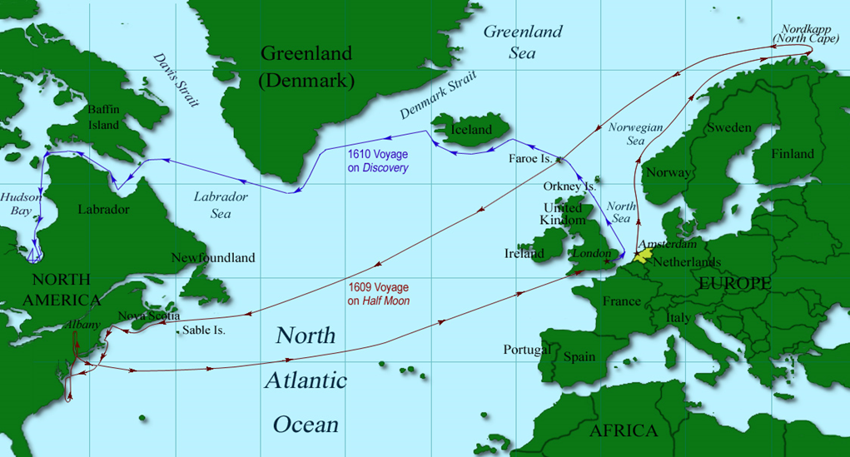

HENRY HUDSON biography

1. What do we know about Hudson's early life?

2. Who hired Hudson in 1607? Why did they hire him?

3. What happened on the first voyage?

4. Where did he go on his second voyage?

5. Why did the Dutch hire Hudson?

6. How did his third voyage differ from the others?

7. What places did Hudson see on his third voyage?

8. Why did Hudson get in trouble with the English?

9. What happened to Hudson on his final voyage?

10. How did his voyages affect Dutch exploration?

