FRENCH AND INDIAN WAR

The Colonies in America

People from Europe began coming to America to live. Spain, France, Sweden, Holland, and England claimed land.

The first French settlement was Quebec. It was a large settlement but little more than a trading center, like most other French settlements.

The first permanent settlement in North America was the English colony at Jamestown, in what is now Virginia. John Smith and company had come to stay. The Pilgrims set up a colony at Plymouth, in what is now Massachusetts. Other English colonies sprang up all along the Atlantic coast, from Maine in the north to Georgia in the south. France, meanwhile, was taking control of most of Canada. English interests came into conflict with French interests. Disputes arose over the Ohio Territory and parts of Canada. War was approaching.
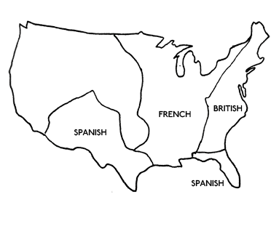

At first glance, it looked like a mismatch. English troops outnumbered French troops almost 2-to-1. English colonies had their own fighting armies called militias and produced their own food. French settlements had to rely on soldiers hired by fur-trading companies and food from the homeland.

On the other hand, French forces were controlled by a single government and had settlements that were close together and, therefore, more easily defended. Each English colony had its own assembly government, and the colonies often argued with one another over simple things
The Beginning of the War

In the early 1750s, French troops arrived in the Ohio Valley. They built a series of forts just west of the Appalachian Mountains. One of the more famous of these was Fort Duquesne. In 1754, a small battle started the war.

Colonel George Washington headed a small force of 150 English soldiers who had been ordered to capture Fort Duquesne. The fort, of course, was guarded by a lot more than 150 men. Washington's men fired on a French patrol but had to retreat. They built a crude structure named Fort Necessity. A large French force surrounded this "fort" and forced Washington to surrender. They sent him back to Virginia with a message that the Ohio Territory was French territory.

The English responded in force. General Edward Braddock, accompanied by Washington, marched on Fort Duquesne. It was a disaster. While the English troops marched in straight lines, the French troops and their Native American allies fired from behind rocks and trees. This was hugely successful. Braddock himself was killed in the July 9, 1755 battle.

William Pitt, took over. His strategy for winning the war: take Canada.

The English Take Control

The battleground became Canada, and the struggles were fierce. Lake Champlain became a main battleground. In 1757, the French seized Fort William Henry, at the southern end of the lake. The fort was important because it gave the holder command of the Hudson River and northern New York. It also protected the two other Lake Champlain forts, St. Frederic and Ticonderoga.

French success, however, did not last long. The English, under Jeffery Amherst and James Wolfe (their two most successful commanders), seized the island fortress of Louisbourg.

In the same year, 1758, British troops captured Fort Frontenac, on Lake Ontario, the main supply center for French forces in the Great Lakes area. French troops were now completely cut off from reinforcements of food, troops, and weapons.

The next year, 1759 brought a huge event: a British victory at Quebec, the French headquarters of Canada. The Battle of Quebec was an major struggle. The French had thought that they were safe in their fort high on a cliff, surrounded by easily defensible plains and the sea. Instead, British troops had somehow climbed the 300-foot-tall cliffs under cover of night and. French commander the Marquis de Montcalm sent his troops out onto the Plains of Abraham to do battle, and the English troops prevailed.
Victory and Lessons Learned
The Battle of Quebec was a British victory but General James Wolfe was killed in the battle. His assistant, Jeffery Amherst, continued to press the attack, sailing down the St. Lawrence River to attack Montreal, the last French stronghold. The result was another British victory. The French surrendered Montreal.
Scattered fighting continued throughout Canada for the next few years, but the war was basically over. The Treaty of Paris was signed in 1763, and France gave up all claims to Canada.

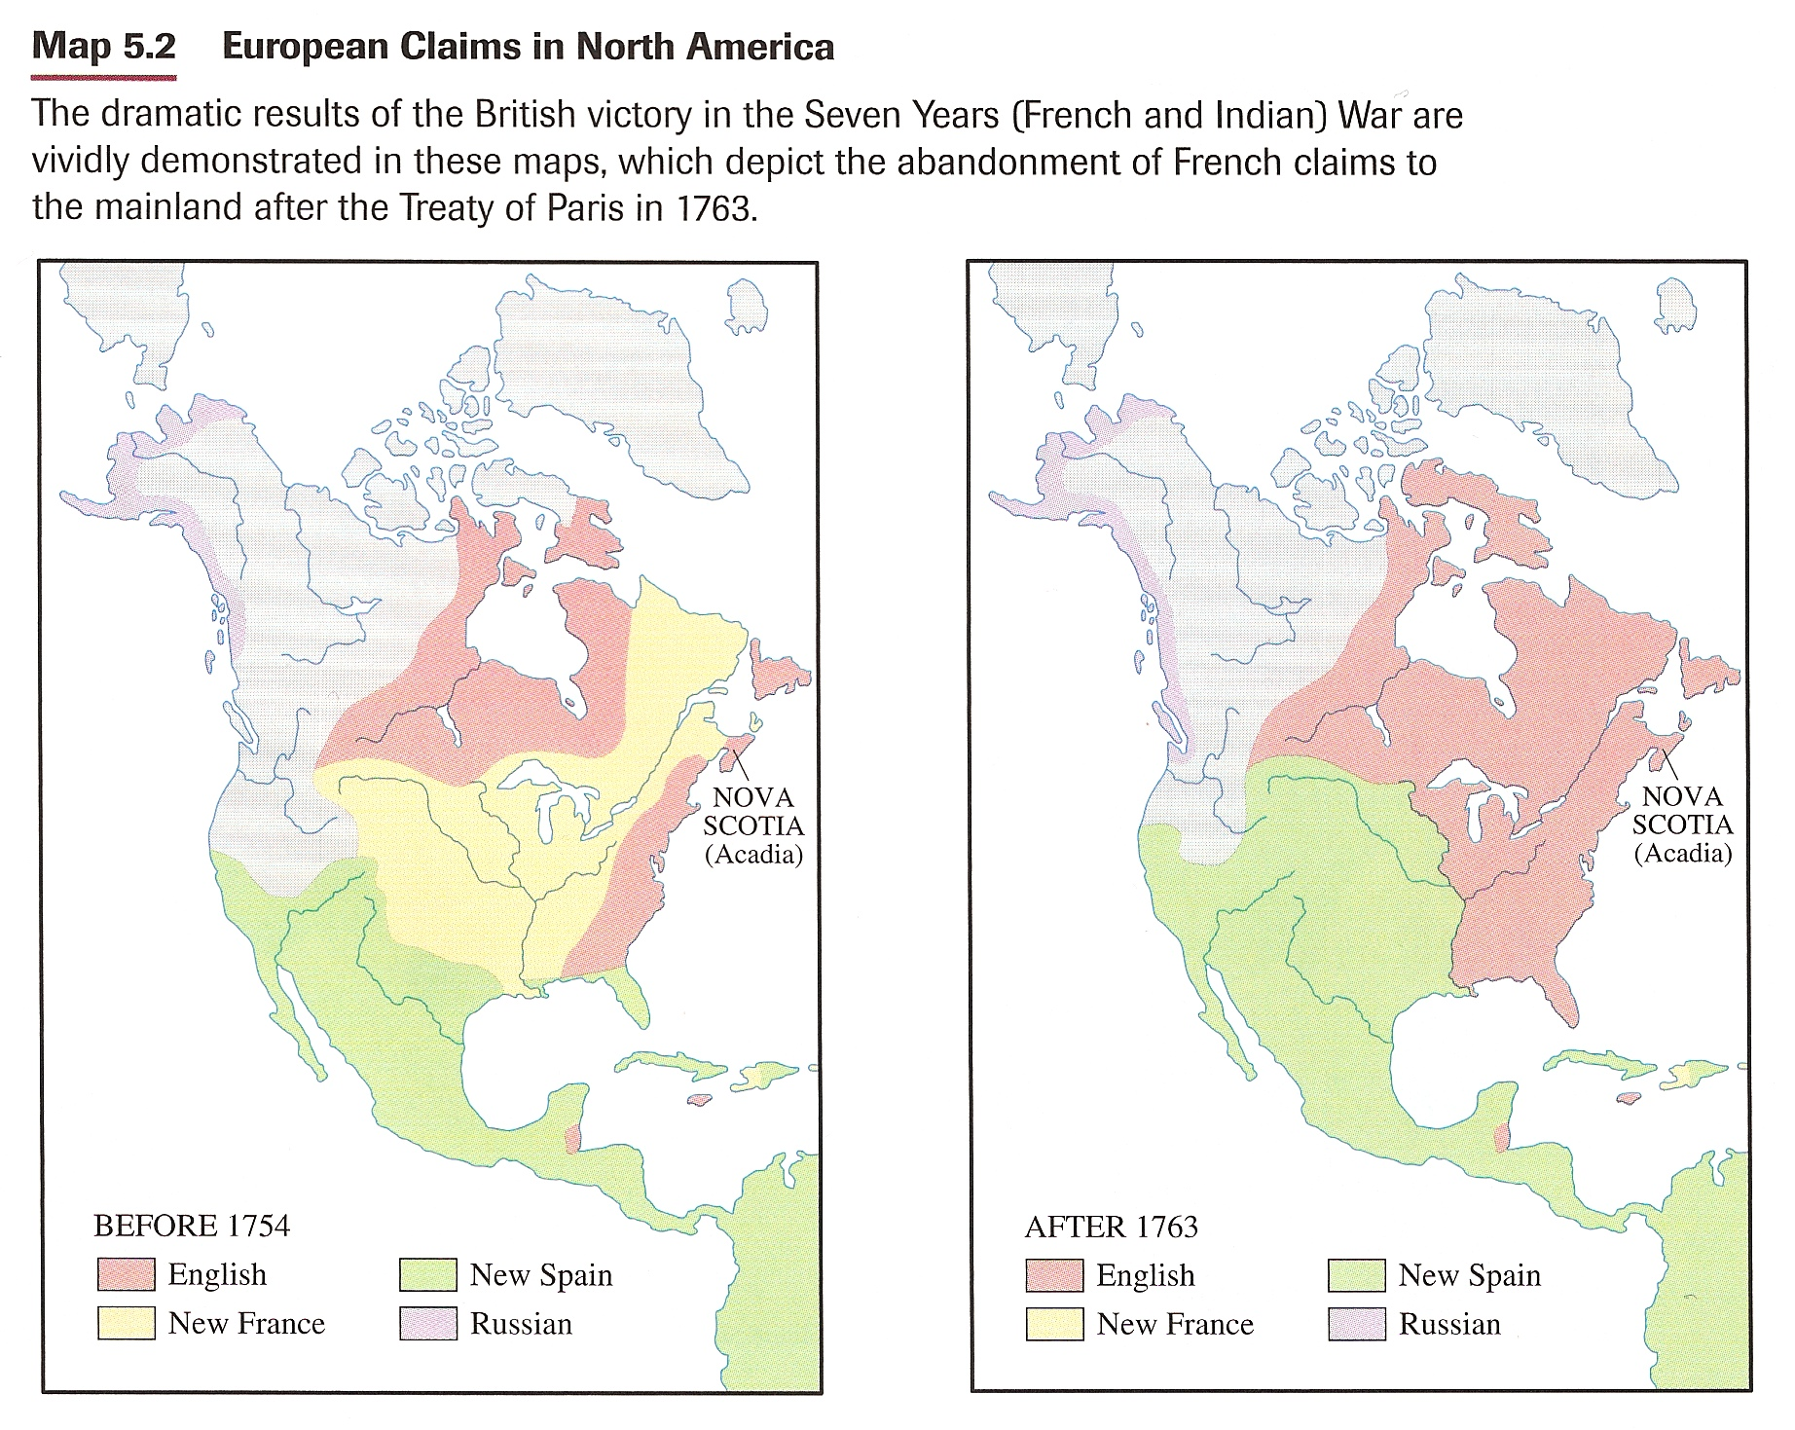

To finance the war, England had gone into debt. Since the war was fought to protect the borders of the American colonies, the English government decided to make the Americans pay for most of that debt. This created problems in America.
The French and Indian War, as Americans called it, showed the American colonists how powerful the English army and navy could be. It also showed how vulnerable these same troops could be. The Americans noticed the effectiveness of the tactics used by the French and Native Americans. When the British tried to keep the American colonies from rebelling in 1775, the British troops faced the same kind of tactics.

