Execution of King Charles
An Examination of Primary Sources
In August 1648 King Charles I was taken prisoner.
General Henry Ireton demanded that Charles was put on trial. Oliver Cromwell had doubts about this and it was not until several weeks later that he told the House of Commons that
"the providence of God hath cast this upon us". Once the decision had been made Cromwell "threw himself into it with the vigour he always showed when his mind was made up, when God had spoken".
In January 1649, Charles was charged with "waging war on Parliament." It was claimed that he was responsible for "all the murders, burnings, damages and mischiefs to the nation" in the English Civil War.
The jury included members of Parliament, army officers and large landowners. Some of the 135 people chosen as jurors did not turn up for the trial. For example. General Thomas Fairfax, the leader of the Parliamentary Army, did not appear. When his name was called, a masked lady believed to be his wife, shouted out, "He has more wit than to be here."
This was the first time in English history that a king had been put on trial. Charles believed that he was God's representative on earth and therefore no court of law had any right to pass judgement on him. Charles therefore refused to defend himself against the charges put forward by Parliament. Charles argued, Parliament had no legal authority to arrange his trial.
Charles was given his last opportunity to defend himself against the charges. When he refused he was sentenced to death. His death warrant was signed by the fifty-nine jurors who were in attendance.
On the 30th January, 1649, Charles was taken to a scaffold built outside Whitehall Palace. Charles wore two shirts as he was worried that if he shivered in the cold people would think he was afraid of dying. He told his servant "were I to shake through cold, my enemies would attribute it to fear." Charles told the audience: "It is not my case alone, it is the freedom and liberty of the people of England; and do you pretend what you will, I stand more for their liberties. For, if power without law may make laws, may alter the fundamental laws of the kingdom, I do not know what subject he is in England that can be sure of his life, or anything that he calls his own."

Primary Sources
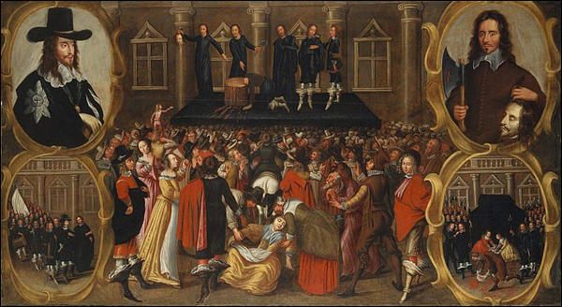(Source 1) The Execution of Charles I of England (c. 1649)

(Source 2) Lucy Hutchinson wrote an account of Charles I's trial. Her husband John Hutchinson was one of those who signed the king's death warrant.
In January 1648, the king was brought to his trial... When he was charged with the blood spilt in the war... he smiled...
His looks and gestures suggested that his only sorrow was that all the people that opposed him had not been killed... Mr. Hutchinson... addressed himself to God by prayer... God did not signal his favour towards the King...... it was therefore his duty to act as he did.

(Source 3) Charles I made a short speech before he was executed. Later, the speech was printed in a news-sheet and distributed all over England.
I never did begin the war with the two Houses of Parliament... They began war upon me... if anybody will look at the dates of what happened... they will see clearly that they began these unhappy troubles, not I... therefore I tell you I am the martyr of the people.

(Source 4) John Lilburne, who was one of the leaders of the Levellers, wrote a pamphlet attacking the execution of Charles I (1649)
I refused to be one of his (Charles I) judges... they were no better than murders in taking away the King's life even though he was guilty of the crimes he was charged with... it is murder because it was done by a hand that had no authority to do it.
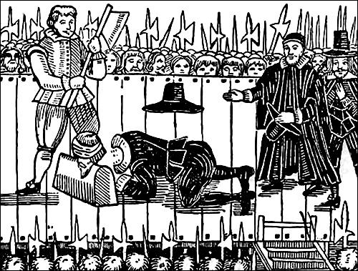
(Source 5) Woodcut of the execution that appeared in The Confession of Richard Brandon (1649)

(Source 6) Extract from a pamphlet on the execution of Charles I that was published soon after his execution.
The King... looking upon the block, said to the executioner... "It might have been a little higher"... The executioner replied, "It can be no higher Sir"... When the King's head was cut off, the executioner held it up and showed it to the spectators.

(Source 7) John Rushworth was one of the fifteen men on the scaffold when Charles I was executed. Later he wrote an account of what happened.
The scaffold was hung round in black... the axe and block was in the middle of the scaffold..."I shall be very little heard by anybody here," began the King, speaking from notes on a small piece of paper he had taken from his pocket... He protested his innocence of beginning the war... Then turning to Colonel Hacker, he asked, "Take care that they do not put me to any pain"... Then the King took off his cloak... the King, stooping down, laid his neck upon the block; and after a little pause, stretching forth his hands, the executioner at one blow cut his head from his body.

(Source 8) Richard Brandon, The Confession of Richard Brandon (1649)
Upon Wednesday last (20th June, 1649) Richard Brandon, the late Executioner and Hang-man, who beheaded his late Majesty, King of Great Britain, departed this life. But during the time of his sickness, his conscience was much troubled, and exceedingly perplexed in mind, yet little shew of repentance, for remission of his sins, and by-past transgressions, which had so much power and influence upon him, that he seemed to live in them and they in him. And upon Sunday last, a young man of his acquaintance going in to visit him, asked him how he did, and whether he was not troubled in conscience for cutting off of the King's head?
He replied, yes! Further acknowledging, That he was no sooner entered upon the scaffold, but immediately he fell a trembling, and hath ever since continued in the like agony. He likewise confessed, that he had 30 pounds for his pains, all paid him in half crowns...
About 6 of the clock at night, he returned home to his wife living in Rosemary Lane, and gave her the money, saying, That it was the dearest money that ever he earned in his life, for it would cost him his life.
Which prophetical words were soon made manifest; for it appeared, that ever since he hath been in a most sad condition.

Questions for Students
Question 1: Why did Charles refuse to defend himself against the charges put forward by Parliament?

Question 2: Select information from the sources that suggest Charles believed that he was not guilty of starting the English Civil War.

Question 3: Study source 8. Why have some historians said that this is a work of pro-Royalist propaganda?

Question 4: Compare the information on Charles' execution in sources 1, 5, 6, 7 and 8. Do you think these sources provide accurate information on the execution?

