CULTURE
A GEOGRAPHIC PERSPECTIVE
Charles A. Heatwole, Ph.D.
Department of Geography, Hunter College

INTRODUCTION
Geography literally means "earth description." It seeks to describe and explain the distribution of phenomena that characterize our planet's surface. In so doing, geography seeks answers to questions that include:
- Where are things located?
- Why are they there?
- What is their significance?
- What is a particular location or region like?
- How and why are some places on Earth alike or different from others?
All told, an amazing variety of attributes characterize our planet. They include physical features such as climates, landforms, and natural vegetation. They also include human beings, their attributes, and their works-such as cities, towns, agriculture, transportation systems, and industries.

GEOGRAPHY AND CULTURE
Culture, the way of life that characterizes a group of people, is one of the most important things that geographers study. There are thousands of cultures on Earth today and each contributes to global diversity. One reason for the existence of so many cultures is that there are so many ways that Earth's 6.3 billion people can be culturally different. Specifically, a culture consists of numerous cultural components (see list below) that vary from one culture group to the next.

Cultural Components (a partial list)
Religion | Language | Architecture | Cuisine | Technology | Music
Dance | Sports | Medicine | Dress | Gender roles | Law
Education | Government | Agriculture | Economy | Sport | Grooming
Values | Work ethic | Etiquette | Courtship | Recreation | Gestures

For example, language is a cultural component. While some cultural communities use English, others speak Spanish, Japanese, Arabic, or another of the thousands of languages spoken today. Religion is another cultural component, and there are hundreds (if not thousands) of ways that different culture groups practice and are characterized by that trait. Likewise, there is a world of cultural differences with respect to technology and medicine, economic and agricultural activity, and modes of architecture and transportation. Cultural communities may differ in dress, grooming, music, cuisine, dance, sport, etiquette, and other cultural components, all of which make for a culturally diverse world (see Fig. 1).
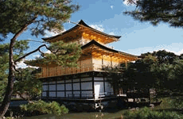 | 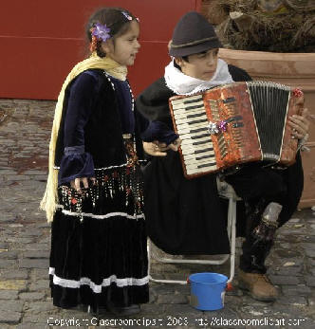
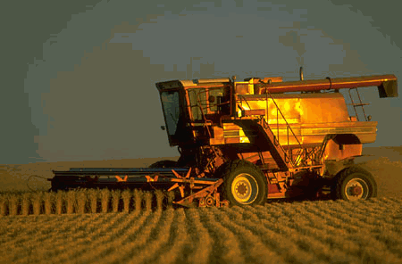 | 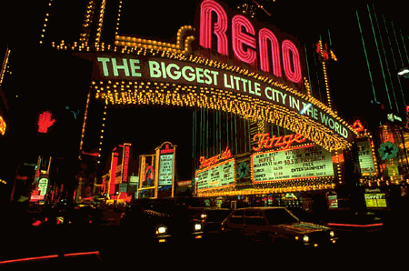
Fig. 1. How many cultural components from the list above can you identify in these four photos?
Cultural components are not limited to humans. Culture characterizes Earth as well; for it is primarily through the agency of their culture that people interact with and modify Earth’s surface. Thus, areas may have different looks and feels that reflect differences in culture. For example, church steeples dominate the skylines of numerous small towns in New York State. Minarets, tall slender towers, dominate similar settlements in the Middle East.

CONCEPTS OF CULTURAL GEOGRAPHY
Because of the innumerable cultural differences that characterize people and land the world over, there is an entire subfield of geography devoted to the study of culture—appropriately named cultural geography. Those concepts are culture region, cultural
landscape, cultural diffusion, cultural ecology, and cultural interaction.

1. What is a Culture Region?
A culture region is a portion of Earth’s surface that has common cultural elements. Identifying and mapping culture regions are significant tasks because they show us where particular culture traits or cultural communities are located. Maps of culture regions provide answers to the most fundamental geographical question: Where?
The concept of culture region serves roughly the same educational purpose as that of historical period. When teaching world history, for example, the subject is commonly divided into time segments that might be labeled The Neolithic Revolution, The Cold War Era, and so forth. The purpose of these arbitrary divisions is to make world history more comprehensible by dividing it into periods that have common themes. Similarly, the purpose of regions (which also are arbitrary) is to make geography—or cultural geography, in this case—more comprehensible by dividing the world into areas that have something in common.
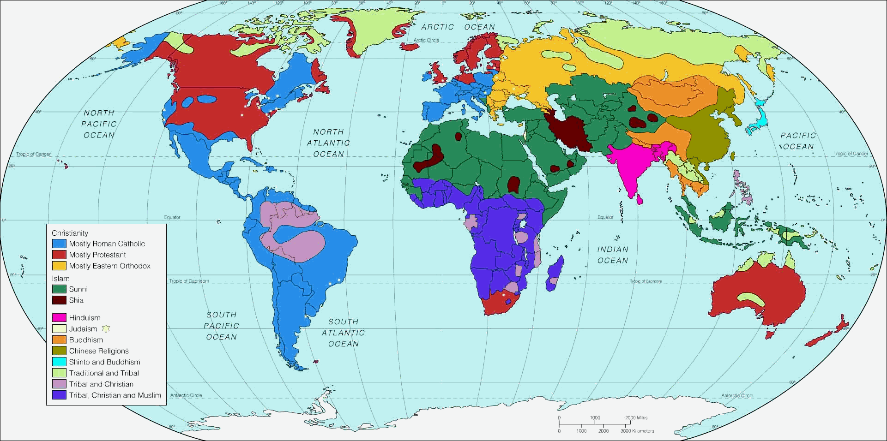
Fig. 2. This world map of religions shows several culture regions. The Hindu culture region in South Asia is an example. Click on the image for a larger scale map.
Culture regions, like cultures themselves, display considerable variety. For starters, any number of cultural components may be used to define culture regions. A map of world religions, for example, includes a shaded area in South Asia where Hinduism is dominant (see Fig. 2).
That is a culture region based on a single cultural component, as are each of the other shaded areas on that map. Similarly, a language map of Europe would show a shaded area where Basque is dominant (see Fig. 3). That also would be a culture region based on a single cultural component. In contrast, if you were learning about Japan, you might look at a list of cultural components and characterize the Japanese culture region with respect to religion, language, architecture, cuisine, and so forth. For comparison’s sake, you might then compare that list to the U.S. culture region, or to the Mexican culture region, or the culture region of some other country.
Culture regions differ greatly in size. Some are exceedingly large, like the Islamic culture region that encompasses millions of square miles of North Africa and Southwest Asia. Some are very small, like Spanish Harlem, which encompasses about two square miles of Manhattan. Many others are of intermediate size, like the Corn Belt, which occupies a portion of the mid-western United States.
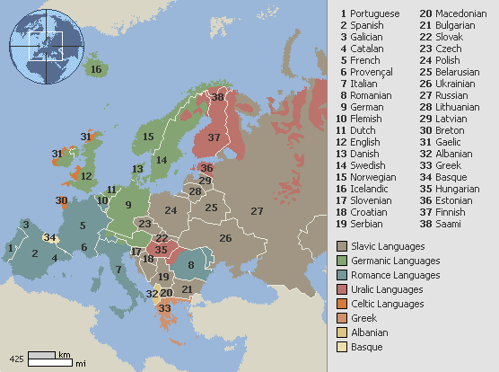
Fig. 3. This language map of Europe shows several culture regions, including the Basque-speaking region (#34 on the map’s legend).
When people see the words Hindu culture region, they may logically infer that only Hindus live there. Not so. That region also is home to millions of Muslims, Buddhists, Christians, and other non-Hindus. Similarly, there are some people in Spanish Harlem who do not speak Spanish, and some farmers in the Corn Belt who do not grow corn. Culture regions tend to exhibit a certain diversity—their titles identify a dominant characteristic (Hinduism, Spanish, corn) but do not necessarily mean that everybody who lives there shares that characteristic. We must understand that diversity typically exists within a culture region through the use of specific examples, to avoid making logical assumptions that are nevertheless wrong.
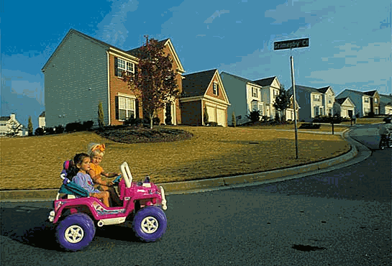
Fig. 4. Several distinctive attributes typify this suburban culture area somewhere in the United States.

Culture regions can be found in urban, suburban, or rural settings. Many cities contain ethnic neighborhoods. Basically, these are urban culture regions whose borders are defined by the locations of specific cultural communities. Different cities around the world have ethnic mixes, however. If you were learning about France, you would discover that Arabs, sub-Saharan Africans, and West Indians comprise large ethnic communities in many cities. In Germany, in contrast, Turks and various Slavic peoples often are the major groups. Urban fringes the world over also exhibit cultural differences.
The typical American suburb exhibits housing, land use, and lifestyles that differ significantly from what is observed on the periphery of cities in West Africa or Central America, for example (see Fig. 4). Rural parts of the world may differ on the basis of language, religion, or some other cultural component—most notably agriculture. Thus, dairy farming and apple growing characterize different sections of rural New York State. Both are visually distinctive and may be thought of as separate culture regions. In contrast, rural culture regions elsewhere in the world might be dominated by cattle ranches, rice fields, banana plantations, or some other form of agriculture.
Fig. 5. New York City’s Chinatown is a product of cultural diffusion.
Over time culture regions tend to appear and disappear, and expand and contract in between. Many millennia ago, for example, there were no human beings in North America. In the course of subsequent migrations, however, different peoples occupied different parts of the continent. As a result, by 1492 North America was a mosaic of Native American culture regions. Many of them have since disappeared or have diminished in size. Similarly, an ancient Phoenician culture region gave way to a Roman culture region, which in turn disappeared. Much more immediately, there are lots of areas and neighborhoods in New York State and elsewhere that are experiencing "ethnic change"—a situation in which one cultural community is expanding or contracting in opposition to another.
Culture unites and divides humanity: while it instills a sense of unity among some peoples, it creates differences (perhaps deep animosities) between others. Accordingly, maps of culture regions may provide important perspectives on contemporary problems that are rooted in cultural differences. For example, Americans have come to appreciate that all Iraqis are not the same. Rather, they are divided mainly into three cultural communities (Sunnis, Shiites, and Kurds) who occupy culture regions that are more or less separate. To a large degree, the future of Iraq is likely to be determined by the extent to which the occupants of those culture regions work together for the common good.
2. What is Cultural Diffusion?
Cultural diffusion concerns the spread of culture and the factors that account for it, such as migration, communications, trade, and commerce. Because culture moves over space, the geography of culture is constantly changing. Generally, culture traits originate in a particular area and spread outward, ultimately to characterize a larger expanse of territory. Culture region describes the location of culture traits or cultural communities; cultural diffusion helps explain how they got there.
For example, New York State generally lies within the English-speaking culture region. Nevertheless there are significant cultural communities within New York State in which Spanish, Chinese, Hebrew, Arabic, or another language is dominant (see Fig. 5). Similarly, while most of New York State is part of the Christian culture region, there also are local cultural communities in which Judaism, Islam, or Buddhism is dominant. What all these languages and religions have in common is that none originated in New York State or even in North America. Rather, each has come to characterize segments of the Empire State as a result of cultural diffusion.
Similar stories apply to other parts of the world. If you were to read about Australia, for example, you would learn that that continent was once the exclusive domain of an aboriginal cultural community. Because of cultural diffusion, however, most of the present-day Australian people and their homeland bear the unmistakable imprint of European culture—particularly, cultural characteristics that diffused from Great Britain.
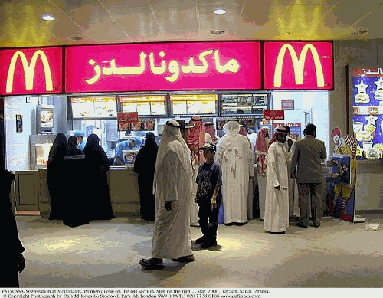
Fig. 6. A McDonald’s in Riyadh, Saudi Arabia. Businesses as well as people can exemplify cultural diffusion.
Cultural diffusion occurs in different ways. As suggested by the examples above, migration is an important example. When people move, they take their "cultural baggage" with them. Thus, there are uncountable instances, past and present, in which the arrival of migrants has resulted in the appearance of culture traits or entire cultural communities in areas where they were not previously present. An important modern variation involves businesses that establish facilities or outlets in foreign lands. Thus, the appearance of McDonald’s, Burger King, and Starbucks outside the U.S. is a form of cultural diffusion—and so too the appearance of sushi bars in America (see Fig. 6).
People’s tendency to copy one another characterizes another type of cultural diffusion. An example occurs when a farmer looks over the fence, sees a neighboring farmer using a new or different agricultural technique, and adopts it. Similarly, people sometimes adopt a new cultural trait in response to contact with an advertisement, or by seeing something on TV or in a movie, or by interacting directly with people who display a particular cultural trait.
Finally, there is an oft-observed tendency for culture traits to originate and take hold in large cities and then "trickle down" the settlement hierarchy to smaller cities, towns, and rural areas. Contemporary cultural fads in particular have a tendency to diffuse in this manner. Because diffusion occurs over time as well as over space, there may be a time lag between the origin of a trait in a large city and its appearance in small towns and rural areas.
Nowadays, the above phenomenon is particularly evident and important in developing countries, where modernization tends to take hold in major cities and then trickle down to the countryside. China, for example, is a land of rapidly modernizing cities—many with world-class industries, office towers, and port facilities. In contrast, portions of rural China are still dominated by traditional pre-modern agricultural tools and techniques.
In reality, therefore, China is not a cultural community, but is instead a mosaic of many cultural communities. The same is true of Mexico, India, Peru, and virtually every other country on Earth today. Cultural differences exist within countries as well as between them. Thus, when you choose a country to learn about "cultural community," you should come away with an understanding that, say, all Chinese (or all Mexicans, Indians, Peruvians, etc.) are not the same. Rather, countries are composed of numerous cultural communities, just as in the United States.
When a cultural item diffuses, it typically does not keep spreading and spreading forever. Instead it tends to diffuse outward from its place of origin, encounter one or more barrier effects—things that inhibit cultural diffusion—and stop spreading. Barrier effects can assume physical or social forms. Physical barrier effects consist of characteristics of the natural (physical) environment that inhibit the spread of culture. The classic examples are oceans, deserts, mountain ranges, dense forests, and frigid climates. For example, the Atlantic Ocean was a physical barrier that prevented the westward spread of European culture for many centuries. The dense rain forest of the Amazon lowlands long served as a physical barrier, isolating numerous native peoples and their ancient ways of life. Similarly, the rugged Andes Mountains have long served to inhibit diffusion of foreign culture throughout that region, thus helping to perpetuate indigenous cultural characteristics. One result is that Quechua (pronounced KAY-chew-ah), purportedly the language of the Incas, continues to be spoken by millions of Andean residents.
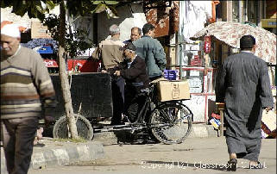
Fig. 7. Street scene in Indonesian New Guinea. As exemplified by the number of men in modern attire in the background compared to the man in the foreground, loss of isolation is encouraging disappearance of cultures.
Social barrier effects consist of characteristics that differentiate human groups and potentially limit interaction between them, thus inhibiting the spread of culture. Examples include language, religion, race and ethnicity, and a history of conflict between specific cultural communities. Islam, for instance, nowadays acts as a social barrier in many Middle Eastern countries by discouraging adoption of certain styles of western dress and music.
For much of human history, therefore, barrier effects tended to isolate cultural communities from each other, inhibiting their ability to share cultural characteristics. Today, however, traditional barrier effects are being overwhelmed by modern means of communication. Isolation is on the decline. Cultural characteristics are diffusing as never before.

Adoption of a new culture item is often accompanied by disuse of an old one. Hence, global decline in cultural diversity is a significant modern trend. Virtually hundreds of languages spoken by formerly isolated peoples will disappear during the next 50 years because, due to diffusion of "modern global languages" (such as English, Spanish, and French), they are not being passed on to the next generation. This does not mean we are heading towards a single global culture, but rather a trend toward cultural communities that come in fewer flavors (see Fig.7).
In some parts of the world, for example, long-cherished cultural traditions are perceived by local practitioners to be threatened by intrusion (i.e., diffusion) of alternatives. Westernization is a term often associated with this process. Thus, while cultural diffusion encourages cultural sharing and interaction between peoples, it may also promote conflict.

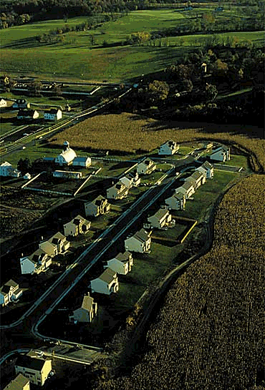
Fig. 8. Suburban encroachment on farmland alters the cultural landscape. In this scene a farmstead (center left) has been leapfrogged by a suburban development that abuts a cornfield (lower right).
3. What makes up a Cultural Landscape?
What do a high-rise apartment, silo, stop sign, golf course, shopping mall, railroad, pyramid, oil derrick, and banana plantation have in common? The answer is that each is a facet of the cultural landscape. The cultural landscape consists of material aspects of culture that characterize Earth’s surface. That includes buildings, shrines, signage, sports and recreational facilities, economic and agricultural structures, crops and agricultural fields, transportation systems, and other physical things. Some geographers would include humans as components of the cultural landscape if their clothing and grooming visually reflect cultural preferences. Because cultural landscape so often embodies humans’ most basic needs—shelter, food, and clothing—many geographers consider it the most important aspect of cultural geography.
All cultures change over time (albeit at different rates). As a result, the cultural landscape of a given locale may look much different today than in the past. For example, the skyline of New York City is much taller today than it used to be, thanks to technological innovations that include electricity, elevators, construction materials, and machinery. Similarly, large areas of New York State have seen the transformation of farmland to suburbia, thanks to changes in economics, agriculture, and transportation (see Fig. 8).
Typically, cultural landscapes change in bits and pieces. Thus, most cultural landscapes are a mixture of new buildings and old ones (possibly including abandoned structures), modern superhighways and old narrow streets, gleaming office buildings and rusting manufacturing facilities, and so on. Thus, if you were to look at Peru, you would learn that its cultural landscape consists of a variety of old and new elements. That would include architectural artifacts from the Inca period (e.g., agricultural terraces, roads, and ruins—like Machu Picchu), ornate cathedrals that date from Spanish colonial times, and a host of more modern structures.

Similarly, if you were learning about Egypt, you would read of pyramids and temples that date from the time of the ancient pharaohs, grand mosques built in recent centuries, grand hotels built in recent years, and other elements of varying age (see Fig. 9). People of all regions and times have left their cultural imprints on Earth, and many of these endure. As a result, the cultural landscape may be a tool for understanding the history and status of a given area, as well as current trends.
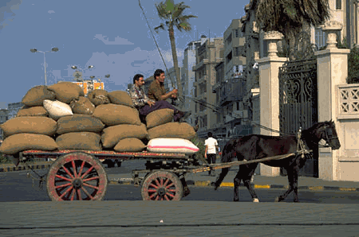
Fig. 9. Cultural landscapes often combine the old and the new. Modern buildings and traditional transportation are juxtaposed in this scene from Cairo, Egypt.
Arrangement and placement of elements in the cultural landscape may be as noteworthy as the elements themselves. For example, American farmers tend to live on their farms, residing in individual, scattered farmsteads. In much of the rest of the world, however, farmers live in villages comprised of tightly clustered residences, from which they commute to their farmland. The visual difference between these contrasting cultural landscapes is unmistakable. Similarly, roads in American towns often adhere to a grid pattern that is predictable and facilitates flow. In contrast, there are older cities in other lands with road networks that are purposefully asymmetrical and include numerous dead ends—apparently to thwart would-be invaders. Finally, in some cultural contexts, the notion of favorable (or unfavorable) locations and sacred directions dictates the placement and orientation of landscape elements.

4. What is Cultural Ecology?
Cultural ecology addresses the relationships between culture and the physical environment. Culture has arisen and evolved in a great variety of physical settings that differ in climate, natural vegetation, soils, and landforms. In these diverse natural environments, humans developed adaptive strategies to satisfy their needs for clothing, food, and shelter. The result is a literal world of difference in clothing styles and the materials from which they are made; the production, preparation, and consumption of foods; and the architectural styles and materials that define human shelter.
The astonishing variety of physical settings that characterize our planet, and the amazing variety of human adaptive strategies to them, go a long way to explain why there are so many cultures on Earth today.
The concept of cultural ecology often helps us better understand the cultural landscape. Thus, while a cultural landscape study might identify and describe a building that typifies a specific area, cultural ecology may be employed to explain why that building looks the way it does.
The Taos Pueblo, a large adobe structure that is a quintessential element of the cultural landscape of the American Southwest, provides a good example (see Fig. 10). In the pueblo’s immediate physical setting, scant rainfall results in scant vegetation. Trees are few, except along permanent watercourses and in high mountains. Also, the low humidity contributes to uncomfortably warm daytime temperatures that contrast with uncomfortably cold nights during much of the year.
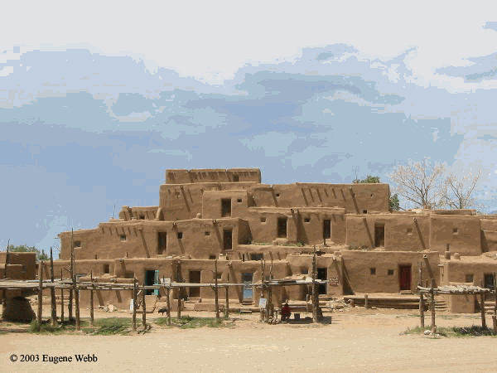
Fig. 10. The Taos Pueblo exemplifies the concept of cultural ecology through its use of locally available materials and adaptation to climatic conditions.
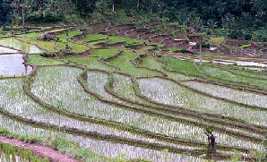
Fig. 11. Terraced rice fields in Bali reflect cultural adaptation to a mountainous tropical environment.
The pueblo embodies several adaptations to these conditions. It consists of finished mud brick (for which the raw material is locally abundant) over a skimpy lattice of timber. The design produces an amalgam of box-like attached residences, a feature that limits the walls that are exposed to the hot sun and leaves flat rooftops, which may act as catchments for scarce rainfall. Also, the largely windowless thick walls help regulate temperature within by heating up slowly during the day, keeping rooms cool in the face of afternoon heat. In contrast, when the sun goes down and the air turns cold, the heat that built up in the adobe during the day keeps the interior significantly warmer than the nighttime air.
Other physical settings offer other examples of cultural ecology. The terraced rice paddies of Bali, Indonesia, embody cultural adaptation to a rainy equatorial climate and to what would otherwise be useless (at least with respect to paddy farming) slopes (see Fig. 11). Meanwhile in snowy alpine Europe, the inverted-V roofs of chalets facilitate snow removal, lessening the chance for structural damage.
Evidence of cultural ecology may be local as well as global, as four examples from New York State attest. The location of Rochester has much to do with the presence therein of the falls of the Genesee River, an early source of industrial power. The distinctive and attractive Finger Lakes wine country is partly the result of a local microclimate, soils, and slopes that are favorable to grape growing. Manhattan’s tallest buildings have historically been located in midtown and downtown, where bedrock is closest to the surface. Finally, parts of the Long Island Railroad’s main line coincide with a glacially deposited ridge, which helps keep water off the tracks. These are all examples of cultural adaptation to physical environment.
Cultural ecology focuses on culture-environment interaction in the past as well as the present. Regarding the past, identification and analysis of culture hearths, regions that in ancient times gave rise to significant cultural complexes, are of particular importance. These include the Nile Valley, the Fertile Crescent (including Mesopotamia), Indus Valley, Huang Ho Valley, and Mesoamerica. Each provides examples of how ancient peoples built impressive civilizations thanks to interaction between humans and fertile river valleys—which gave rise to agricultural surpluses, which in turn freed some people from daily food production and allowed them to develop other pursuits.
Finally, avoiding cultural stereotypes (and correcting cultural stereotypes that we may already have in their heads) is one of the most important things to do when learning the geography of culture. Cultural stereotyping often involves particular peoples’ clothing, food, and/or shelter, which are prominent aspects of cultural ecology. Thus, unless otherwise informed, a student might look at Fig. 10 (see previous page) and conclude that all Native Americans in the southwestern U.S. reside in something that looks like the Taos Pueblo. In reality, the Taos Pueblo is merely a remnant traditional structure. Most of the local people live in more modern-looking homes made of modern construction materials.
Sadly, there is an abundance of literature that reinforces or creates cultural stereotypes. I recently came across a picture book for U.S. elementary school students claiming to show how children live in other lands. It was a collection of stereotypes. For example, "Eskimos" (nowadays more properly called "Inuits") were dressed in animal skins, carried spears, lived in igloos, had dog sleds parked outside, and entertained themselves by using walrus skins to toss each other around. In reality, contemporary Inuits are just as likely (perhaps more so) to order outerwear from L.L. Bean, use a snowmobile, hunt with a modern high-power rifle (if, indeed, they are inclined to go hunting), live in housing made of modern construction materials rather than ice blocks, and spend their leisure time watching TV.
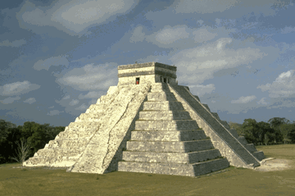
Fig. 12. The orientation of Mayan temples reflected their belief that north is a sacred direction.
Most cultural stereotyping rests on the notion that certain people live pretty much as did their distant ancestors. There are many people alive today—especially in some developing countries—who continue to exhibit cultural characteristics little changed from those of distant ancestors. But the majority of the world’s cultural communities are now experiencing significant modernization (as described in the section on cultural diffusion). As a result, people who live in distant cultural communities do not all look the same. Instead, different people display old and new cultural characteristics.
Children who live in cultural communities in foreign lands generally are tending to live less and less as their ancient ancestors did, but to increasingly exhibit cultural characteristics that are similar to their own.
As cultures modernize, does geography matter less? The answer is a resounding no! Geography matters more than ever. Physical geography still affects cultural communities in a host of ways. But so does a different kind of geography—a geography of labor pools and free-market capitalism; a geography of manufacturing and deep-water port facilities; a geography of transportation systems and bilateral relationships; a geography of global linkages as opposed to isolated cultural communities in particular physical settings.

5. What is Cultural Interaction?
Cultural interaction focuses on the relationships that exist between cultural components that characterize a community. When geographers seek to explain why a particular culture trait is found in a particular area, they often discover that the answer lies in another trait possessed by that same cultural community. This demonstrates that cultural components may be interrelated.
Here are some examples.
- Concepts of personal privacy in Islamic culture regions explains why residences lack street-level windows.
- Buddhists regard golden colors as a symbol of enlightenment. That explains why gold-domed temples figure so prominently in cultural landscapes in various parts of Southeast Asia.
- If the residents of a particular neighborhood were conservative Jews, then that would explain the presence of kosher grocery stores, signs in Hebrew, synagogues, and particular styles of clothing.
- Because north was a sacred direction to the ancient Mayans, the boulevard-facing facades of their temples were always aligned in a north-south manner (see Fig. 12).
Bars and liquor stores are not likely to be found in Muslim neighborhoods because Islam forbids consumption of alcoholic beverages. Cultural interaction may explain the presence—as well as the absence—of particular traits in particular areas.
These examples attest to the explanatory power of cultural interaction. But they also demonstrate that religious beliefs often underlie relationships between cultural components. Few culture traits have the power and importance of religion. Indeed, religion is often the key to understanding the way of life of a particular cultural community.

SUMMATION AND APPLICATION
In summary, geography seeks to describe and explain the distribution of phenomena that characterize Earth’s surface. Because culture differentiates human beings and the lands they occupy, it is one of the most important things that geographers study. There is an entire subfield of academic geography devoted to the study of culture: cultural geography.
The key concepts of cultural geography are culture region, cultural diffusion, cultural landscape, cultural ecology, and cultural interaction. Each offers opportunities to learn culture from a geographical point of view. Specifically, that perspective involves the following:
- Delineating and describing parts of Earth that have common cultural elements, as well as comparing and contrasting areas that are culturally different (i.e., studying the concept of culture region);
- Describing how cultural components spread over space and come to characterize different parts of our planet (i.e., studying the concept of cultural diffusion);
- Appreciating how culture contributes to the visual distinctiveness of different areas (i.e., studying the concept of cultural landscape);
- Understanding how cultural communities have adapted to—and, in turn, impacted—the natural environment (i.e., studying the concept of cultural ecology); and
- Noting how one particular culture trait might lead to the appearance of others in a specific cultural community (i.e., studying the concept of cultural interaction).
These concepts, though distinct, may overlap in ways that help to describe and explain the nature of cultural communities. Here is a closing example.
There is a culture region in southeastern Pennsylvania associated with a large Amish population. The sect originated in Europe centuries ago. Their presence in Pennsylvania is the result of cultural diffusion—migration to America. The cultural landscape of the Pennsylvania Amish is dominated by dairy farms, so big barns and silos are much in evidence. The fact that they are dairy farms, as opposed to, say, wheat farms, is explained by a local climate favorable to raising dairy cows, and to lucrative and nearby urban markets for their products. These relationships between Amish culture and both the natural and human environments provide examples of cultural ecology. Amish religious beliefs stress separation from "the world." (Indeed, persecution of Amish due to their religious beliefs explains why they left Europe for Pennsylvania in the first place.) The interrelationship between religion and other aspects of Amish culture exemplifies cultural interaction.

CULTURE
A GEOGRAPHIC PERSPECTIVE
QUESTIONS

1. What does “global diversity” mean?

2. What are some examples of components that make up a culture?

3. What are ways people interact with the Earth to show cultural components?

4. What is a culture region?

5. Give an example of a culture region?

6. List some examples of culture regions that have appeared and disappeared.

7. What does cultural diffusion mean?

8. What are four factors that influence cultural diffusion?

9. How do “barrier effects” impact cultural diffusion? Give an example.

10. What makes up a Cultural Landscape?

11. Explain what “Cultural ecology” means

12. Why must we be careful to avoid cultural stereotypes?

13. Buddhists regard golden colors as a symbol of enlightenment. How does this represent what we
know as cultural interaction?

