CALL TO FREEDOM
CHAPTER SEVEN
SECTION 5 INDEPENDENCE!

BEFORE YOU READ….
Answer these questions to see how much you might already know about this topic

TRUE FALSE
___ ___ 1. Colonists won several battles in the west with the help of the Indians.
___ ___ 2. Promising freedom to slaves did not help the British during the war
___ ___ 3. The British won many victories in the South
___ ____ 4. Benedict Arnold was a great American hero
___ ___ 5. The French made a great contribution for the colonists at the end of the war

Look at this map

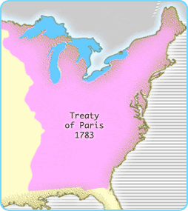

How does the area controlled by America differ from before the war?

The War in the West
VOCABULARY
STRATEGIC: IMPORTANT

PURSUADED: CONVINCED

Main idea: How did geography impact Clark’s campaign in the West?
- Who was George Rogers Clark?

- What was Clark’s goal?

- How did Clark gather an army to fight the British?

- How was Clark able to surprise the British at Kaskaskia?

- What impact did Clark have on the Indians?

The War in the South
VOCABULARY
CAMPAIGN: BATTLE

Main idea: What were the events of the war on the South?
- How did the plan to set slaves free work for the British?

- What did Quamino Dolly do?

- How did the British use information from him?

- What did the British soldier do to homes in the countryside as they marched through the South

- What happened the Continental army of General Gates?

- Who was Francis Marion?

- How did colonists use guerilla warfare to fight the British?

Victory at Yorktown
Main idea: How did Washington win the Battle of Yorktown?
1. What did Benedict Arnold do that hurt the cause of the colonists?

2. Why did Cornwallis move his army into Virginia?

3. Who was the Comte de Rouchambeau?

4. Why did Cornwallis have to surrender at Yorktown?

The Treaty of Paris
VOCABULARY
ABSOLUTE: TOTAL

INDEPENDENCY: FREEDOM

Main idea: How did the Revolutionary War finally end?

- Who did the colonists send as delegates to negotiate a treaty with England?

- How long did it take to conclude a treaty?

- What terms did the British agree to?

- What were the new borders of America:
  - The Northern boundary

  - The Western boundary

  - The Southern boundary

