CALL TO FREEDOM
CHAPTER SEVEN
SECTION 3 DARKEST HOURS FOR THE REVOLUTION

BEFORE YOU READ….
Answer these questions to see how much you might already know about this topic

TRUE FALSE
___ ___ 1. Colonists had a “home-field” advantage during the war.
___ ___ 2. Slaves were not permitted to fight in the Continental army.
___ ___ 3. Almost all native-Americans sided with the British during the war.
___ ____ 4. Canada was an easy colonial victory.
___ ___ 5. Washington’s army was driven out of New York

What are some of the things a country needs to successfully fight a war? (list)
1.
2.
3.
4.
5.

Look at this chart.

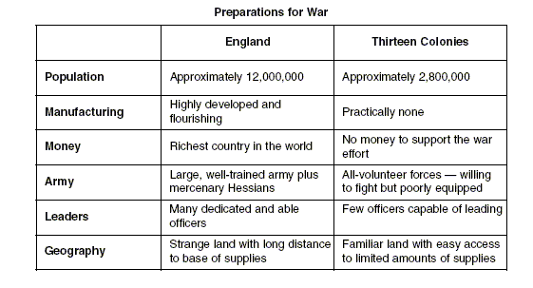

What DO YOU THINK was the most important advantage the British had at the start of the war?

Comparing Strengths and Weaknesses
VOCABULARY
MERCENARY: A SOLDIER THAT IS PAID TO FIGHT FOR A WAR FOR THE COUNTY OTHER THAN THEIR OWN.

Main idea: What advantages and disadvantages did the Patriots have when the war began?
1. Who had the advantage in these areas at the start of the war?
Resources
Military Experience and Training
Money (Wealth)
Weapons
Navy

2. Why was it a disadvantage for the British to be fighting the war here in North America?

3. Why was important that the colonists were fighting for a cause?

4. Why DO YOU THINK the British had to hire mercenaries to help fight the war?

A Call to Arms
VOCABULARY
RECRUIT: ASK SOMEONE TO JOIN A GROUP OR CAUSE

ENLIST: VOLUNTEER TO JOIN

Main idea: What happened to slaves during the war?
- Who was put in charge of organizing the Continental army?

2. Why DO YOU THINK Southerner did not want to allow slaves to fight in the Continental army?

3. How did the British take advantage of Washington’s decision not to let slaves fight in the Continental army?

4. Which African Americans were eventually permitted to join the Continental army?

Other Sources of Help
VOCABULARY
NEUTRAL: NOT TAKING SIDES IN A FIGHT OR ARGUMENT

Main idea: How did different groups living in the colonies contribute to the war effort?
1. On what side the Indians fight during this war?

- What were some of the contributions made by women during the war (list)

- How did “Molly Pitcher” get her nickname?

British Victories
VOCABULARY
ENLISTMENTS: AMOUNT OF TIME SOLDIERS HAD SIGNED UP TO AGREE TO FIGHT FOR THE ARMY

Main idea: What were the problems faced by the Continental army in Canada and New York?

- The attack on Canada started as a success in what city?

- Why did things go terribly wrong at Quebec?

- What was it easy for the British to push Washington’s army out of New York?

