CALL TO FREEDOM
CHAPTER SIX
SECTION 4 NEW TAXES AND TENSIONS

BEFORE YOU READ….
Answer these questions to see how much you might already know about this topic

TRUE FALSE
___ ___ 1. Colonists stopped buying goods that the British taxed.
___ ___ 2. Hundreds of people died in the Boston Massacre
___ ___ 3. The British lowered the price on tea to encourage colonists to buy it
___ ____ 4. Colonists eventually paid for the tea they tossed into Boston harbor
___ ___ 5. The British forced colonists to have soldiers live in their homes.

INTERPRETING A PICTURE

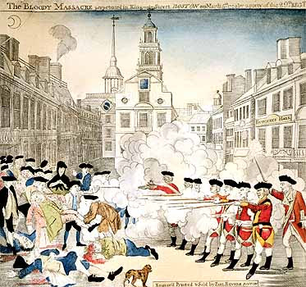

Briefly describe what is happening in this picture:

The Townshend Acts
VOCABULARY
- VIOLATED: FAIL TO COMPLY

WRITS OF ASSISTANCE: SEARCH WARRANTS

BOYCOTT: DO NOT USE

CUSTOMS OFFICIALS: PEOPLE RESPONSIBLE FOR KEEPING RECORDS ABOUT IMPORTED GOODS AND THE TAXES ON THOSE GOODS

Main idea: What series of events led to the arrival of British troops in 1768?
- How did people in cities celebrate the repeal of the STAMP ACT?

- What did the TOWNSHEND ACTS tax?

- What was the money from these taxes supposed to be used for?

- What did the WRITS OF ASSISTANCE do?

- Why did colonists hate the WRITS OF ASSISTANCE?

- How did the colonists respond to these taxes?

- Why was the ship Liberty seized?

The Boston Massacre
VOCABULARY
TENSION: DANGER, NERVOUSNESS AND FEAR

BRANDED: MARKED WITH A HOT IRON

Main idea: How did Sam Adams and John Adams differ in their response to the Boston Massacre?
- What event happened on March 5, 1770?

- What were colonists doing when British soldiers fired in into the crowd?

- What does the word ‘propaganda” mean?

- Take a look at the engraving of the Boston Massacre on page 173. What do you think this picture did to those who saw it throughout the colonies?

- What eventually happened (punishment) for the soldiers who fired into the crowd at the Boston Massacre?

A Tax on Tea
VOCABULARY
MONOPOLIZE: COMPLETE CONTROL

Main idea: Why did the colonists oppose the Tea Act?
- Where did colonists get most of their tea?

- What did the Tea Act do to the price of team in the colonies?

- Why were colonial merchants worried about this law?

- When the tea ships would not leave Boston until the taxes were paid, what did the colonists do to show their anger?

The Intolerable Acts
VOCABULARY
INTOLERABLE: CANNOT PUT UP WTH

Main idea: What were the major effects of the Intolerable Acts and what methods did the colonists use to protest them?
1. What did the INTOLERABLE ACTS do ? (5 parts)
1.
2.
3.
4.
5.

2. What name did the British give these ACTS?

3. What two rights did the colonists feel were being taken from them by the INTOLERABLE ACTS?

- What did the British hope these acts would accomplish?

5. What two things did the colonists propose to do ton show their displeasure with these ACTS?

