CALL TO FREEDOM
CHAPTER SIX
SECTION 3 TROUBLE OVER COLONISTS RIGHTS

BEFORE YOU READ….
Answer these questions to see how much you might already know about this topic

TRUE FALSE
___ ___ 1. Colonists wanted to make their own taxes
___ ___ 2. Colonial merchants wanted to raise taxes to help sell their products
___ ___ 3. Most people communicated in colonial ties through letters
___ ____ 4. Newspapers supported higher taxes
___ ___ 5. London merchants wanted the stamp act ended

INTERPRETING A CARTOON

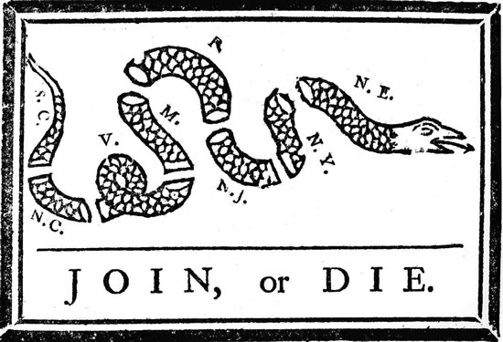

What does this cartoon mean?

Raising Taxes
VOCABULARY
- REGULATE: CONTROL

VICE-ADMIRALTY: COURTS THAT CONTROL TRADE AND ANYTHING TO DOWITH SHIPPING

Main idea: When In what ways did Parliament’s new laws increase England’s control over the colonies?
- Why was Great Britain owe so much money (in heavy debt)?

- Who was George Grenville?

- How did Grenville try to get the money to pay for the war debt and the army the British had in North America?

- What did the SUGAR ACT tax?

- What did Great Britain do to make life difficult for smugglers?

- How were trials for smugglers different for trials of all other Englishmen?

- How did colonial merchants feel about these new taxes?

- Who was James Otis?

Taxation without Representation
Main idea: How did Sam Adams and James Otis influence colonial protests against new taxes?
VOCABULARY
CONSENT: APPROVAL

COLONIAL ASSEMBLIES: ELECTED REPRESENTATIVES THAT MAKE LAWS FO THE COLONIWA

CORRESPONDENCE: WRITTEN COMMUNUCATION (LETTERS)

- Who was James Otis?

- What was Otis’ complaint about the new taxes?

- How many representatives did the colonists have in the British law-making Parliament?

- What did Sam Adams feel about the British being able to tax the colonists?

- What does “No Taxation Without Representation” mean?

- What was the role of the Committees of Correspondence?

- What does “boycott” mean?

- Why did colonists boycott British goods?

- How did London merchants feel about the colonies boycotting their goods?

The Stamp Act
Main idea: What did the Stamp Act do and how did colonists react?
VOCABULARY
RESOLUTIONS: LEGAL PROMISES

- What items did the STAMP ACT tax?

- How did the colonists react to this new tax?

- Who were the Sons of Liberty and what did they do?

- How did the colonists intimidate the tax collector Andrew Oliver?

Repealing the Stamp Act
Main idea: What methods did the colonists use to protest the Sugar and Stamp Acts and what were the results of their efforts?
VOCABULARY
DECLARATION: STATEMENT OF LAW

- What was the STAMP ACT Congress (where did they meet)?

- What does the word “repeal” mean?

- How did London merchants feel about the colonies boycotting their goods?

- What eventually happened to the STAMP ACT?

- What did the DECLARATORY ACT say?

