CALL TO FREEDOM
CHAPTER SIX
SECTION 2 CONSEQUENCES OF THE FRENCH AND INDIAN WAR

BEFORE YOU READ….
Answer these questions to see how much you might already know about this topic

TRUE FALSE
___ ___ 1. Pioneers made a great deal of money in their work
___ ___ 2. It was safer to live in to backcountry than in colonial cities
___ ___ 3. The Ohio-valley was attractive to settlers because of the gold there
___ ____ 4. Daniel Boone led an army to conquer the Indians in the Ohio-Valley
___ ___ 5. The king did not care about his colonists

MAP SKILLS

Where on this map would you find the Ohio-valley (place a small circle on the map)

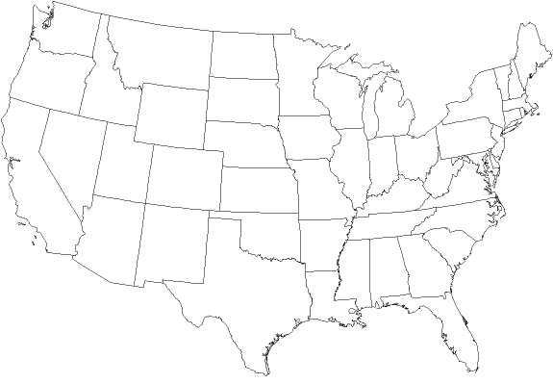

Have your parent ever tried to protect you by telling you to avoid certain areas?

The Frontier
VOCABULARY
- BACKCOUNTRY: THINNLY POLULATED AREA OF THE FRONTIER

PIONEERS: SETTLER WHO WENT INTO THE FRONTIER TO START A NEW LIFE

FORESTED: CONTAINING A LARGE NUMBER OF TREES (FOREST)

WILD GAME: ANIMALS YOU CAN HUNT FOR FOOD

EASED: GOT LESS

VOCABULARY
OPPOSED: AGAINST
TENSIONS: TROUBLES

MILITIA: AN ARMY MADE UP OF CITIZENS

ALLIANCE: AN AGREEMENT BETWEEN FRIENDS TO FIGHT FOR AND SUPPORT EACH OTHER

ALLIES: FRIENDS

Main idea: When and why did pioneers begin settling lands west of the Appalachian Mountains?
1. What people who lived on the frontier do for a living?

2. What does “back country” mean?

3. What do we call the first people who settled in this area?

4. What dangers did these people face?

5. What was attractive about the Ohio Valley?

Conflicts in the Ohio-River Valley
Main idea: Why did Pontiac and his followers fight the British and what happened as a result?
VOCABULARY
ENTITLED: DESERVED

- Why did the victory of the British in the French and Indian war encourage settlement of the Ohio valley?

- After the Treaty of Paris (which ended the war), which European power controlled the Ohio Valley?

- What did the British want to do with this territory?

- How did Chief Pontiac change England’s plans for this area?"

- Describe what Pontiac’s rebellion did to English control of this area.

- How was Pontiac eventually defeated?

The Royal Proclamation of 1763
Main idea: Why did King George issue the Royal Proclamation, and how did the colonists react to this?
VOCABULARY
PROCLAMATION: A WRITTEN LAW

BANNED: DID NOT ALLOW

DISREGARD IGNORE

- Why did the English want to prevent colonists from settling in the Ohio Valley?

- How did colonists react to the Royal Proclamation of 1763?

- Who was Daniel Boone?

- Why did YOU think colonists defied the Proclamation and went into the Ohio Valley anyway?

