BIZARRE SUPREME COURT CASES

United States v. Causby (1946)
Background of the case
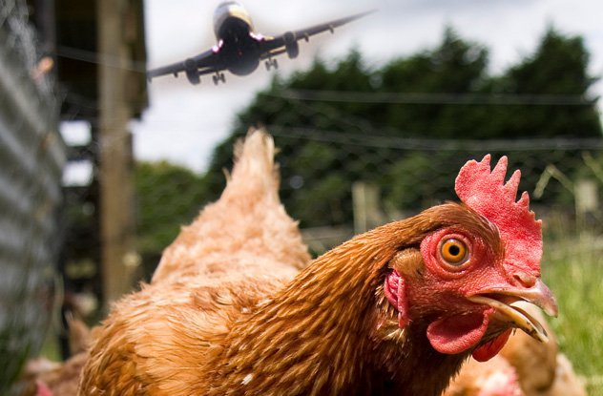
Thomas Lee Causby owned a chicken farm outside of Greensboro, North Carolina. The farm was located near an airport used regularly by the United States military. According to Causby, noise from the airport regularly frightened the animals on his farm, resulting in the deaths of several chickens. The problem became so severe that Causby was forced to abandon his business.
Under an ancient doctrine of the common law, land ownership extended to the space above and below the earth. Using this doctrine as a basis, Causby sued the United States, arguing that he owned the airspace above his farm. By flying planes in this airspace, he argued, the government had confiscated his property without compensation, thus violating the Takings Clause of the Fifth Amendment. The United States Court of Claims accepted Causby's argument, and ordered the government to pay compensation.
Did the flying of planes by the United States military over Causby's farm constitute a violation of the Takings Clause of the Fifth Amendment?
How would you rule on this?

The court's decision

In a 5-2 opinion authored by Justice William O. Douglas, the Court concluded that the ancient common law doctrine "has no place in the modern world." The courts ruled that though landowners do own the air immediately above the property, they don’t own the air infinitely upward.
Justice Douglas noted that, were the Court to accept the doctrine as valid, "every transcontinental flight would subject the operator to countless trespass suits.
However, while the Court rejected the unlimited reach above and below the earth described in the common law doctrine, it also ruled that, "if the landowner is to have full enjoyment of the land, he must have exclusive control of the immediate reaches of the enveloping atmosphere." Without defining a specific limit, the Court stated that flights over the land could be considered a violation of the Takings Clause if they led to "a direct and immediate interference with the enjoyment and use of the land." Given the damage caused by the particularly low, frequent flights over his farm, the Court determined that the government had violated Causby's rights, and he was entitled to compensation.
This changed the amount of space that a landowner owns above his or her property from “infinite” to the “safe distance as to which various airplanes could take off and land near the property.” That distance is 300–1,000 ft, depending on the type of aircraft and whether it is day or night.
The planes over Causby’s farm flew below that mark, so Causby received compensation from the government and won his case. But the government received a win in return, one that had little basis in the existing letter of the law but that enabled air travel as we know it.
Without this ruling, airlines would have to apply for tens of thousands of permits for any long-distance flight.

