BIZARRE SUPREME COURT CASES

Korematsu v United States (1941)

Background of the case
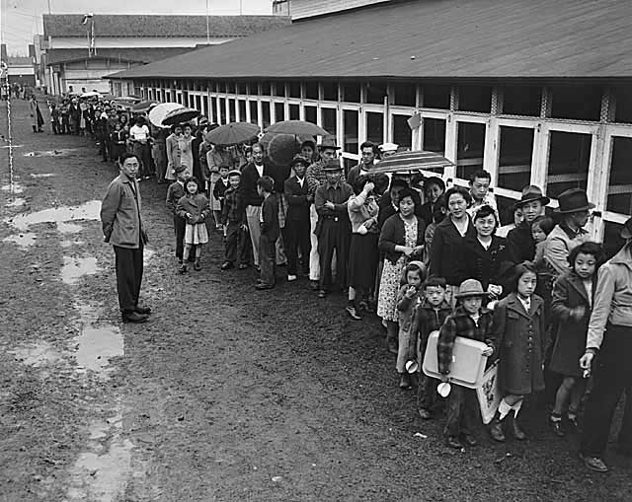
After the bombing of Pearl Harbor in 1941, the US feared another attack by Japan, and that those of Japanese descent living in the US would aid them.
On Feb. 19, 1942, two months after the Pearl Harbor attack by Japan’s military, Pres. Franklin D. Roosevelt issued Executive Order 9066, which enabled his military commanders “to prescribe military areas from which any or all persons may be excluded.”
Although the order mentioned no group in particular, it was applied to most of the Japanese-American population on the West Coast.
Soon after, U.S.-born sons and daughters of Japanese immigrants of southern California were ordered to vacate homes, leaving behind all but what they could carry.
Roosevelt signed another executive order, creating the War Relocation Authority, a civilian agency to speed the process of relocating Japanese Americans. A few days later, the first wave of “evacuees” arrived at a War Relocation Center, a collection of tents in the California desert. Most spent the next three years there.
Fred Korematsu and his family were to be relocated. Although his family followed the order, Fred failed to submit to relocation. He was arrested and eventually was taken to a Relocation Center south of San Francisco. He was convicted of having violated military order and received a sentence of five years’ probation. He and his family were subsequently relocated to an Internment Camp in Utah.
Fred Korematsu appealed his conviction to the U.S. Court of Appeals, which upheld the conviction
How would you rule on this?

