BARTOLOMEU DIAS BIOGRAPHY
Born in 1450, Bartolomeu Dias was sent by Portuguese King John II to explore the coast of Africa and find a way to the Indian Ocean. Dias departed in August 1487, rounding the tip of Africa in January, 1488. The Portuguese named this point of land the Cape of Good Hope. Dias was lost at sea during another expedition around the Cape in 1500.

EARLY LIFE

Almost nothing is known about the life of Dias before 1487, except that he was at the court of John II, King of Portugal. He likely had sailing experience. He was in his mid- to late 30s when King John appointed him to head an expedition in search of a sea route to India.

THE VOYAGE

In August 1487, Dias' three ships departed from the port of Lisbon, Portugal for the coast of Africa. Dias' cargo included limestone markers used to stake Portuguese claims on the continent. These markers were planted at the shoreline and served as guideposts for future Portuguese explorations of the coast.

Dias' expedition party included six Africans who had been brought to Portugal by earlier explorers. Dias dropped them off at different ports along the coastline of Africa with gold, silver and messages of goodwill from the Portuguese. One of the three shops stayed behind while these people reached out to the local tribes for peace.

In early January 1488, as Dias' ships sailed off the coast of South Africa, storms blew them away from the coast. Dias ordered a turn to the south, probably because he had believed the winds that would take him around the tip of Africa and keep his ships from being dashed on the rocky shoreline. King John had obtained a 1460 map from Venice that showed the Indian Ocean on the other side of Africa.

Dias' decision was risky, but it worked. The crew spotted landfall in February 1488, about 300 miles east of present-day Cape of Good Hope. They found a bay and the much warmer waters of the Indian Ocean.

From the shoreline, locals pelted Dias' ships with stones until an arrow fired by one of Dias men hit a tribesman. Dias ventured further along the coastline, but his crew was nervous about the dwindling food supplies and urged him to turn back. He agreed to sail another three days, then turn back. On the journey back, Dias observed the southernmost point of Africa which he named the rocky cape Cabo das Tormentas (Cape of Storms).

When he returned to the supply ship, Dias and his crew were surprised to find that only three of the nine men left behind had survived repeated attacks by locals. In Lisbon, after 15 months at sea and a journey of nearly 16,000 miles, the returning mariners were met by triumphant crowds, but in a private meeting with the king, however, Dias was forced to explain his failure. Despite his immense achievement, Dias was never again give command of an expedition.

Dias settled for a time in West Africa. King John’s successor, ordered Dias to serve as a shipbuilding consultant for the expedition of Vasco da Gama, who was about to make another attempt to reach India. Dias sailed with the Da Gama expedition as far as the Cape Verde Islands, then returned. Da Gama's ships reached India in May 1498, nearly a decade after Dias' historic trip around the tip of Africa.

Afterward, the King sent out a massive fleet to India. Dias captained four of the ships. They got lost and reached Brazil in March 1500, then headed across the Atlantic toward South Africa and then to India. Storms struck the fleet of 13 ships. In May 1500, four of the ships were wrecked, including Dias', with all crew lost at sea.

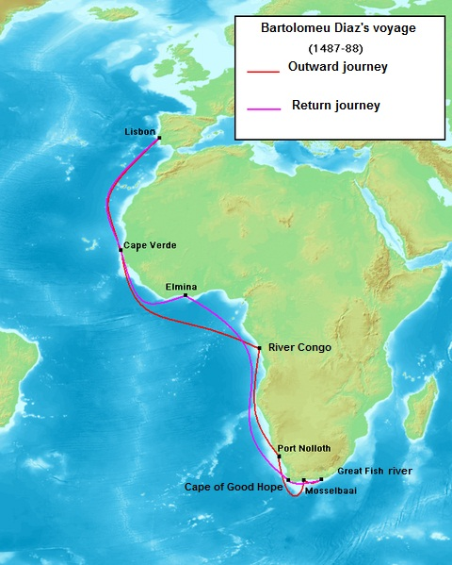

BARTOLOMEW DIAS BIOGRAPHY

1. Who was the King of Portugal who appointed Dias to search for a route to India?

2. How did the Portuguese stake their claims to the coastline of Africa?

3. What evidence did the King of Portugal have that there was an ocean on the other side of Africa?

5. What did Dias find when he returned to the supply ship he had left behind?

6. Upon his return to Portugal, how was Dias received by the crowds?

How was he received by the King?

7. Dias was later appointed (assigned) to sail with what other explorers?

8. What eventually happened to Dias?

