2 reasons the American Revolution was a mistake By Dylan Matthews
- tweet
- share
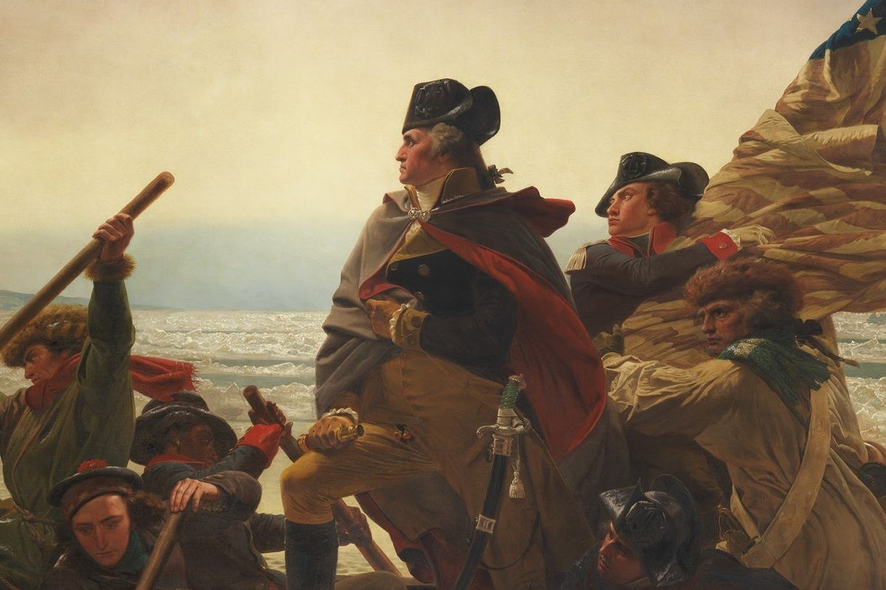

This July 4, let's not mince words: American independence in 1776 was a monumental mistake.
We should be mourning the fact that we left the United Kingdom, not cheering it.
We obviously can't be entirely sure how America would have fared if it had stayed in the British Empire, perhaps gaining independence a century or so later, along with Canada. But I'm reasonably confident that a world in which the revolution never happened, would be better than the one we live in now, for three main reasons:
- Slavery would've been abolished earlier and

- American Indians would've faced rampant persecution but not the outright ethnic cleansing Andrew Jackson and other American leaders perpetrated, and

- Abolition would have come faster without independence
The main reason the revolution was a mistake is that the British Empire, in all likelihood, would have abolished slavery earlier than the US did, and with less bloodshed.
Abolition in most of the British Empire occurred in 1834, following the passage of the Slavery Abolition Act. That left out India, but slavery was banned there, too, in 1843. In England itself, slavery was illegal at least going back to 1772. That's decades earlier than the United States.
This alone is enough to make the case against the revolution. Decades less slavery is a massive humanitarian gain that almost certainly dominates whatever gains came to the colonists from independence.
The main benefit of the revolution to colonists was that it gave more political power to America's white male minority.
For white slaveholders in the South … the war was "a revolution, first and foremost, mobilized to protect slavery"
It's true that had the US stayed, Britain would have had much more to gain from continuing slavery than it did without America. It controlled a number of colonies with slave economies — notably Jamaica and other islands in the West Indies — but nothing on the scale of the American South.
Without the Revolution, the South's political influence in the British Empire would have been vastly smaller than its influence in the early American republic. The revolutionaries understood this. Indeed, a desire to preserve slavery helped fuel Southern support for the war. I
In 1775, after the war had begun in Massachusetts, England’s governor of Virginia, offered the slaves of colonial rebels freedom if they came and fought for the British cause. This proclamation probably united white Virginians behind the colonial rebel effort.
Anger ran so deep that Thomas Jefferson included it as a grievance in a draft of the Declaration of Independence. That's right: the declaration could've included "they're conscripting our slaves" as a reason for independence.
For white slaveholders in the South, the war was a revolution, first and foremost, mobilized to protect slavery.
Slaves understood that their odds of liberation were better under British rule than independence. Over the course of the war, about 100,000 African slaves escaped, died, or were killed, and tens of thousands enlisted in the British army, far more than joined the rebels. Black Americans' quest for liberty was mostly tied to fighting for the British — the side in the War for Independence that offered them freedom. At the end of the war, thousands who helped the British were evacuated to freedom in Nova Scotia, Jamaica, and England.
This is not to say the British were motivated by a desire to help slaves; of course they weren't. But American slaves chose a side in the revolution, the side of the crown. They were no fools. They knew that independence meant more power for the plantation class that had enslaved them and that a British victory offered far greater prospects for freedom.

- Independence was bad for Native Americans
Starting with the Proclamation of 1763, the British colonial government placed firm limits on westward settlement in the United States. It wasn't motivated by an desire to keep American Indians from being enslaved or anything; it just wanted to avoid border conflicts.
But all the same, the policy enraged American settlers, who were appalled that the British would seem to side with Indians over white men. The British government saw Native Americans as subjects of the crown, similar to colonists.
American colonists … refused to see Indians as fellow subjects. Instead, they viewed them as obstacles in the way of their dreams of land ownership and trading wealth. This view is reflected in the Declaration of Independence, which attacks King George III for backing "merciless Indian Savages."
Britain probably would've moved into Indian lands. But fewer people would have died.
Independence also enabled acquisition of territory in the West through the Louisiana Purchase and the Mexican-American War. That ensured that America ensnared yet more native peoples. The US refused to make them American citizens for a century. And then, of course, it violently forced them into reservations, killing many in the process.
American Indians would have likely faced violence and oppression without American independence, but American-scale ethnic cleansing wouldn't have occurred. American Indians knew this. Most tribes sided with the British or stayed neutral.

