VASCO DA GAMA

Explorer Vasco da Gama was born in Portugal around 1460. In 1497, he was ordered by the Portuguese king to find a sea route to the East. His success proved to be one of the biggest moments in the history of navigation. He later made two other voyages to India, and was named Portuguese governor of India in 1524.

Early Years

Little is known about his upbringing except that he was the son of Estvo da Gama, who was commander of a fortress the southwestern Portugal. When he was old enough, young Vasco da Gama joined the navy, where was taught how to navigate.

Known as a tough and fearless navigator, da Gama gained this reputation when, in 1492, King John II of Portugal sent him to take French ships as an act of vengeance against the French government for interfering with Portuguese shipping.

In 1495, King Manual took the throne. By this time, Portugal had established itself as one of the most powerful countries in Europe. Much of that was due to Henry the Navigator, who had brought together mapmakers, geographers and navigators and sent ships to explore the coast of Africa.

Bartolomeu Dias discovered the southern tip of Africa. This journey proved, for the Atlantic and Indian oceans were connected. The trip sparked a renewed interest in seeking out a trade route to India.

FIRST VOYAGE

Historians know little about why da Gama, was chosen to lead the expedition to India in 1497. On July 8 of that year, he captained a team of four vessels to find a sailing route to India and the East.

Da Gama pointed his ships south, taking advantage of the winds along the coast of Africa. His choice of direction was also an attempt to prove Christopher Columbus wrong, who had believed he'd found a route to India by sailing east.

After several months of sailing, he rounded the Cape of Good Hope and began making his way up the eastern coast of Africa, toward the uncharted waters of the Indian Ocean. By early January, many of da Gama's crewmembers were sick, forcing the expedition to anchor for rest and repairs for nearly one month.

In early January of 1498, da Gama and his crew dropped their anchors in the port of Mozambique, a Muslim city-state that sat on the outskirts of the east coast of Africa dominated by Muslim traders. Here, da Gama was turned back by the ruling Sultan, who felt offended by the explorer's modest gifts.

By early April, the fleet reached what is now Kenya, before setting sail across the Indian Ocean. They reached Calicut on May 20. The residents of Calicut were Hindu. Da Gama had not heard of the religion.

Still, the local Hindu ruler welcomed da Gama and his men and the crew ended up staying in Calicut for three months. Not everyone embraced their presence, especially Muslim traders who clearly had no intention of giving up their trading grounds to Christian visitors. Eventually, da Gama and his crew were forced to trade on the waterfront in order to secure enough goods for the passage home. In August of 1498, da Gama and his men took to the seas again, beginning their journey back to Portugal.

Da Gama's timing could not have been worse; his departure coincided with the start of a monsoon. By early 1499, several crewmembers had died. The fleet didn't reach Portugal until July 10, nearly a full year after they'd left India.

In all, da Gama's first journey covered nearly 24,000 miles in close to two years, and only 54 of the crew's original 170 members survived.

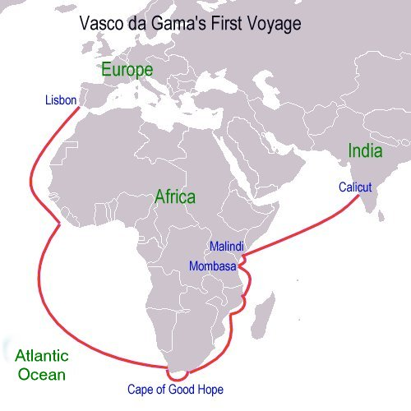

VASCO DA GAMA BIOGRAPHY
- Where do you think Da Gama get his love for the sea?

- What did Da Gama do that made him famous and got the attention of the Portugese king?

- How did the voyage of Bartholomew Dias help Da Gama?

4. When did Da Gama take his voyage (in relationship to the voyage of Columbus)?

5. After rounding the Cape of Good Hope, what happened to Da Gama's crew members?

6. Describe Da Gama's encounter with the ruling Sultan of Mozambique. Why did this happen?

7. What trouble did he have with Muslim traders?

8. What troubles did he have on the way back to Portugal?

