VASCO BALBOA

Explorer Vasco Núñez de Balboa became the first European to see the Pacific Ocean.

Early Life and Exploration

Born in 1475 in Spain, Vasco Balboa went on to become the first European to see the Pacific Ocean.

At a time when many people in Spain were seeking their fortunes in the New World, Balboa joined an expedition to South America. After exploring the coast of present-day Colombia, Balboa stayed on the island of Hispaniola (now Haiti and the Dominican Republic). While there, he got into debt and fled, hiding away on a ship headed for the fledgling colony of San Sebastian.

Once he arrived at the settlement, Balboa discovered that most of the colonists had been killed by nearby native peoples. He then convinced the remaining colonists to move. They established the town of Darién on the Isthmus of Panama, which is a small strip of land that connects Central America and South America. Balboa became the governor of the settlement.

Seeing the Pacific Ocean

In 1513, Balboa led an expedition to search for a new sea reportedly to the south and possibly find gold too. He hoped that if he was successful, he would win the favor of the king of Spain. While he didn't find gold, he did see the Pacific Ocean, and claimed it for Spain.

Death

The news of the discovery arrived after the king had someone else to serve as the new governor of Darién. The new governor was reportedly jealous of Balboa and ordered him to be arrested on charges of treason. After a brief trial, Balboa was beheaded.

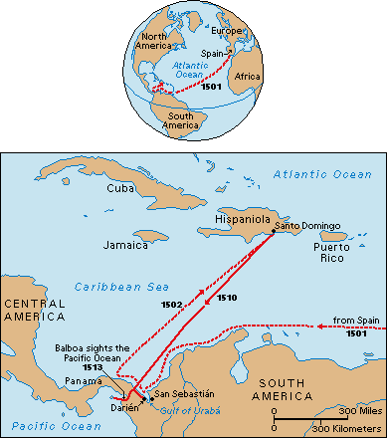

VASCO BALBOA biography

- Balboa came to the New World to find fame and fortune. Why was he forced to flee from his first job? How did he get away?

2. When Balboa arrived in the colony of San Sebastian (see map), what did he and the rest of the crew find?

3. What did he convince the crew to do once they arrived in San Sebastian?

4. What motivated Balboa to look for a new sea?

5. Look at the map…..WHAT YEAR did Balboa cross the narrow strip of land to reach the Pacific Ocean

6. What eventually happened to Balboa?

.

