The Stone Age Tasaday Tribe Controversy
A lost tribe was discovered in 1971 living deep in a Philippine rainforest and the story became an international sensation.
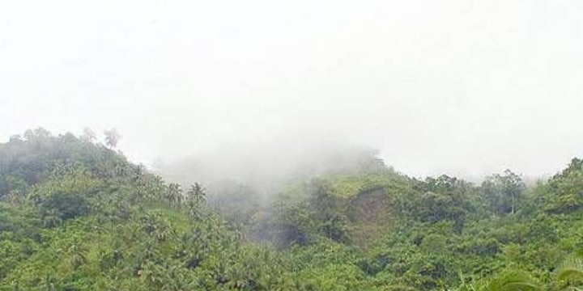
Can Rainforest Still Hide Primitive Tribes?

NBC broke the news. On July 16, 1971 David Brinkley announced: “The outside world, after maybe a thousand years, has discovered a small tribe of people living in a remote jungle in the Philippines. Until now, the outside world didn’t know they existed… and they didn’t know the outside world existed.” There were said to be only 26 members of this group still alive and they were described as the most primitive surviving culture on Earth.

Filipino Politician Finds Cavemen

A Filipino politician, Manuel Elizalde, claimed to have located these people and he appointed himself their protector. But, Robin Hemley, in his 2003 book Invented Eden, describes Elizalde as a man of “dubious background.” He had been a hard-drinking playboy before he took a deep interest in protecting ancient tribes from logging and mining interests.

In 2003, The Guardian summed up the contemporary descriptions of these isolated natives: “These people, the Tasaday, spoke a strange language, gathered wild food, used stone tools, lived in caves, wore leaves for clothes, and settled matters by gentle persuasion. They made love, not war, and became icons of innocence; reminders of a vanished Eden.”

Worldwide Sensation of the Tasaday

When news broke of the discovery a bit of a media frenzy got underway. Archaeologists, anthropologists, journalists and others swarmed into the Mindanao rainforest in search of these strange people.

As the New York Times noted in an obituary of Elizalde in 1997, the investigations proved fruitful: “Their enthusiastic reports led to a book, ‘The Gentle Tasaday: A Stone Age People in the Philippine Rain Forest,’ by John Nance; glowing accounts in The National Geographic, and extensive television coverage.” And, Jamie James wrote in Time Magazine (May 2003) that, “celebrities such as Charles Lindbergh and Gina Lollobrigida (who was a chum of Imelda Marcos, for whom she wrote the text of a coffee-table book about the Tasaday) choppered in to have a look...”

So many people wanted to meet the Tasaday that Philippine dictator Ferdinand Marcos declared the area in which they lived off limits to just about everyone. Elizalde, a member of the Marcos cabinet, set up a foundation and solicited donations to pay for the protection and welfare of the Tasaday.

Renewed Access to the Tasaday People

Ferdinand Marcos was tossed out of the country in 1986 and the region where the Tasaday tribe lived was opened up.

A Swiss anthropologist named Oswald Iten and a Filipino journalist, Joey Lozano, trekked into the rainforest to find the Tasaday. The people they met neither dressed in leaves nor living in caves; they wore Levis and T-shirts and had houses.

The British online encyclopedia h2g2 adds that, “Further research showed that the Tasaday actually came from two other tribes, tribes that had been part of the modern world for years. They (Iten and Lozano) publicized their findings through an ABC television documentary entitled ‘The Tribe that Never Was.’ ”

According to Benjamin Radford in Live Science: “Elizalde had convinced local villagers to pretend to live in caves, in return for promises of money and aid.” With an eye to attracting the media he also persuaded them to shed their 20th century clothes and wear leaves instead. Semi naked primitive people were going to make the front page.

But, little of the promised the aid money showed up. Radford explains that Elizalde “skipped town in the early 1980s with a reported $35 million and a harem of teenage girls. He died at the age of 60 in 1997, ending the saga of another ‘lost tribe.’ ”

Sources
- “Invented Eden.” Robin Hemley, Douglas and McIntyre, May 2003.
- “Too Good to be True.” Tim Radford, The Guardian, November 13, 2003.
- “Manuel Elizalde, 60, Dies; Defender of Primitive Tribe.” Robert McG. Thomas Jr., New York Times, May 8, 1997.
- “The Tribe Out of Time.” Jamie James, Time Magazine, May 19, 2003.
- “The Tasaday Hoax.” H2g2, undated.
- “A Savage Hoax: The Cave Men Who Never Existed.” Benjamin Radford, Live Science, June 25, 2008.

