THE ROYAL PROCLAMATION OF 1763

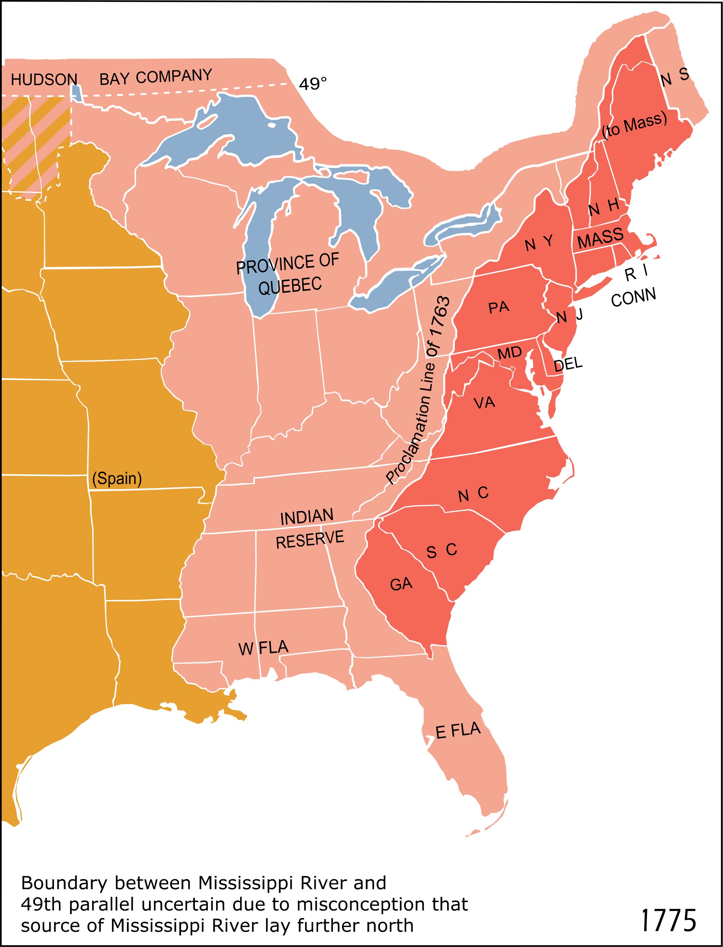

After Britain won the Seven Years' War and gained land in North America, it issued the Royal Proclamation of 1763, which prohibited American colonists from settling west of the Appalachian Mountains

The Treaty of Paris, which marked the end of the French and Indian War, granted Britain a great deal of valuable North American land. But the new land also gave rise to a plethora of problems.

The ceded territory, known as the Ohio Valley, was marked by the Appalachian Mountains in the east and the Mississippi River in the west.

Despite the acquisition of this large swath of land, the British tried to discourage American colonists from settling in it. The British already had difficulty administering the settled areas east of the Appalachians. Americans moving west would stretch British administrative resources thin.

Further, just because the French government had yielded this territory to Britain did not mean the Ohio Valley's French inhabitants would readily give up their claims to land or trade routes. Scattered pockets of French settlers made the British fearful of another prolonged conflict. The war had dragged on long enough, and the British public was weary of footing the bill. The last thing the British government wanted were hordes of American colonists crossing the Appalachians fueling French and Native American resentment.

The solution seemed simple. The Royal Proclamation of 1763 was issued, which declared the boundaries of settlement for inhabitants of the 13 colonies .

Ottawa Chief Pontiac led numerous attacks against British and colonial expansion and settlement and his violent aggression is one reason Britain issued the Proclamation of 1763.

But what seemed simple to the British was not acceptable to their colonial subjects. This remedy did not address some concerns vitally important to the colonies. Colonial blood had been shed to fight the French and Indians, not to cede land to them. What was to be said for American colonists who had already settled in the West?

In addition, the colonies themselves had already begun to set their sights on expanding their western boundaries; such planning sometimes even causing tension among the colonies. Why restrict their appetites to expand? Surely this must be a plot to keep the American colonists under the imperial thumb and east of the mountains, where they could be watched.

Consequently, this law was observed with the same reverence the colonists reserved for the mercantile laws. Scores of wagons headed westward. How could the British possibly enforce this decree? It was nearly impossible.

The Proclamation of 1763 merely became part of the long list of events in which the intent and actions of one side was misunderstood or disregarded by the other.

