The Neolithic Revolution
The most important technological development ever to occur in human history was the domestication of plants (agriculture) and animals (pastoralism). Together these developments are called the Neolithic Revolution and they allowed the development of urban centers (towns and cities), trade and most of the other things we consider to be components of "civilization."
When and how did this most important event occur?
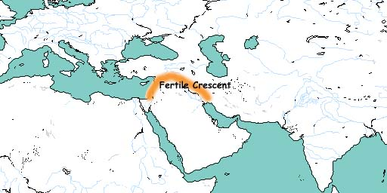

The Neolithic Revolution occurred first in the so-called "Fertile Crescent" or Mesopotamia in what is now modern Iraq. It also occurred independently (probably) at later dates in China, the Americas and possibly in parts of Africa and New Guinea. Agriculture and pastoralism diffused from Mesopotamia to Egypt, Western Europe and the Indus Valley (modern Pakistan).
To understand how the Neolithic Revolution occurred, it is necessary to understand the system it replaced. Until the Neolithic Revolution, humans engaged in an activity called "hunting and gathering" —the acquiring of food by hunting wild animals and gathering wild plants.
This system is called "food extraction.” Hunting and gathering is actually a very efficient system that much of the time produces ample food. The main disadvantages are an inability to maintain surpluses against bad times and a very low population density.
By comparison, agriculture and pastoralism, (“food production,”) provide large surpluses and can supply a much larger population per square mile. This allows a growth in population, an ability to store food against bad times and the maintenance of non-food producers who can specialize as craftsmen, warriors and leaders.
These developments, in turn, allow for a more complex society. There are, however, drawbacks. Farmers had to work much harder and thus had less leisure than hunter-gatherers. In essence, agriculture is much more labor intensive than hunting and gathering.
Agriculture also led to a much greater dependence on a smaller range of foods, so there is evidence that early farmers were more malnourished than hunter-gatherers. Farmers could produce far more food (and thus could have more children) but the food was of lower nutritional quality.
The Neolithic Revolution was actually a gradual event. It probably developed from the practice that some hunter-gathering societies have of encouraging their favorite plants to grow by clearing away competing plants (weeding or burning) and saving the seeds and planting them.
From this practice probably came the idea of clearing a whole area (by fire, for example) and planting the WHOLE area with several of your favorite foods. Then you move on to hunt and gather elsewhere and, hopefully, when you come back to that area you will find lots of your favorite foods growing.
The only step that is left to take is for the hunter-gatherers practicing this technique to settle down next to the cleared area and tend it more systematically. Once they do this, they become farmers, even though they may very well still hunt and gather to some degree to supplement their farming.
Both systems (food extraction and food production) have advantages and disadvantages
So why has agriculture essentially taken over the world?
The development of cultures is greatly determined by what strategies produce the most offspring. The strategy that produces the most children generation after generation will eventually win over strategies that allow the production of fewer children no matter how happy or unhappy those children are.
Agricultural societies fed more people, allowed for larger families and so could push out, absorb or slaughter the hunter-gathering societies in the long run.

QUESTIONS

1. What does “domestication” mean?

2. What is “pastoralism?

3. According to the article, what was the most important technological development ever made?

4. Where on a map would you find the Fertile Crescent?

5. Describe the process of “food extraction:”

7. What is the main disadvantage to food extraction?

8. What were some changes brought on by “food production?”

9. What is one disadvantage to a food producing society?

10. Why were people living in the food production societies often malnourished?

11. Describe the earliest type of farming which appeared during the later stages of the hunting gathering period.

12. Why did Food-producing societies eventually took over the world?

