The Middle Passage

The “Middle Passage” was the path taken by slave trading ships from the West-coast of Africa,(where slaves were obtained) across the Atlantic Ocean to the New World (where slaves were sold or traded for goods such as sugar & molasses). However, this voyage has come to be remembered for much more than simply the transport and sale of slaves.

The Middle Passage was the longest, hardest, most dangerous, and most horrific part of the journey of the slave ships. With extremely tightly packed loads of human cargo that stank and carried both infectious disease and death, the ships would travel east to
west across the Atlantic on a miserable voyage lasting at least five weeks, and sometimes as long as three months. The Middle Passage has come to represent the ultimate in human misery and suffering. The abominable and inhuman conditions faced by Africans during the Middle Passage clearly display the barbarity of the slave trade.

The Bottom of the Triangle:
The Economic Role of the Middle Passage

Even before the first Africans were brought to the shores of Virginia in 1619, the slave trade had become the basis for most aspects of the Atlantic economy. The Middle Passage across the Atlantic became the essential part of a system of trading routes between Europe, Africa, and North America. The exchange of goods along these routes became known collectively as the triangular trade.

Developed primarily by sea captains from England and New England, ships in the triangular trade carried goods between Europe, Africa, and the new world, although not necessarily in that order. The triangular trade system was highly successful because each region produced goods which were not produced elsewhere, and therefore were considered extremely valuable to the others, hence netting a great profit for those who transported these goods.

Triangular Trade Routes

England produced both textiles and manufactured goods which were not available in either North America or Africa. These products, along with rum obtained from New England would be traded in Africa for slaves and various riches such as gold and silver. Next, England would trade slaves and their domestic goods to the West Indies, where sugar and molasses were available. From there the sugar, molasses, and the remainder of the slaves, textiles, and domestic goods would be traded in America for tobacco, fish, lumber, flour, foodstuffs, or perhaps rum which had been distilled in New England.
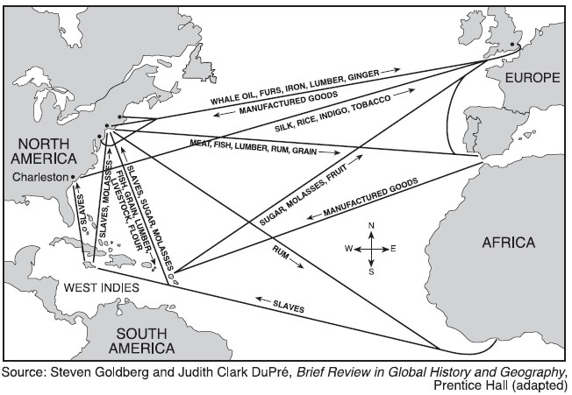

The triangular trade was obviously quite necessary at this time because none of the regions were truly self sufficient, each depended on the others for goods they could not provide for themselves. While the Middle Passage served as a great source of wealth for many whites, it was an inhuman practice and the Africans who were enslaved were subjected to atrocious conditions during the voyage.

Hell Below Deck: Life on the Slave Ships

The Middle Passage was the most infamous route of this triangular trade. Although danger lurked constantly throughout the voyage across the Atlantic, the greatest danger to the slave ships always came when they were loading on the African coast.

Once aboard the ships, the negroes realized that they were being sent far away from home, and often there was violence even before the ship set sail. However, most of these uprisings were easily put down. Others jumped overboard and plunged from the ship into the sea, choosing to either drown or be devoured by blood-thirsty sharks rather than be taken from their homeland.
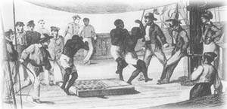

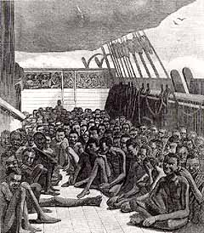
Captains of slave ships were known as either “loose packers” or “tight packers,” depending upon how many slaves they crammed into the space they had.

Most ships, especially those of the later 18th century, were “tight packers,” carrying a huge quantity of slaves who were often forced to lie in spaces smaller than that of a grave, or in some cases stacked spoon-fashion on top of one another. Regardless, life for a slave in the “tween decks,” as they were called, was extremely uncomfortable. In addition to extreme overcrowding, there was also inadequate ventilation, not to mention little or no sanitation.

In most slave ships the slaves were stowed on shelves which were usually less than half a metre high, and therefore the slaves could not sit up. The slaves were chained together which further limited their ability to move and any attempt to move would either hurt themselves or others. On some ships the women and children were allowed to move about the slave deck freely, however, the men were as good as always chained. The slaves were sometimes left below deck for days at a time, denied food, drink or any exercise, because of bad weather.

Although some captains would have their crew periodically clean the "tween decks" with hot vinegar, most chose rather to leave them alone, resulting in their atrociously unclean condition. In addition to disease and suffocation below deck, it would not be uncommon to find the body of a slave completely covered by lice.

Death aboard the slave ships

The length of the journey varied, and took everything from 40 days to 150 days, depending on the wind and ocean currents. However, one thing is clear, more slaves died the longer the trip was. Often the food storage would run low if the voyage lasted longer than the captain had estimated or if the food went bad. In times of food shortage slaves who were sick or not expected to survive the voyage, would not be given any food. In addition, the slaves could go days without food, if the weather was bad. Starvation was one of the most important reasons for slaves dying aboard the slave ships.

Diseases was another important reason for death among slaves. The overcrowded slave decks, lack of clean water and bad sanitation, caused diseases to spread like wildfire. Diseases such as dysentery and small pox were common, and the conditions the slaves lived under and the lack of medical help lead to the death of many slaves. Slaves showing any signs of disease were thrown overboard alive. The lack of exercise lead to other sufferings such as gangrene and sores, which, though not necessarily deadly, would be extremely painful.

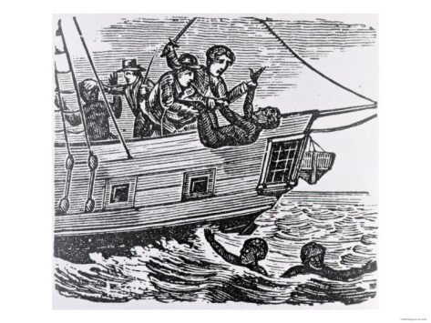
Sometimes slaves were punished and beaten so violently that they would die. Brutal punishment, and even killing of slaves, were something the slave traders generally could get away with because the slaves were not thought of as human beings.

Some slaves, maybe slaves who were sick or who the traders did not have enough food for, were thrown overboard.

Some slaves could not stand the horrible conditions, being separated from their families, seeing others suffer and die around them every day, and being tied in chains, and either went mad or took their own lives. Most suicides were done by jumping overboard and drowning

Estimate death rate

It is difficult to estimate the exact number of slaves who lost their lives on the journey from Africa to America. This is because few records were kept of those who died during the voyage and sometimes the captain could order that slaves should be thrown overboard, and these slaves would never be missed.

The estimated death rate was about 32 per cent, however this rate did vary greatly, and some historians dear to say that nearly as many slaves died on the course of the Middle Passage as made it to the Caribbean's. Occasionally the entire cargo of slaves died of diseases or as a result of shortage of food and water, but this rarely happened.

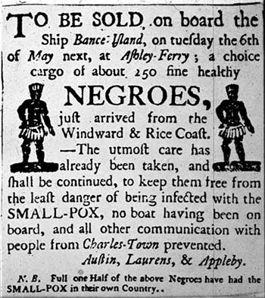
Eventually, after the arduous 3,700 mile voyage, the slave ship would reach North
America. In order to strengthen them before sale, the slaves were normally fed better in the days directly before their arrival to the New World, though their suffering was far from over. Before they could be sold, the slaves would be oiled to make their skin shiny and any imperfections, such as scars from whippings, would be filled in with hot tar in order to improve their appearance and get the best market price. Most slave ships would not be allowed to dock in the ports which they came to due to their horrible stench and the fear of the spread of any diseases which had been spread throughout the ship. Therefore, the slavers would drop anchor a few miles off shore and carry the slaves to land in smaller boats which had been stored aboard the ship. The Africans would then be sold at auction and were forced to live out the rest of their lives as slaves.

Fighting Back: Revolt on the Slave Ships

Some of the slaves who were transported along the Middle Passage attempted to rebel against the captain and crew. The Africans would make crude weapons out of their chains and shackles and attempt to kill crew members during the time when they were on deck. However, these uprisings were usually put down quickly by the crew, which used advanced weapons such as pistols and rifles to slaughter numerous slaves. Although there were some successful slave mutinies along the Middle Passage, most Africans who attempted to revolt were killed in the process and thus put out of their misery.

One of the few successful, and certainly the most celebrated, slave revolts along the Middle Passage occurred on the Amistad. In this incident, a group of captive Africans, were able to kill the captain and most of the crew, completing a successful mutiny. They left a few crew members alive to sail them back to Africa, but the remaining sailors tricked the Africans and landed in the United States instead. A long legal battle ensued, as many men championed their cause for freedom. Eventually the Supreme Court ruled that the Amistad passengers were legally free and allowed them to return to Africa.

Middle Passage

- How did the “middle passage” get its name?

- List the products carried in the colonial triangular trade routes

- What were the three stops on the triangular trade system

- Why was the triangular trade route needed?

- Why was the loading part the greatest danger to slave ships?

- What is the difference between the terms “loose-packers” and “tight-packers” and what were the advantages to each?

- Which slaves were permitted to come on deck?

- How often and how were the “tween” decks cleaned?

- Why was there such a difference between ships in how long it took to make the journey?

- What would happen on the longer voyages?

- How did ship captains treat slaves who were sick with disease?

12. What were some of the causes of death aboard ship?

- What was the estimated death rate?

- Why don’t we have an accurate death rate?

- What steps did the captains take to make their slaves more attractive to buyers?

- How successful were slave revolts on ships?

