Stuart Britain: what was life like for ordinary people?
It was one of the most turbulent periods in British history: over the course of 111 years, Stuart Britain witnessed events including the Gunpowder Plot of 1605, the bloody civil wars of 1642–51, and the beheading of King Charles I in 1649. And that’s not to mention the disastrous Great Fire of London in 1666 or the successful foreign invasion that came to be known as the ‘Glorious Revolution’ in 1688
Tuesday 19th July 2016 Submitted by: Emma Mason

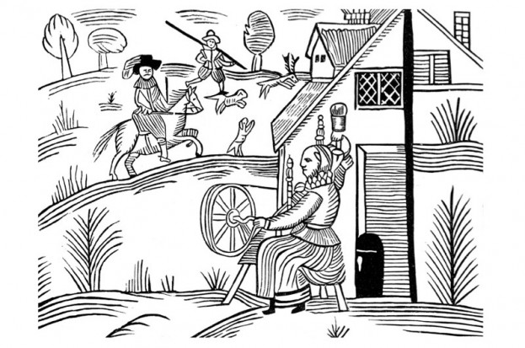
But what was life like for ordinary people during this time? Here, Andrea Zuvich, author of A Year in the Life of Stuart Britain, investigates…

“Why do you write mainly about the rich and privileged few?” This is a question that historians are often asked. One answer is that there is generally much more information available to us about this select group of people than there is about anyone else. The wealthy were more likely to be well educated – or educated enough so that they could read and write – and therefore we have more written accounts from them and about their lives. Meanwhile the ‘common people’, although no less interesting, were largely illiterate, so their stories tended to be shared orally and many have been lost over time.

Nevertheless, we have been able to determine some of the features about the lives of everyday people who lived, worked and died in Stuart Britain. Before we go further, let us clarify what is meant by ‘Stuart Britain’. The Stuarts as a Scottish monarchy certainly stretches back to the late 1300s, and is very interesting in and of itself, but ‘Stuart Britain’ is a specific period in British history from 1603, when King James VI of Scotland became the heir to Queen Elizabeth’s English throne, to 1714, and the death of his great-granddaughter Queen Anne.

A life of poverty

The majority of people during the era of Stuart Britain were poor, with a large portion living in terrible poverty. The 16th century witnessed a surge in population, which had a negative impact on living standards and led to an increase in poverty and hunger. Indeed, poverty was such a problem during the early modern period (which was, roughly, from the mid-15th century to the mid-18th century) that Poor Laws were instituted. These laws, the most well known of which was instituted in 1601 during the reign of Elizabeth I, were created in order to help relieve the poorest in society.
Most of the working population tended to work for a ‘master’, with some historians estimating this to be two-fifths of the labor force. There was good reason for this: under a master a person could reasonably expect to be provided with room and board, and wages as well.

Vagrancy was a major problem during the early modern period. Before the institution of the modern welfare state, the poorest relied upon charity from family, neighbours, their fellow townspeople, and from begging. Some of the poor emigrated from the British Isles to the burgeoning colonies in the New World, and according to historian John Morrill, more people emigrated from Britain than immigrated into it during this period.
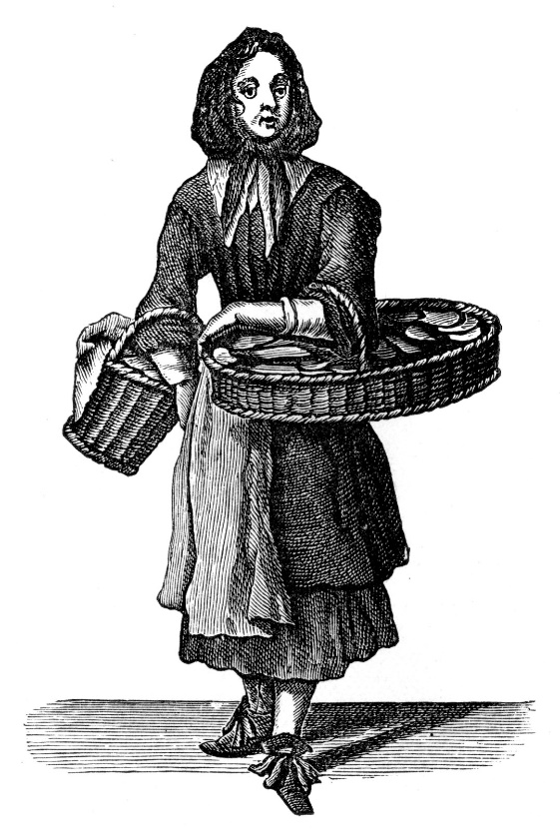
Woman selling Dutch biscuits, 1689. Series of etchings first published by Pierce Tempest (London) under the title 'The Crys of London, both Men and Women, Drawn after life, in variety of Actions and Habits'. Marcellus Laroon the Elder, Franco-Dutch painter, 1653–1702. (Photo by Culture Club/Getty Images)
Although many people lived hand-to-mouth in the first half of the Stuart period, things improved somewhat in the latter portion because laboring families were able to work not only to survive, but to have a more comfortable standard of living than their ancestors before them.

The paucity of food resources for many people meant that the principal aim of each day was finding their next meal. In a time when only limited foodstuffs were available, people depended heavily upon the harvest. To make matters worse, during the Civil War hungry soldiers (who often had their pay in arrears) would often plunder ordinary people’s stocks of food and livestock, leading to undernourishment or even starvation.
But the food eaten by the working classes – primarily legume-based dishes and pottages – were in some respects more healthy than that chosen by the wealthy, who typically indulged in meaty, rich diets and sugar-heavy desserts. The latter diet often resulted, unsurprisingly, in a variety of ailments – not least hemorrhoids. Few in Stuart Britain, it seems, appreciated the benefits of a fiber-rich diet!

The vast majority of people in Stuart Britain resided in agricultural villages, while the rest lived in the towns and cities. These were typically crowded and insalubrious, especially in the most congested city, London. Indeed, it was from the slums of St Giles in London that the Great Plague of 1665 is believed to have spread. But there were also many parts of London to be admired at this time: according to Samuel de Sorbiere’s A Journey to London in the Year 1698, “The squares in London are very many and very beautiful, as St. James, Soho, Bloomsbury, Red Lion”.
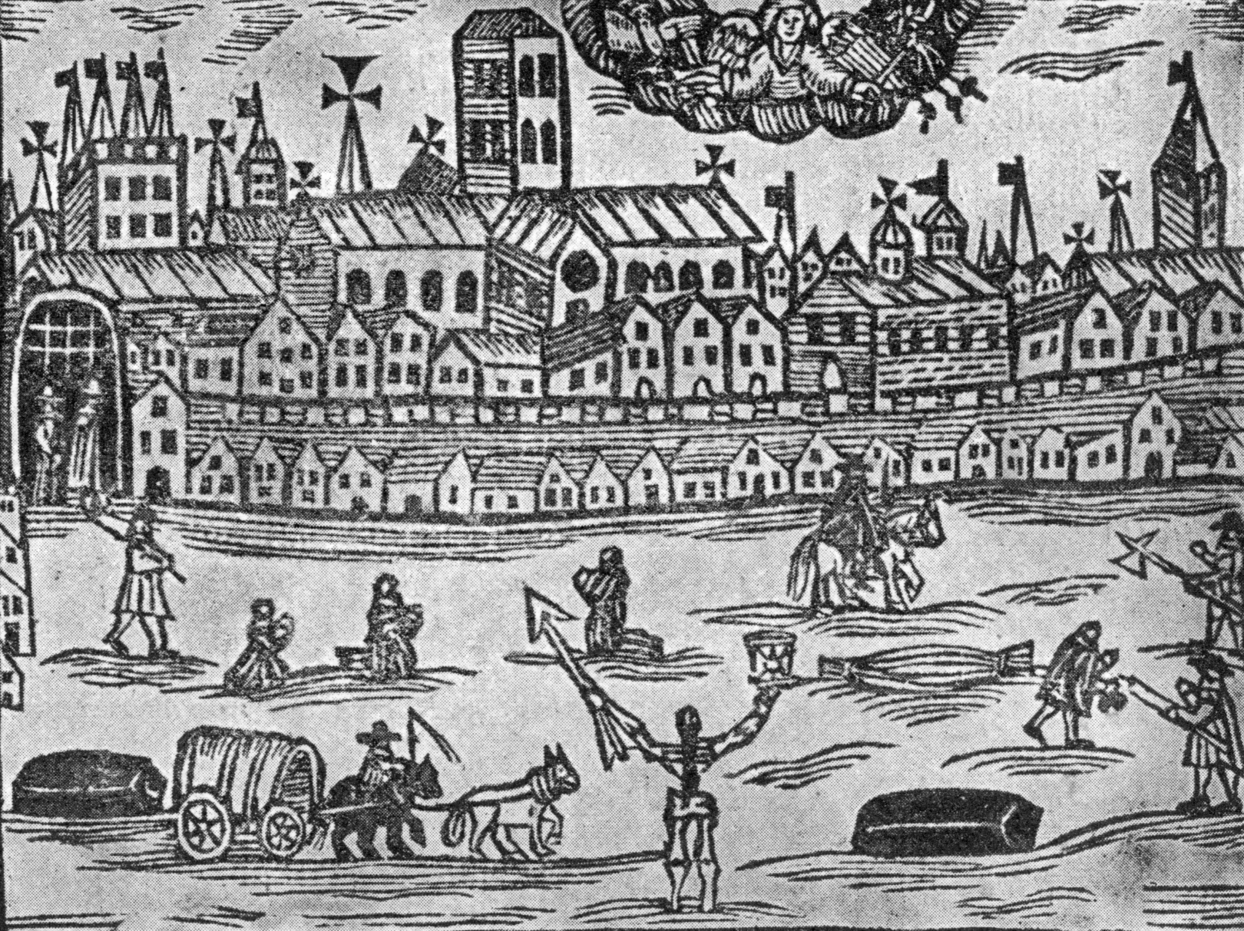
The angel of death presides over London during the Great Plague of 1665–66, holding an hourglass in one hand and a spear in the other. Published in 'The Intelligencer', 26 June 1665. (Photo by Hulton Archive/Getty Images)

Wealthier merchants, whom we would today tend to classify as middle-class, largely prospered during the Stuart period. When the plague catastrophically swept through London in 1665, it was this group of people who, like the aristocracy above them, were better able to flee from that scene of pestilence to parts of the countryside where plague was less likely.

In towns, people were employed as shoemakers, smithies, tailors, porters, saddlers, glovers and chimney sweeps, among other things. On the streets were people selling a variety of objects – from mops to oysters – and human wares: prostitution. Those who worked in agriculture had jobs involving all aspects of husbandry, including milking cows, collecting eggs from chickens, toiling in the fields, and other tasks associated with livestock and crop cultivation.
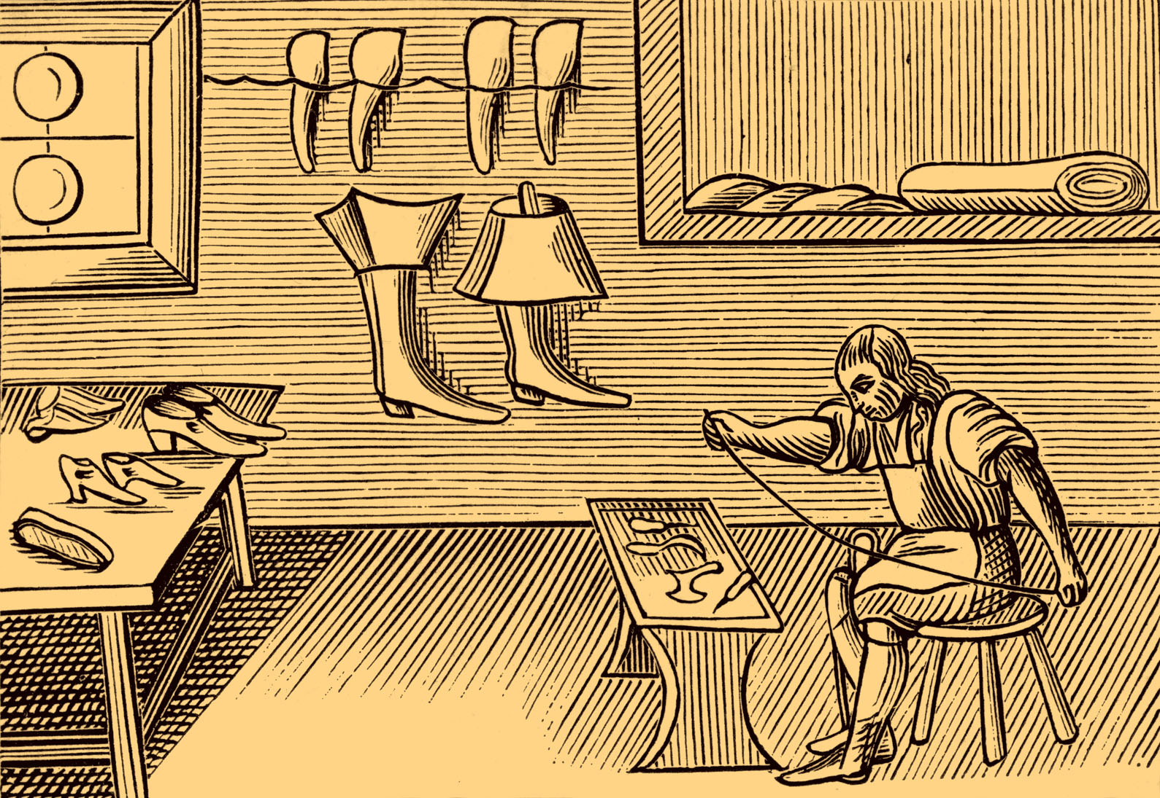
Image depicting a shoemaker, taken from a 1659 English edition of John Amos Comenius' ‘Orbis Pictus’, a widely circulated school textbook of its time. (Photo by Culture Club/Getty Images)

Battle of the sexes

Within the domestic sphere there were clearly defined roles for the sexes, and sexual inequality was generally regarded as perfectly natural. Women were bound to obey their fathers and brothers, then their husbands, and then their sons. In his Advice to a Daughter (1688), George Savile, First Marquess of Halifax, wrote,

“… there is inequality in the sexes, and that for the better economy of the world, the men, who were to be the lawgivers, and the larger share of reason bestow’d upon them… you have more strength in your looks, than we have in our laws, and more power by your tears than we have by our arguments”.

A wife was entrusted with the running of the household, the preparation of food and the raising of children. A woman could eschew marriage if she were wealthy or if she chose to live a life of servitude (women tended to find employment not only as servants but also as wet nurses, while particularly skilled women pursued midwifery). Some women found greater freedom in widowhood. We should not, however, conclude that because life was difficult for women it was easy for men. It wasn’t: the fact is, life was very hard for most people.

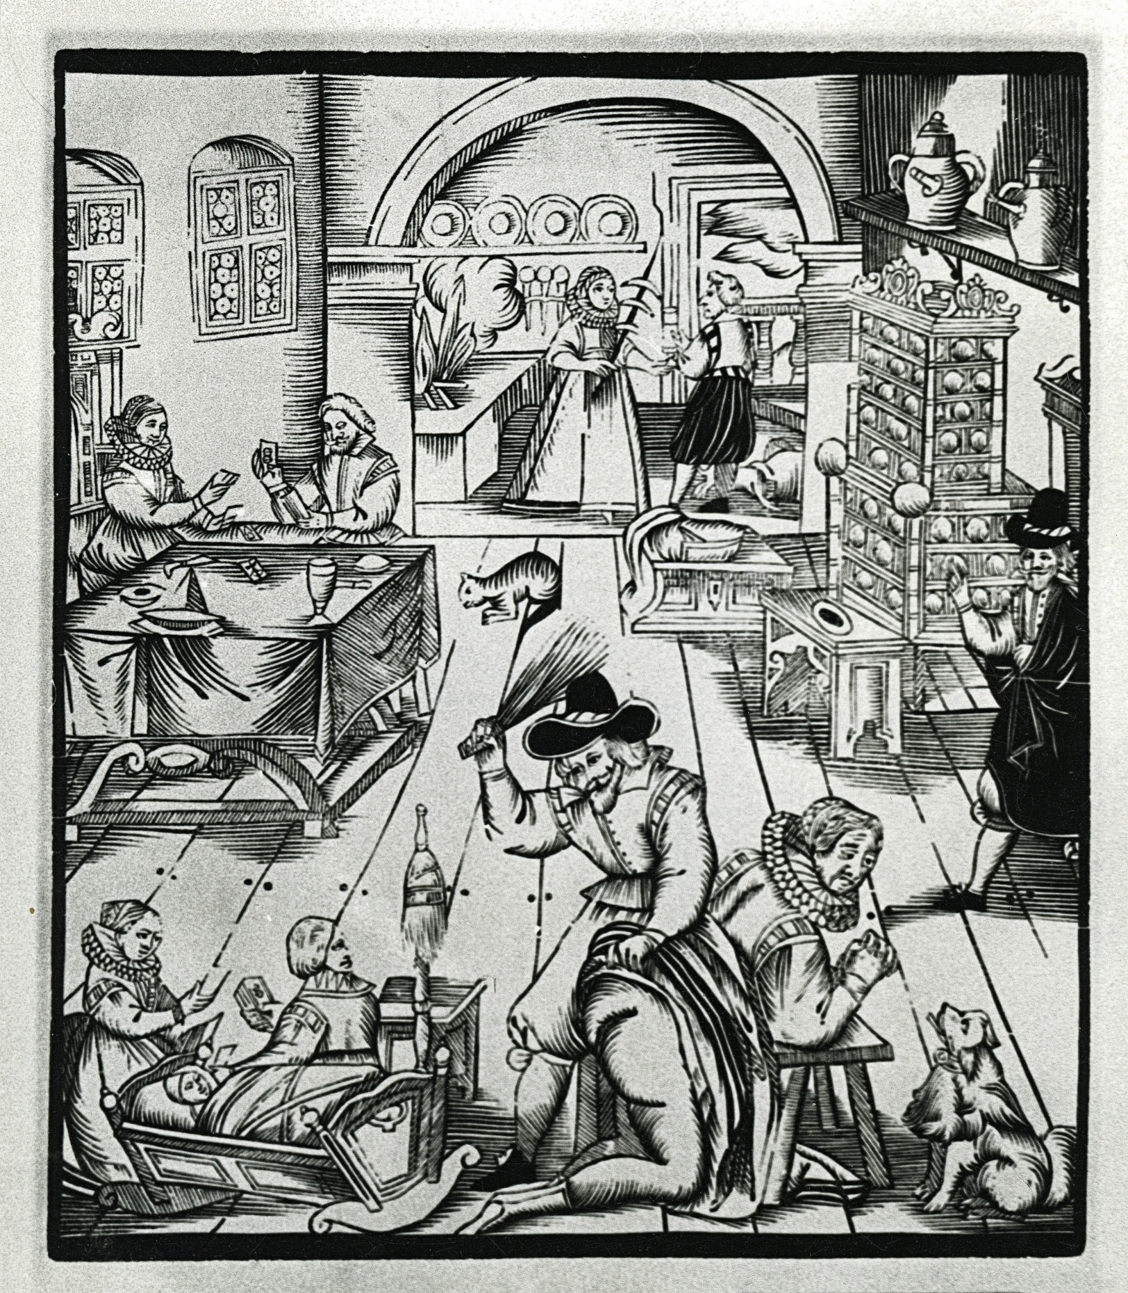
Woman flogged by her husband, 17th century. (Photo by Photo12/UIG via Getty Images)

Love and marriage

By today’s standards, however, we might consider poorer people in Stuart Britain to be more fortunate than their aristocratic counterparts in that they could choose their spouse based on genuine affection, and not solely material or political advantage. This, nevertheless, wasn’t exactly encouraged, as can perhaps be gleaned from John Ray’s A Collection of English Proverbs (1670): “He who marrieth for wealth doth sell his liberty. Who marrieth for love without money hath good nights and sorry days”.

Marriage was a very important social institution. In 1604’s An Act for the Due Execution of Diverse Laws and Statutes Heretofore Made Against Rogues, Vagabonds and Sturdy Beggars and Other Lewd and Idle Persons, people “who desert families shall be judged to be rogues”. During the reign of Charles II (1660–85), a case came to trial involving a tooth-drawer, Thomas Middleton, in which he was indicted on bigamy – a serious offence in Stuart Britain. At court, Middleton had to produce documentary evidence proving he was only legally married to one woman.

In the latter part of the Stuart period, William Petty (scientist, economist, and one of the founders of Royal Society) published Political Arithmetick, in which he covered people, husbandry, manufacture, commerce and public revenues, among other important topics. In this he wrote, “the whole kingdom grows every day poorer and poorer; that formerly it abounded with gold, but now there is a great scarcity both of gold and silver; that there is no trade nor employment for the people, and yet that the land is under-peopled; that taxes have been many and great; that Ireland and the plantations in America and other additions to the Crown, are a burthen [burden] to England; that Scotland is of no advantage”.
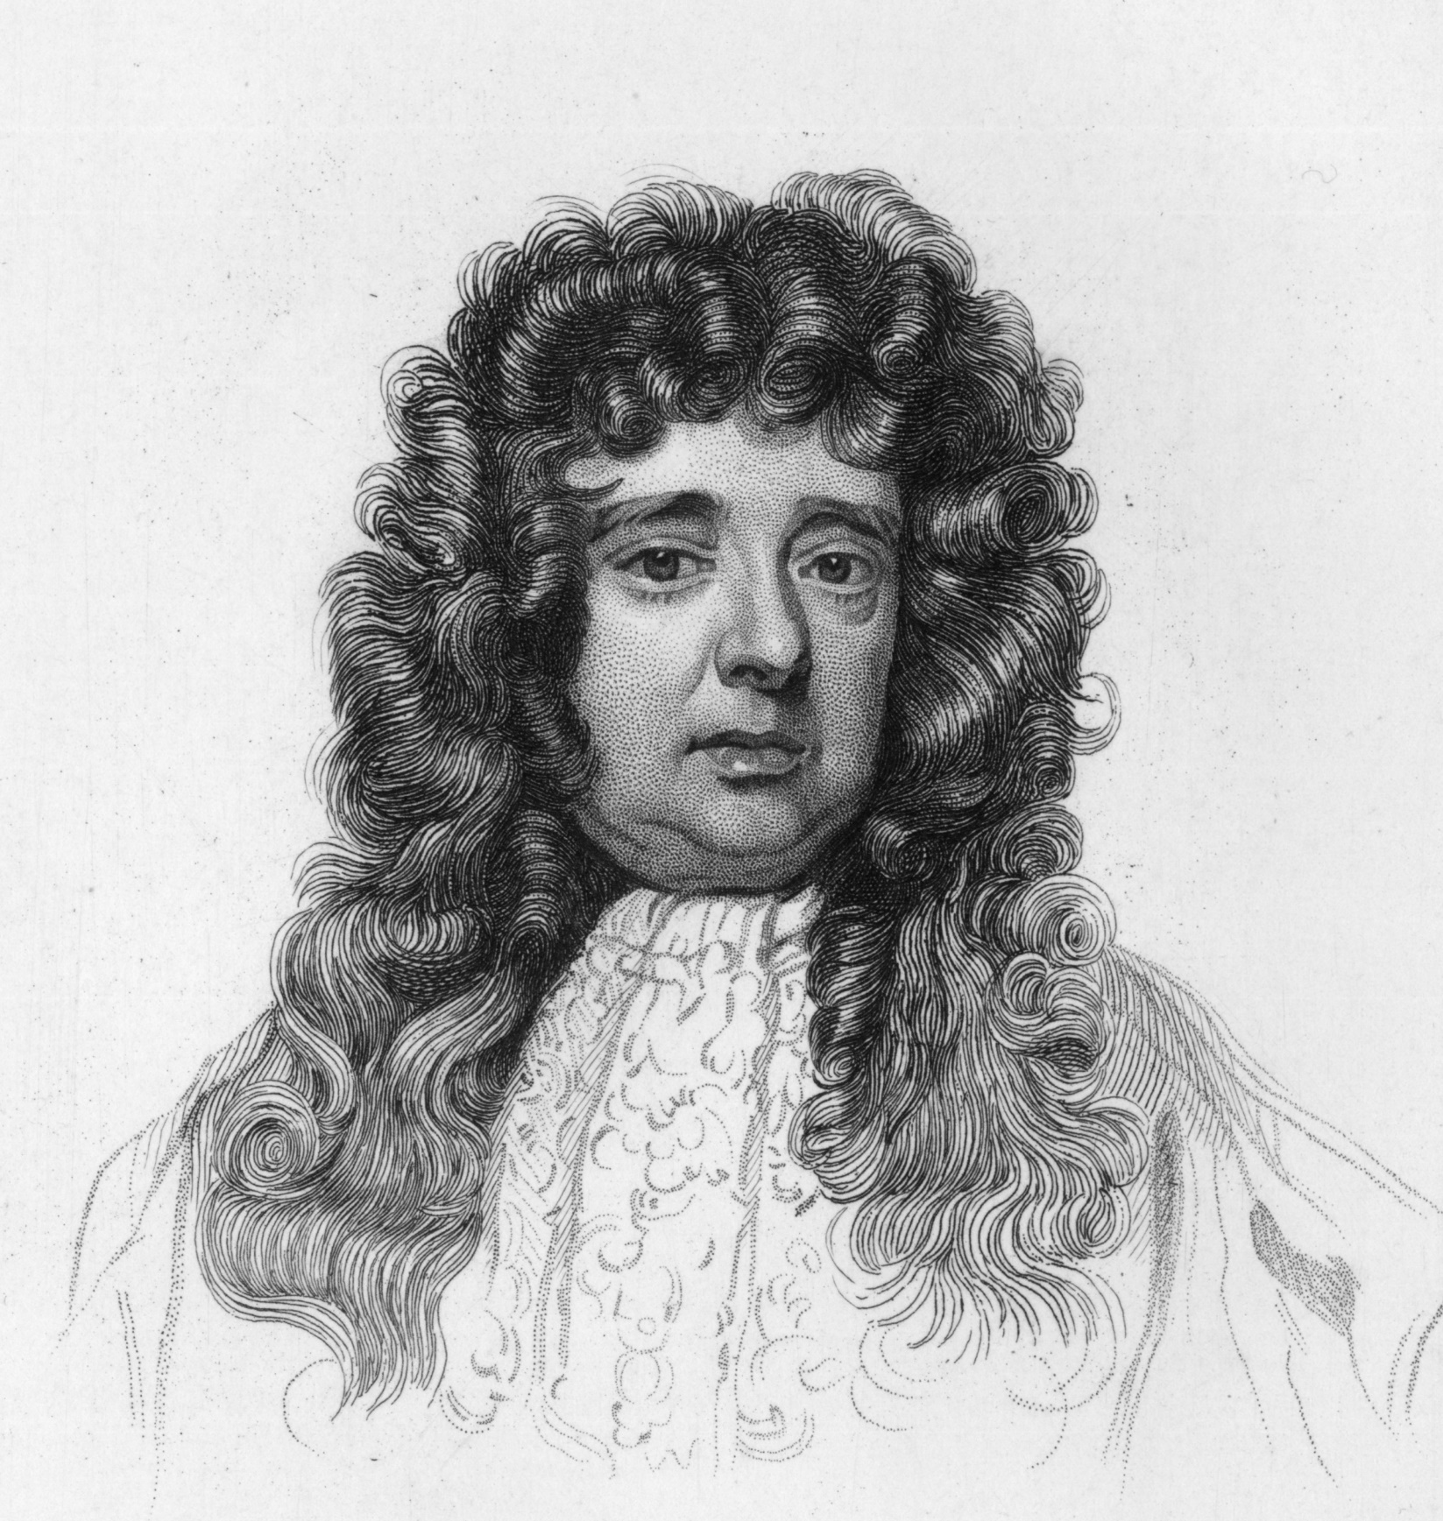
Sir William Petty, c1673. (Photo by Hulton Archive/Getty Images)

This might seem overly harsh, but Petty was concerned that the kingdom had over-stretched itself and needed to get its population and economy under control. Scotland had been joined in union to England, Wales, and Ireland during the early 17th century, and went on to be officially joined by the Acts of Union in 1707, under Queen Anne. This unification was considered controversial.

Life expectancy

Life expectancy during this period was generally a good deal shorter than in the present day. The child mortality rate was very high, and childbirth was a dangerous and potentially fatal event for the mother, too: if the trauma of birth didn’t kill her, infection could days later. Studies by historians in the 1980s estimated that between 10 and 25 women out of 1,000 perished as a result of childbirth in the Stuart period.
‘Bills of mortality’ provide a fascinating overview of what people in London died from (or at least what was believed to have killed them), such as worms, plague, dysentery, or a rather disgusting ailment called “griping in the guts” – diarrhoea combined with a terrible stomachache. Personal hygiene was not high on the Stuart agenda, and parasites such as fleas and lice affected every social class. Even intestinal worms plagued many people in Stuart Britain.

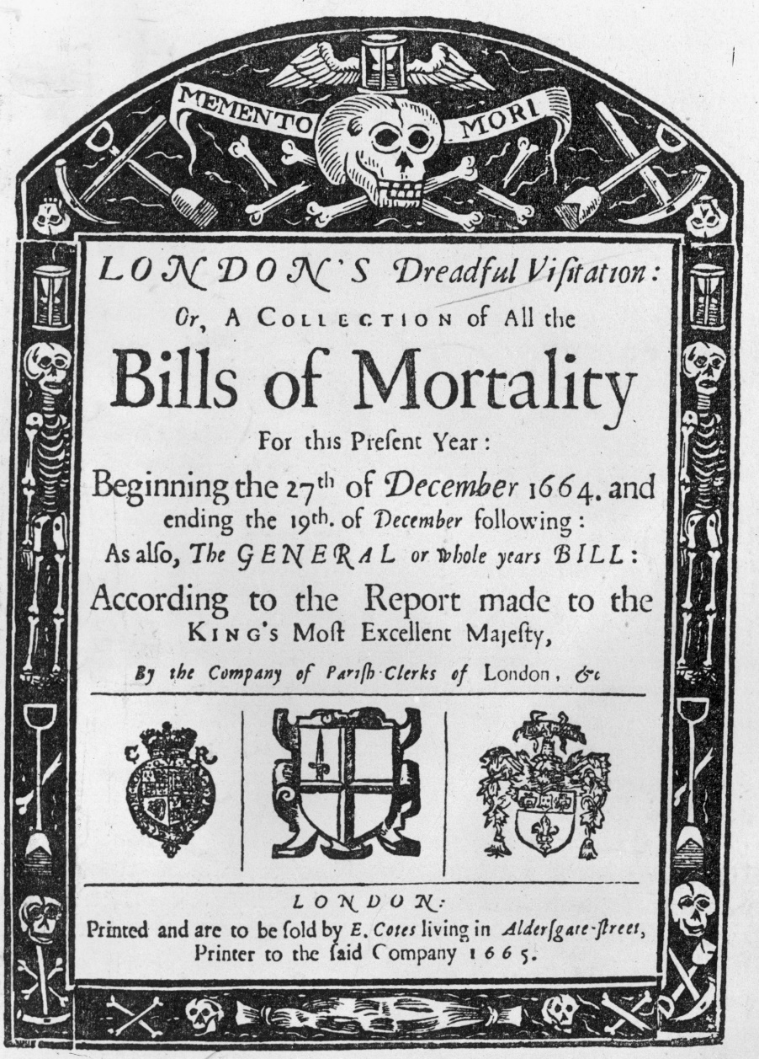
The title page of London's ‘Bills of Mortality’ (1665). (Photo by Hulton Archive/Getty Images)

Pastimes

People in Stuart Britain enjoyed a variety of pastimes, including country dances, singing and listening to live music, going to see a play at the theatre, and witnessing the gory spectacle of blood sports including cock-fighting and bear-baiting. In this vein, public executions were also popular entertainments.

During the Stuart period some ‘exotic’ foods and beverages began to make their way into Britain. Instead of being confined to local and sometimes European trade, Stuart Britain was able to trade in a global marketplace the likes of which had never been seen before: furs from North America, tea from China, and everything in between meant that some truly fascinating new tastes tantalised the British palate. In 1633, bananas were sold in London for the first time, and coffee and tea became so popular that the first coffeehouses opened – these were seen as veritable dens of political dissent and intrigue.
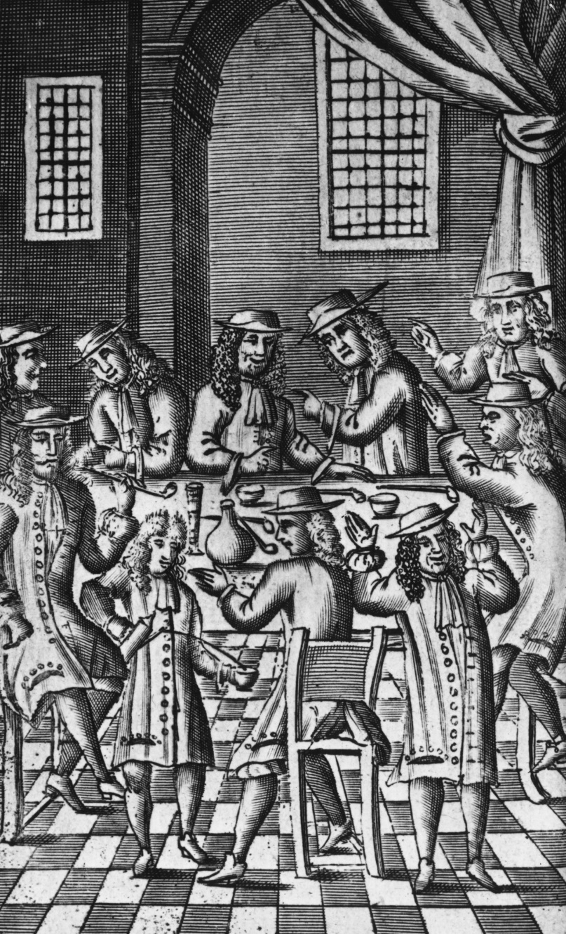
Heated debate in a coffee house on Bride Lane, Fleet Street, London, 1688. (Photo by Hulton Archive/Getty Images)

Coffee was considered a man’s drink, and women weren’t welcome in coffeehouses. Tea, on the other hand, was regarded as more of an aristocratic ladies’ drink, whereas hot chocolate (which also appeared for the first time in Britain during the 17th century) was a luxury enjoyed by both sexes in the upper echelons of society.

So while we may often tend to focus on the sumptuous lifestyles of the aristocracy of the Stuart period, this was not how most people lived. And when we do find documents describing other walks of life, these can reward us with equally – if not more, fascinating and valuable insights.

