SOLON THE LAWMAKER
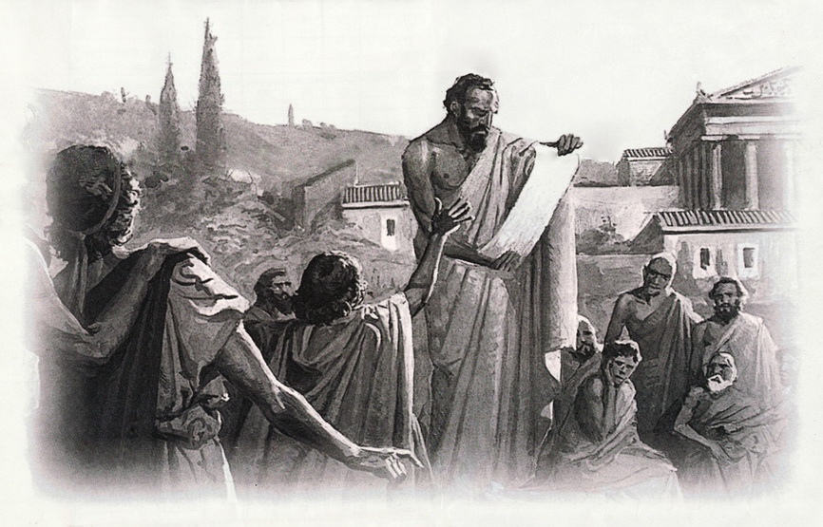
Solon (638-558 BC) was an Athenian
politician, lawmaker and poet.

He is considered as the first innovative
lawmaker that set the ground for the creation
of democracy, the governmental system that
made Athens powerful and granted the city
its fame all over the centuries.

Although his reforms lasted for short in his
time, he laid the foundations for the
economic, cultural and military development
of the town.

Solon was born into a noble family in 638 B.C. He was a merchant by profession and a poet. In 594 BC, he was elected an Archon, kind of governor, in ancient Athens. That time, the society of Athens was facing an economic and moral depression due to an agricultural crisis. Farmers could not repay their debts to the wealthy landowners and in return they were sold as slaves, including their wives and children.

Political and social instability

This debt caused instability and rivalry in the society. As Athens was divided in regions and families, there was much controversy over which family rules and which would prove better than the other. At this point, Solon was elected and made the necessary reforms to improve the local society. He created reforms three areas the constitution, the economy and Athenian morality.

The Laws of Solon

The first thing of Solon was to set all enslaved Athenians free and to relieve them from their debts. This made him very popular among the people. Also, as he had understood that farming couldn't get people enough for living, he envisioned to make Athens a powerful trade center and to have Athenian ships travel the Aegean and the Mediterranean Sea.

He prohibited exporting any other product than olive oil and he gave benefits for foreign tradesmen to settle in Athens. This was he set the foundation for the economic growth of Athens, which would also grant the city its cultural development and military power.

New political system

Another important contribution of Solon was in the formation and establishment of democracy, the governmental system that would mark the history of the city and would influence the entire world in the centuries to come. Solon divided the Athenian society into classes based on income, not birth status. Only the top three classes had political rights and could be elected in public posts.

Solon permitted all citizens to participate in the Ecclesia, the council that discussed public issues, and had the right to vote for any particular issue. Also, some of them by turns would become members of the court that could monitor the officials when needed.

With certain rules, Solon also tried to reform the morals of the Athenians.

He abolished some laws that gave only men the right to have property and that required a large amount if dowries.

He gave any citizen the right to take legal action on behalf of another citizen and forced every man to take part in wars. This stressed the importance to be politically active for the good of the state.

Traveling around the world

When Solon completed his reformation works, he left Athens to sail around the world. It is said that before he left, he made the Athenians sign a contract that they would keep those reformations for at least 10 years before they make any change in the political system. Solon wanted to prevent any political instability until the town gets strong again and recover from its political problems.

However, only four years after Solon had left, Pisistratus took over the power in Athens and established tyranny. Solon, a strong opponent of Pisistratus, was killed in Cyprus shortly after the Pisistratus had taken over control.

In the years to follow his death, Solon was remembered as a wise man with innovative ideas. Upon these ideas, Pericles, a few decades later, established the famous Athenian democracy. Today he is thought as the founder of this governmental system.

Please answer the following questions after you do the reading:

1. What kind of family life did Solon have?
2. What had caused the economic and moral troubles in Athens at this time?
3. Explain how "debt" caused huge problems for farmers.
4. What was the first law passed by Solon?
5. How did he want to improve Athens?
6. How did Solon divide the classes of Athens?
7. In what ways were people given more say in their government?
8. What happened after Solon left?

