SHOW WHAT YOU KNOW
THIRD MARKING PERIOD #2
(CHAPTER 8)
REVIEW

Know these topics for the next assessment.
Be ready on the date the exam is given.
You may use your reading guides, power point worksheet and the textbook.

UNLIKE THE PREVIOUS EXAMS, THERE WILL BE NO REVISIONS HERE
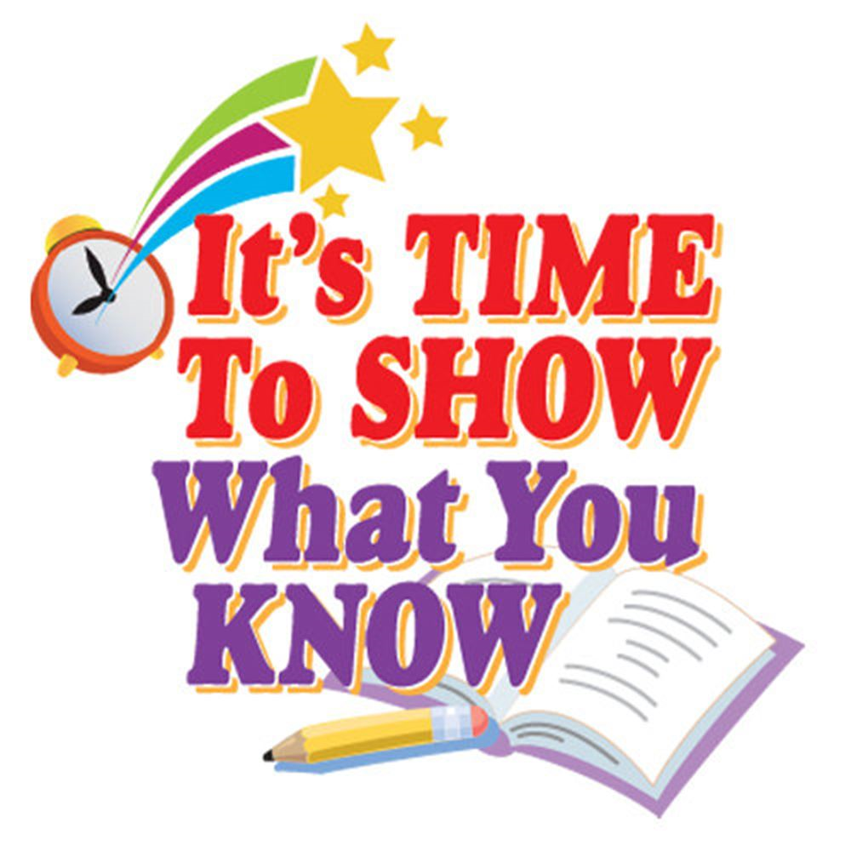
Vocabulary words and important terms to know
- Ordinance
- Federalist
- Anti_Federalist

Some important people to know
- James Madison
- Alexander Hamilton
- George Mason
- George Washington
- Samuel Adams

Major concepts and ideas:
- What powers were given to the new Congress by the Articles of Confederation?
- How did the Northwest Ordinance create a formula for new states to join the country?
- What caused Shay’s rebellion?
- How did Shay’s rebellion point out a weakness in the Articles of Confederation?
- What were some of the weaknesses of the Articles of Confederation?
- What issues divided the small and large states at the Constitutional Convention?
- What issues divided the Northern and Southern states at the Constitutional Convention?
- How was the issue of counting slaves resolved at the Constitutional Convention?
- What are the three branches of government and what is their role?
- What is the difference between a Federalist and Anti-Federalist?

