SHOW WHAT YOU KNOW
FOURTH MARKING PERIOD #2
(CHAPTER 11)
REVIEW

Know these topics for the next assessment.
Be ready on the date the exam is given.
You may use your reading guides and the textbook.

THERE WILL BE NO REVISIONS HERE
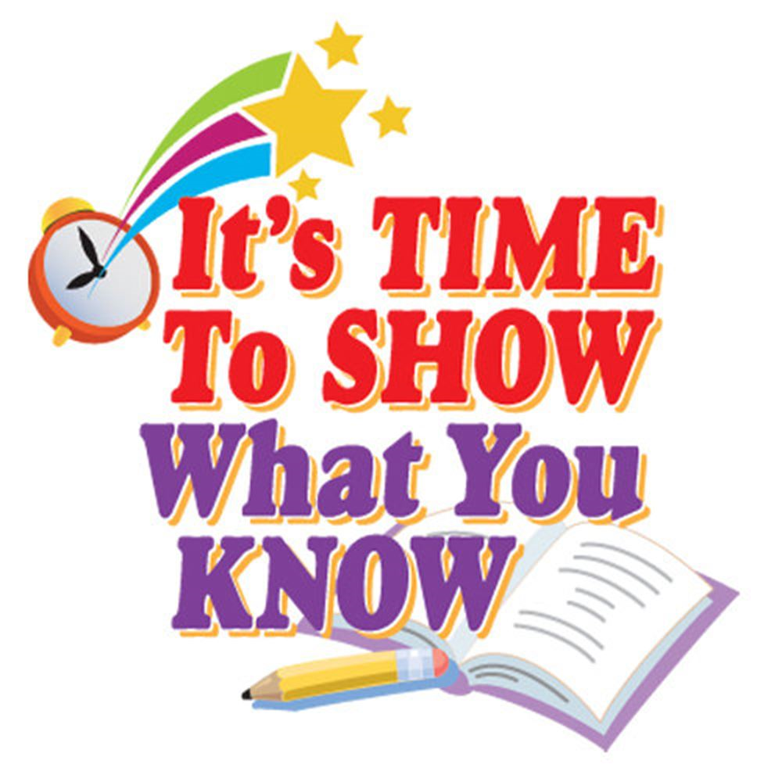
Vocabulary words and important terms to know
- Mob Rule
- “Midnite” judge
- Judicial Review
- Impressment
- Embargo

People to know
- Thomas Jefferson
- James Madison
- Toussant L’Overture
- Napoleon
- Merewether Lewis and William Clark
- Sacagewea
- Zebulon Pike
- Tecumseh
- Andrew Jackson

Major concepts and ideas:
- What changes did Thomas Jefferson make when he came into office?
- How did the court case Marbury v Madison change the role of the Supreme Court?
- What deal did Hamilton make that led to the location of our new capitol?
- Explain how the United States acquired the Louisiana Territory from France
- What were the goals of the Lewis and Clark expedition?
- What was the problem Jefferson faced with the Barbary coast and how did he solve it?
- Why did Jefferson feel the Embargo Act was necessary?
- What impact did the Embargo Act have on the United States?
- What were the reasons for and against going to war with Great Britain (England) in 1812?
- Why did the United States attack Canada during this war?
- What happened when the British invaded the United States?
- Why was the Battle of New Orleans a strange victory for America?
- What were the results of the War of 1812?

