**SCIENTISTS LEARN FROM 9000 YEAR-OLD MAN 2014**

**KENNEWICK, Wash. -** When we were children, we were told to listen to people older than us. Well, scientists are listening to the story being told by a man born 9,000 years ago.

His skull was found in 1996, along the banks of the Columbia River near Kennewick, Washington.



Doug Owsley is the Smithsonian's top

anthropologist. Eighteen years ago, he and a

group of scientists went to court against local

Indian tribes for the right to study a 9,000 year

old skeleton - known as "Kennewick Man."

*“It is America's most important skeleton,*

*it is a very rare discovery that doesn't*

*happen but once in a lifetime," said*

*Owsley.*

The tribes believed the bones are related to

their ancestors and need to be reburied. The

court ruled in favor of science.

"Kennewick Man" tells us about how humans first came to North America.” Owsley replied*:*

*“This skeleton leads us to believe that people came to North America thousands of years earlier than we had thought. The skeleton is related to people from East Asian coastal populations," said Owsley.*

He was five feet seven, and a muscular 163 pounds. His diet left a chemical signature in his bones.

*"You find that this man is heavily dependent on seals," said Owsley. "It appears he has had lots of salmon in his diet. This man is a marine-mammal hunter."*

*“His enormous right arm bone suggests he hunted with a spear, and life was often brutal, amd very physical," said Owsley. "He has half a dozen fractured ribs."*

He had a severe shoulder injury, two skull fractures - and a spear-head jammed in his hip.

*"I think this is something that's intentionally thrown at this man with the intention of killing him," said Owsley. "This is a very tough person and he was able to get away."*

Kennewick Man's bones have been locked away by the federal government, but Owsley says there's still so much to learn - including what finally killed him.

*"I feel like the skeleton is just beginning to talk to us and we need to carry on that conversation," said Owsley.*

A conversation "Kennewick Man" has been waiting to have for a very long time.

**DNA LINKS KENNEWICK MAN TO NATIVE-AMERICANS**

**2016**

SEATTLE — DNA tests show a link between 8,500-year-old human bones found in the

state of Washington and the Native American tribes that live in the region today.

The DNA results will lead to a re-thinking of who Kennewick Man's was. The bones are locked up in a Seattle museum The skeleton has been the

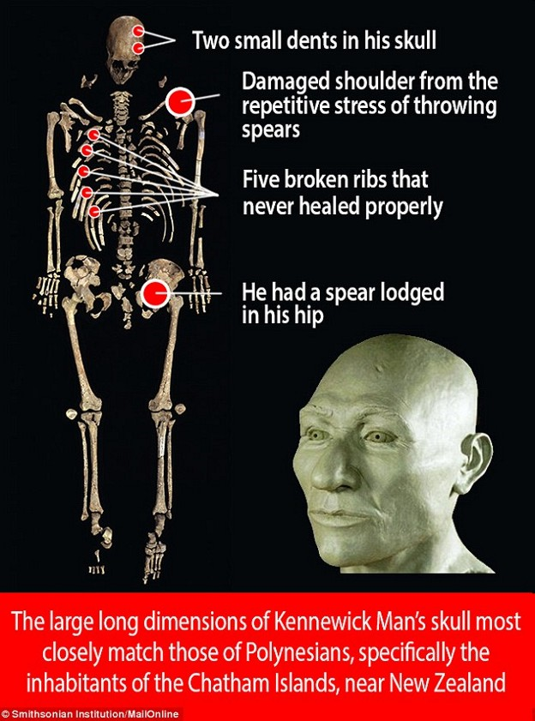

subject of legal battles ever since it was found

in 1996 on the banks of the Columbia River.

**The story from the skull**

Back then, Native American leaders wanted the

remains for reburial. But scientists who wanted

to study the bones went to court, saying that the

skeleton was not linked with a present-day tribe

.

Based on the shape of the skull, researchers

argued that Kennewick Man looked more like

the inhabitants of a far-off land — perhaps from

the Far North or China.

After a series of hearings, federal judges sided

with the scientists so the bones were used for

further study. Today the bones are locked away

in Seattle at the University of Washington

Museum of Natural History and Culture.

Just last year, dozens of researchers produced

a 680-page book detailing what they learned

about Kennewick Man. They concluded that the

man had several wounds during his lifetime,

was about 40 years old when he died — and that his narrow skull most closely resembled those such as Polynesians or Japan. They said Kennewick Man appeared to favor a diet of fish and marine mammals, based on a chemical analysis of his bones. This was cited as further evidence that he wasn't a local, but rather a traveler who made his way down the Pacific Coast to Washington.

**A different story from the genes**

At the same time, other researchers were trying to find DNA from a bone that had been taken from Kennewick Man during an earlier round of tests. The DNA was highly damaged, which is very typical for ancient DNA, but thanks to advances in technology, some scientists were able to find enough DNA to make a conclusion.

Kennewick Man's genetic past ran counter to the other scientists' view. These scientists ruled out any connection association with Polynesians or other far-off populations. It is very clear that his DNA shows he is most closely related to modern Native Americans.

**TRIBES RETURN KENNEWICK MAN TO THE GROUND**

**2017**

The ancient bones of the Kennewick Man have been returned to the ground.

Early Saturday, more than 200 members of five Columbia tribes gathered to lay the remains of the man they call “The Ancient One” to rest.

*“We always knew the Ancient One to be Indian. We have stories that tell of our history on this land, and we knew, at the moment of his discovery, that he was our relation. This is a big day, and our people have come to witness and honor our ancestor.” said Armand Minthorn, of the local native-American tribal board.*

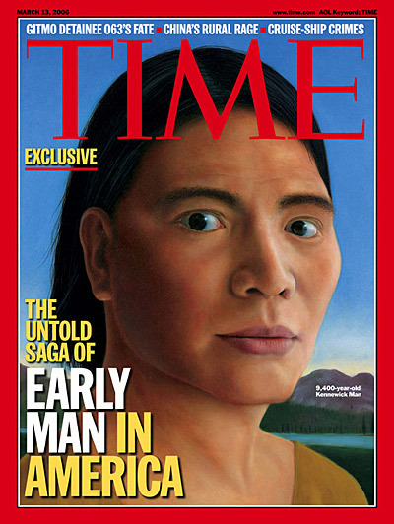

On Friday, representatives of 5 tribes met at the

University of Washington Museum in Seattle to

claim the remains of Kennewick Man stored

there. A law passed by Congress and signed

by President Obama in 2016 required the

skeleton to be turned over to the tribes.

*We jointly believe in respecting our*

*ancestors … and have fulfilled our*

*responsibility to finally lay the Ancient*

*One to rest. Gary Burke, Umatilla board*

*chairman*

Kennewick Man was found on the banks of the

Columbia River a little more than 20 years ago

by two students. The skeleton is among the

oldest and most complete found in North

America.

Tribes immediately filed claims for the Ancient

One, but a federal judge, swayed by an

analysis of the shape of Kennewick Man’s

skull, determined that the skeleton was not

Native American and allowed scientists to study

the bones.

Advances in DNA analysis allowed specialists

to compare DNA from the bones and that of

modern-day populations.

The Ancient One’s DNA was a closer match to modern Native Americans.

Congress passed a law which the President signed to end decades of debate and give the local native-American tribes the opportunity to give their descendant a proper burial and a final resting place.