SAMUEL DE CHAMPLAIN biography

Samuel de Champlain was a French geographer and explorer whose mission was to establish a joint French and Native American agricultural and fur-trading colony. In 21 voyages to New France he planted the foundations for modern Canada

Samuel de Champlain was born in a small seaport town in France. By 1601 he was following his love of travel and the sea and extending his expertise in navigation.

Early Travels

Champlain spent time during 1601-1603 working for Spain. In 1603 he went on an expedition to the St. Lawrence for France. Champlain reached Montreal that summer; by questioning natives through an interpreter, Champlain made astonishingly accurate guesses about the network of the Great Lakes, including Niagara Falls He was back in France by September.

Champlain had interest and curiosity about Acadia (the area of Newfoundland and around the St. Lawrence), where he hoped to find mines and perhaps a more effective route into the interior.

Champlain began a new expedition in May 1604. The expedition made landfall at Nova Scotia. Champlain chose a temporary base for settlement. The winter was a bad one, with severe cold, and the island became surrounded by treacherous ice flows, making it more a prison than a place of safety.

In the summer, Champlain explored the American coast. He made excellent charts of it. The winter of 1605 was spent easily in a fort protected from the cold northwest winds. In 1606, when new arrivals turned up, Champlain again explored southward along the American coast.

The winter of 1606 was mild and easy, for the new arrivals had brought supplies and wine. In May 1607 the whole colony returned to France, stopping to explore Nova Scotia.

In 1608 Champlain went once more to the St. Lawrence. Arriving in June, they began the construction of a fort at the site of what is now Quebec. Champlain helped the Hurons who were rivals of the Iroquois Indians. If the French wanted furs, they had to support the Native Americans who supplied the furs, or at least controlled access to them. Thus they were compelled to support the Hurons against their enemies.

Champlain was back in France over the winter 1609, making reports to the king. The story of Champlain's financial investors were seeking to get control of the fur trade. Champlain had less interest in money than in exploration and in the development of a colony. With patience and persistence, he traveled back and forth across the Atlantic for the next 2 decades. All totaled, he made some 21 voyages across the Atlantic.

Travel to the Interior

In 1615 Champlain made a bold venture into the interior of Canada. Bound by promises to the Hurons to help them against the Iroquois and driven by his own curiosity, he began his voyage to the Huron country. Traveling the river, he reached the northeastern corner of Lake Huron. He was probably the first white man to see it.

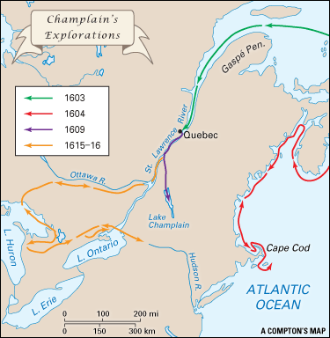

They met with the Huron raiding party and canoed down to Lake Ontario, to the Iroquois village. Champlain was wounded in the knee by an Iroquois arrow, and the raiders had to return home. Unable to walk, he was at times carried like a baby on the back of a Huron Indian.

Champlain had to stay the winter but continued visiting other tribes that were neighbors of the Hurons. He provided a detailed account of the Native American ways of living, one of the earliest and best available. He returned to France in 1616.

In 1619 he wrote accounts of his voyages with sketches and maps.

Champlain was a man of large ideas; his aim was to establish a joint French and Native American agricultural and fur-trading colony. He contemplated the Christianizing of Native Americans and their intermarriage with the French. He is, of all the explorers, the real founder of Canada.

SAMUEL DE CHAMPLAIN biography

1. How many voyages did Champlain end up making to North America?
2. Why was Champlain interested in the area known as “Acadia?”
3. What troubles did he and his group have in the winter of 1604?

4. Why did Champlain get involved in a war between the Hurons and the Iroquois Indians?

5. In 1615, Champlain went deep into the interior of Canada with Huron Indians along with his exploring group. How did Champlain end up getting injured during this?

6.What were three things he hoped to accomplish over time

