Roughing It

The devil seems to have again broken loose in our town. Pistols and guns explode and knives gleam in our streets as in early times. When there has been a long season of quiet, people are slow to wet their hands in blood; but once blood is spilled, cutting and shooting come easy.
Night before last Jack Williams was assassinated, and yesterday forenoon we had more bloody work, growing out of the killing of Williams, and on the same street in which he met his death. It appears that Tom Reeder, a friend of Williams, and George Gumbert were talking, at the meat market of the latter, about the killing of Williams the previous night, when Reeder said it was a most cowardly act to shoot a man in such a way, giving him "no show." [After some more arguing,] Gumbert drew a knife and stabbed Reeder, cutting him in two places in the back.
Reeder [was] taken into the office of Dr. Owens, where his wounds were properly dressed. [Being] considerably under the influence of liquor, Reeder did not feel his wounds as he otherwise would, and he got up and went into the street.

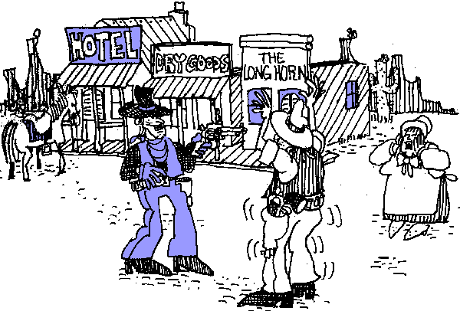

How can the absence of authority endanger lives, liberty, and property?

He went to the meat market and renewed his quarrel with Gumbert, threatening his life. After these threats Gumbert went off and procured a double-barreled shot gun. [He came back, and shot Reeder twice. The doctors examined him and said it was almost impossible for him to recover.]
At the time that this occurred, there were a great many persons on the street in the vicinity, and a number of them called out to Gumbert when they saw him raise his gun, to "hold on," and "don't shoot!"
After the shooting, the street was instantly crowded with inhabitants of that part of the town, some appearing much excited and laughing; declaring that it looked like the "good old times of '60."...It was whispered around that it was not all over yet; five or six more were to be killed before night

