**PURITAN PUNISHMENTS**



In their rigid enforcement of community

standards,

[Puritan New Englanders](http://www.newenglandhistoricalsociety.com/the-great-migration-of-picky-puritans-1620-40/) often resorted to

unusual punishments such as the bilbo,

the cleft stick, the brand, the ear crop and

the scarlet letter.

In Massachusetts, [New Plymouth](http://www.newenglandhistoricalsociety.com/april-5-the-day-the-mayflower-sailed-for-england/),

Connecticut and [New Haven Colony](http://www.newenglandhistoricalsociety.com/how-new-haven-became-part-of-connecticut-it-was-the-regicides/),

the Puritans were more concerned

with moral behavior and clean living

than they were with property rights.

They took their laws from the Bible,

rather than English precedent, and

people were less likely to be punished

for larceny than to be punished for

blasphemy, idolatry, drunkenness,

lewdness, cursing or smoking.

Long-term incarceration was unknown, thought capital punishment for 12 crimes – including blasphemy and [witchcraft](http://www.newenglandhistoricalsociety.com/dirty-laundry-and-a-friend-save-philip-english-from-the-salem-witch-trials/) – accepted. Puritan law recognized the

principle that no one should be deprived of life, liberty or property without due process, and explicitly limited government power.

[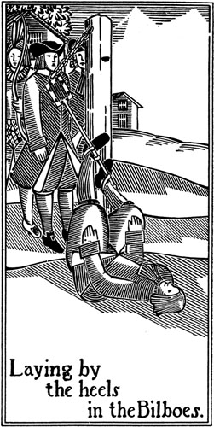](http://www.google.com/url?sa=i&rct=j&q=&esrc=s&source=images&cd=&cad=rja&uact=8&ved=0ahUKEwjOrKXT0-DJAhVCeD4KHWwfDewQjRwIBw&url=http://www.mirrorservice.org/sites/gutenberg.org/3/4/0/0/34005/34005-h/images/&psig=AFQjCNFPyHxKqL6JgX9-r7t92-0lnN4wig&ust=1450364678150109)

**The Bilbo**

The first Puritans took with them the bilbo as

a wayto punish sinners and lawbreakers.

It was named after its place of origin, Bilboa,

Spain, and shipped with the Spanish navy in

anticipation of all the English prisoners they’d

have to shackle

They were a simple but effective restraint;

a long heavy bolt or bar of iron having two

sliding shackles, something like handcuffs,

and a lock. In these shackles were thrust

the legs of offenders or criminals, who were

then locked in with a padlock.

Sometimes a chain at one end of the bilboes

attached both bilboes and prisoner to the

floor or wall.

Bilboes were eventually replaced with

wooden stocks.

**The Scarlet Letter**

[Nathaniel Hawthorne](http://www.newenglandhistoricalsociety.com/nathaniel-hawthorne-holes-up-in-his-bedroom-for-12-years/) enshrined

[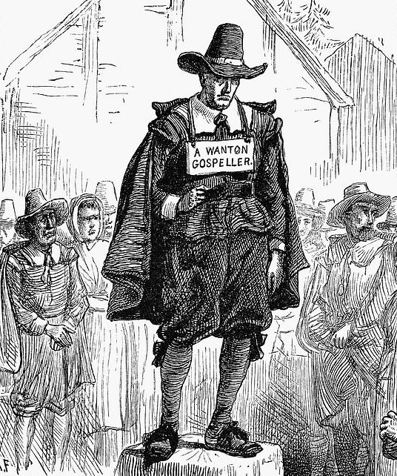](http://www.newenglandhistoricalsociety.com/wp-content/uploads/2015/09/puritan-punishments-granger.jpg)

in literature the Puritan

punishment of ordering a sinner

to wear a scarlet 'A.'

But that wasn't the only letter of

shame.

In 1656 a woman was sentenced

to be whipped at Taunton and

Plymouth, fined and forever

‘to have a Roman B cutt out of

ridd (red) cloth & sewed to her

vper garment on her right arm in

sight.’

The 'B' was for blasphemy.

In 1636, William Bacon was

sentenced to spend an hour in

the pillory wearing in public view

a great 'D' -- for drunkenness.

In 1633, Robert Coles was forced to stand with a white sheet of paper on his back with the word 'Drunkard' written in 'great letters' on it, and stand as long as the court ordered 'for abusing himself shamefully with drink.'

The next year, Coles was sentenced mores severely: He had to wear a D made of red cloth on a white background for a year.

In Massachusetts, anyone who interrupted a preacher during worship was reproved by the magistrate.

If they did it again, they had to pay a fine of five pounds, stand on a block four feet high with a sign in capital letters, 'WANTON GOSPELLER.'

**Cleft Stick**

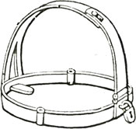

Slanderers, scolds and liars were

liable to have a cleft stick put onto

their tongues while they stood in a

public place.

In 1639 in Salem, Mass., two men

who got drunk and lied were fined

and forced to stand by the

meetinghouse door with a paper on

their hats ‘subscribed for gross

premeditated lyinge.’

A cleft stick was put on their tongue.

Men, women and even children could have their tongues‘thrust into the cleft stick.’ In Rhode Island, a 'whispering stick' was used in a Providence school as a punishment for whispering. It was a wooden gag with holes with which it could be tied in place. Earle wrote that many a child had a cleft stick placed on his tongue 'for ill words or untimely words in school.'

[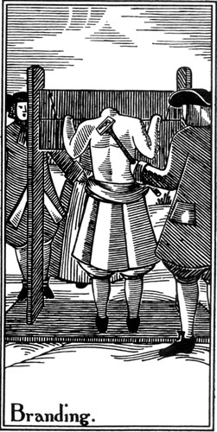](http://www.newenglandhistoricalsociety.com/wp-content/uploads/2015/09/puritan-punishment-maiming.jpg)

**Branding and Maiming**

Branding and maiming were common

punishments, especially for Quakers.

Quakers were banished from

Massachusetts, and the punishment

for returning was painful.

Colonial records described in 1657

what should happen to

Quakers who came back:

*A Quaker if male for the first*

*offense shall have one of his ears*

*cut off; for the second offense*

*have his other eare cutt olff; a*

*woman shal be severely whipt;*

*for the third offense they, he or*

*she, shall have their tongues*

*bored through with a hot iron.*

[Abel Buell](http://www.newenglandhistoricalsociety.com/america-gains-its-first-map-the-mapmaker-gains-back-his-ear/) of Killingworth, Conn., was

caught minting money on homemade

plates.

*The tip only of Buell's ear was*

*cropped off: it was held on his*

*tongue to keep it warm till it was*

*put on the ear again, where it*

*grew on. He was branded*

*on the forehead as high up as possible.*

*This was usually done by a hot iron in the form of*

*a letter designating the crime, which was held on the*

*forehead of the criminal till he could say the words "God save the king."*

**The Ducking Stool**

The way of punishing women is pleasant enough. They fasten an armchair to the end of two beams twelve or fifteen feet long, and by which means it plays freely, and always remains in the natural horizontal position in which a chair should be, that a person may sit conveniently in it, whether you raise it or let it down.

They set up a post on the bank of a pond or river. They place the woman in this chair and so plunge her into the water as often as the sentence directs.

The ducking stool, rather than being fixed in position by the river or pond, could be mounted on wheels to allow the convicted woman to be paraded through the streets before punishment was carried out.

This punishment was for a crime of a troublesome and angry woman who broke the public peace by habitually arguing and quarreling with her neighbors.

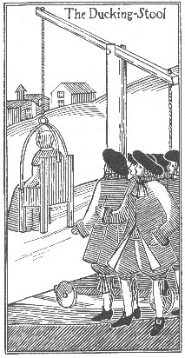

Some words you might need to know before reading:

* larceny: theft
* blasphemy:  speaking negatively against the church, using the Lord's name in vain
* idolatry: laziness
* lewdness: acting in a gross or inappropriate manner
* incarceration: sent to prison
* enshrined: placed
* pillory: public place of punishment
* reproved: punished
* slanders: lies
* premeditated: thought about doing it before actually doing it
* maiming: tearing flesh or scarring the body

Describe the following punishments (and an example as to why these punishments might be given)

1. Bilboe
2. The Scarlet Letter
3. The Cleft Stick
4. Branding and Maiming
5. The Ducking Stool