LAW CLASS
COURT CASES

Morse v Frederick (2007)
Background of the case
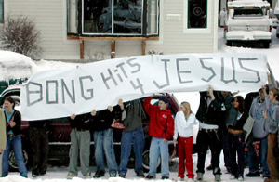

Joseph Frederick knew the Olympic Torch relay runner was coming to his town.
Officials at his Juneau, Alaska school had decided that students should be able to see the Olympic relay pass on its way to the games in Salt Lake City, so a mini-field trip had been organized.
Students were taken outside, across the street from the school. They were surrounded by television cameras and reporters, all hoping to the capture the event on film. Few people noticed Frederick was carrying a banner.
As the Olympic relay approached and cameras rolled, Frederick and some fellow students unfurled the 14-foot banner. It read, “Bong Hits 4 Jesus.” (This was a slang reference to smoking marijuana.) The banner did not create a disturbance, but Principal Deborah Morse told the students to take it down. When Frederick refused, Morse took the banner away and later suspended Frederick for ten days. She cited the school’s policy against materials promoting illegal drugs.
Frederick denied that the banner promoted drug use. He explained, “the words were just nonsense meant to attract television cameras.” He believed the First Amendment protected his right to display this banner at a public school event, and brought suit against Principal Morse. The case eventually went to the Supreme Court.

How would you rule on this?

