Line of Demarcation

The Line of Demarcation
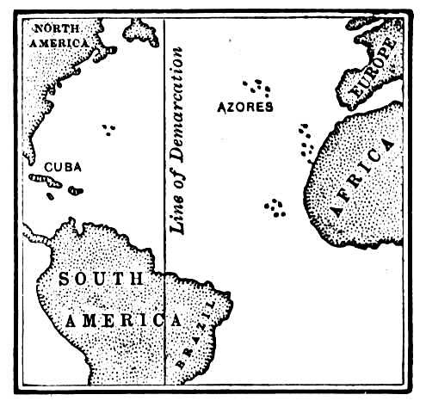
In 1493 the Spanish-born Pope
Alexander said that all lands west of
a pole-to-pole line 350 miles west
of the islands of the Azores
should belong to Spain.

The Pope did not mention Portugal
or its lands, so Portugal could not
claim newly discovered lands even
if they were east of the line.

Another decision made by the Pope,
gave all lands and islands, "at one
time or even yet belonged to India"
to Spain, even if east of the line.

The Portuguese King John II was not pleased with that arrangement, feeling that
it gave him far too little land—it prevented him from possessing India, his goal (as of 1493, Portuguese explorers had only reached the east coast of Africa).

He opened negotiations with King Ferdinand and Queen Isabella of Spain to move the line to the west and allow him to claim newly discovered lands east of the line.

Treaty of Tordesillas ( TOR-DAY-CEE-AHS)

Even though the treaty was negotiated between Spain and Portugal without consulting the Pope, sources call the resulting line the Papal Line of Demarcation.

Very little of the newly divided area had actually been seen by Europeans, as it was only divided by the treaty.

Spain gained lands including most of the Americas.

The easternmost part of current Brazil was granted to Portugal when Pedro Cabral landed there while he was on his way to India.

The line was not strictly enforced—the Spanish did not resist the Portuguese expansion of Brazil. The treaty was rendered meaningless between 1580 and 1640 while the Spanish King also became the King of Portugal.

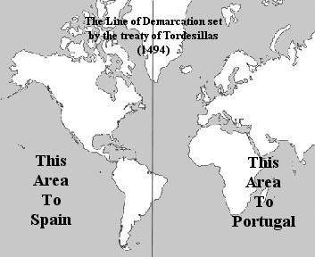

LINE OF DEMARCATION

- Why was the line necessary?

- Would you be suspicious if the Pope (born in Spain) drew a line that favored Spain?

- Who was the King of Portugal and why do you think he complained about the Pope's decision?

- How did Spain and Portugal eventually solve their problem?

- What part of the world did Spain receive?

- What part of the world did Portugal receive?

- How would you feel if you were any of the other European countries at this time?

