LAW CLASS
COURT CASES

Leonard v. Pepsico (1996)
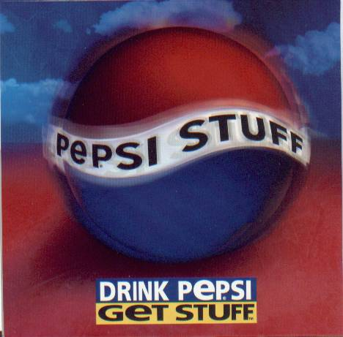
Background of the case

Pepsico (defendant) began a promotional campaign that encouraged its customers to collect “Pepsi points” and trade them in for merchandise.

As a part of this campaign, Pepsico created a commercial that showed some of the available merchandise along with the number of points it would take to acquire it. One item in the commercial was a Harrier Jet, which was said to require seven million points.

Pepsico also released a catalog containing the promotional merchandise.

Pepsico printed an order form in the catalog, listing items that could be redeemed with Pepsi points. The jet was not listed in the catalog or on the order form.

Leonard wanted to redeem the jet, which he was aware at the time cost approximately 23 million dollars. He consulted the catalog, which contained directions for claiming merchandise.

These directions included that if someone does not have enough Pepsi points for an item, additional points could be purchased for ten cents each so long as at least 15 Pepsi points are sent in with the order.

Leonard was not able to collect seven million points purchasing Pepsi products. He submitted 15 points and a check for $ 699,998,85. Leonard sent a letter explaining that the money was for the purpose of buying additional Pepsi points to be used to redeem the jet shown in the commercial.

Pepsico rejected the submission, stating that only items in the catalog or on the order form could be redeemed. Leonard exchanged demand letters with both Pepsico and the advertising company responsible for the commercial. Pepsico filed suit in the United States District Court for the Southern District of New York for declaratory judgment that it was not required to provide the jet under the campaign.

https://www.youtube.com/watch?v=PgqjB5VlgQE

How would you rule on this?

