Iceberg as Metaphor

For this activity, use paper to draw an outline of an iceberg.

Only a small part of an iceberg is visible to us, while most of it is hidden below the water.

Brainstorm and write down on the iceberg
the kinds of emotions that are more easily revealed
in conflict (i.e., sadness, anger, frustration, etc.)
above the water line, and those that are usually
hidden or “underlying” the conflict (i.e., fear,
distrust, pain, isolation, powerlessness, etc.) below
the waterline.

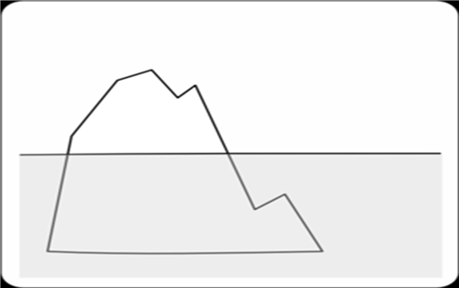

Directions: Read the “Orange Story” aloud and then as a group. reflect on how this relates, in terms of
underlying feelings and needs in a conflict.

The Orange Story

A brother and sister are fighting over an orange.

“I want this orange,” the boy yells
.
“Give me the orange,” the girl yells back.

They argue back and forth until their mom comes over, takes the orange, cuts it in half and gives each child one of the halves.

The children are still not happy. Why?

The children are not happy because the boy needed all of the orange juice for something he was cooking, and the girl needed all of the orange peel for a project she was working on.

Mom did not try to find out what their real, underlying needs were so she wasn’t able to solve the problem in a satisfactory way.

