LAW CLASS
COURT CASES
Zokhrabov v. Park 2011
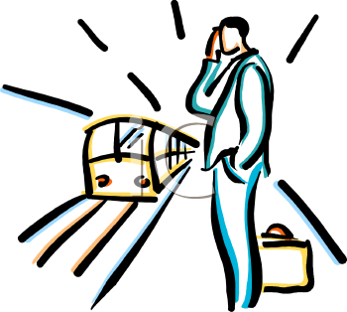
Background of the case

Hiroyuki Joho was killed when he was struck by an Amtrak train a Metra station at in Chicago.

Joho’s accident occurred just before 8 a.m. on Saturday, September 13, 2008, when the 18-year-old man was crossing in a designated crosswalk from the east-side passenger platform where Metra commuter trains arrive from Chicago, to the west-side passenger platform where Metra commuter trains depart toward Chicago.

Joho was about five minutes early for the next scheduled Metra departure to Chicago. The sky was overcast and it was raining heavily as he proceeded west across the double set of tracks, holding an open, black umbrella over his head and a computer bag on a strap across his shoulder.

The Metra station was not a destination for the Amtrak train that was traveling south at 73 miles an hour, and the engineer in the bright blue locomotive maintained speed, but sounded a whistle which triggered automatic flashing headlamps.

Witnesses disagree as to whether Joho realized the train was approaching. He was smiling at the commuters standing on the southbound platform when the train hit him.
A large part of his body was propelled about 100 feet onto the southbound platform where it struck 58-year-old Gayane Zokhrabov from behind, knocking her to the ground. She sustained a shoulder injury, a leg fracture, and a wrist fracture.

Zokhrabov sued Joho’s estate in the circuit court of Cook County seeking damages on
the ground that his negligence caused her injuries. She alleged he owed a duty of care to her while walking in and around the Metra station and breached that duty when he:

(a) failed to keep a proper lookout for approaching trains;
(b) carelessly ran in the path of an approaching Amtrak train; and/or
(c) carelessly failed to yield the right-of-way to approaching trains.”

How would you rule on this?

