LAW CLASS
COURT CASES
Mattel v. MCA Records (2002)
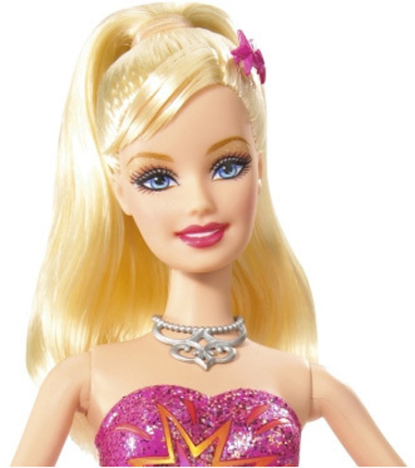

Background of the case

This bizarre case involves two giant corporations essentially fighting over a doll.

MCA records released a single of a song entitled “Barbie Girl” by Aqua in 1997. The song was sarcastic, with lyrics like “I'm a blond bimbo girl, in a fantasy world.”

Mattel's lawyers were angry and filed a suit, accusing MCA of violating their copyrights and trademarks and tarnishing the reputation of their most famous product. Mattel argued that the "Barbie Girl" song tarnished the Barbie trademark since the song implied adult themes in its lyrics that contradicted the wholesome image Mattel promotes in connection with its Barbie doll. They even claimed that the single's pink color was a infringement on their “patented” Barbie color.

Aqua defended their song as social satire.

Barbie shot back, saying that the language on the CD was like “a bank robber handing a note of apology to a teller during a heist.”

Now it was MCA's turn. They counter-sued, saying they were defamed by being called thieves.
.

How would you rule on this?

