LAW CLASS
COURT CASES
Leibeck v McDonalds (1994)
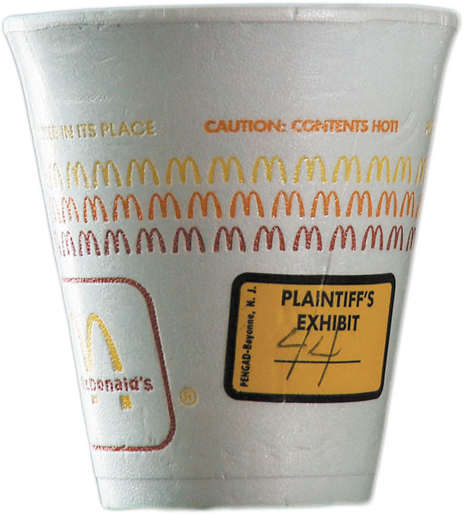
Background of the case
In February 1992, Stella Liebeck, a 79-year-old woman from Albuquerque, New Mexico, ordered a 49-cent cup of coffee from the drive-through window of a McDonald's restaurant.
Liebeck was in the passenger's seat of a 1989 Ford Probe which did not have cup holders. Her grandson parked the car so she could add cream and sugar to her coffee. Liebeck placed the coffee cup between her knees and pulled the far side of the lid toward her to remove it. In the process, she spilled the entire cup of coffee on her lap.
Liebeck was wearing cotton sweatpants; they absorbed the coffee and held it against her skin, scalding her thighs and groin.
Liebeck was taken to the hospital, where it was determined that she had suffered third-degree burns on six percent of her skin. She remained in the hospital for eight days while she underwent skin grafting. During this period, Liebeck lost nearly 20% of her body weight, reducing her to 83 pounds .
After the hospital stay, Liebeck needed care for 3 weeks, which was provided by her daughter. Liebeck suffered permanent disfigurement after the incident and was partially disabled for two years
Liebeck asked McDonald's for $20,000 to cover her actual and anticipated expenses. Her past medical expenses were $10,500; her anticipated future medical expenses were approximately $2,500; and her daughter's loss of income was approximately $5,000 for a total of approximately. Instead, the company offered only $800. When McDonald's refused to raise its offer, Liebeck retained an attorney and filed suit in New Mexico District Court accusing McDonald's of "gross negligence" for selling coffee that was "unreasonably dangerous" and "defectively manufactured".
How would you rule on this?

